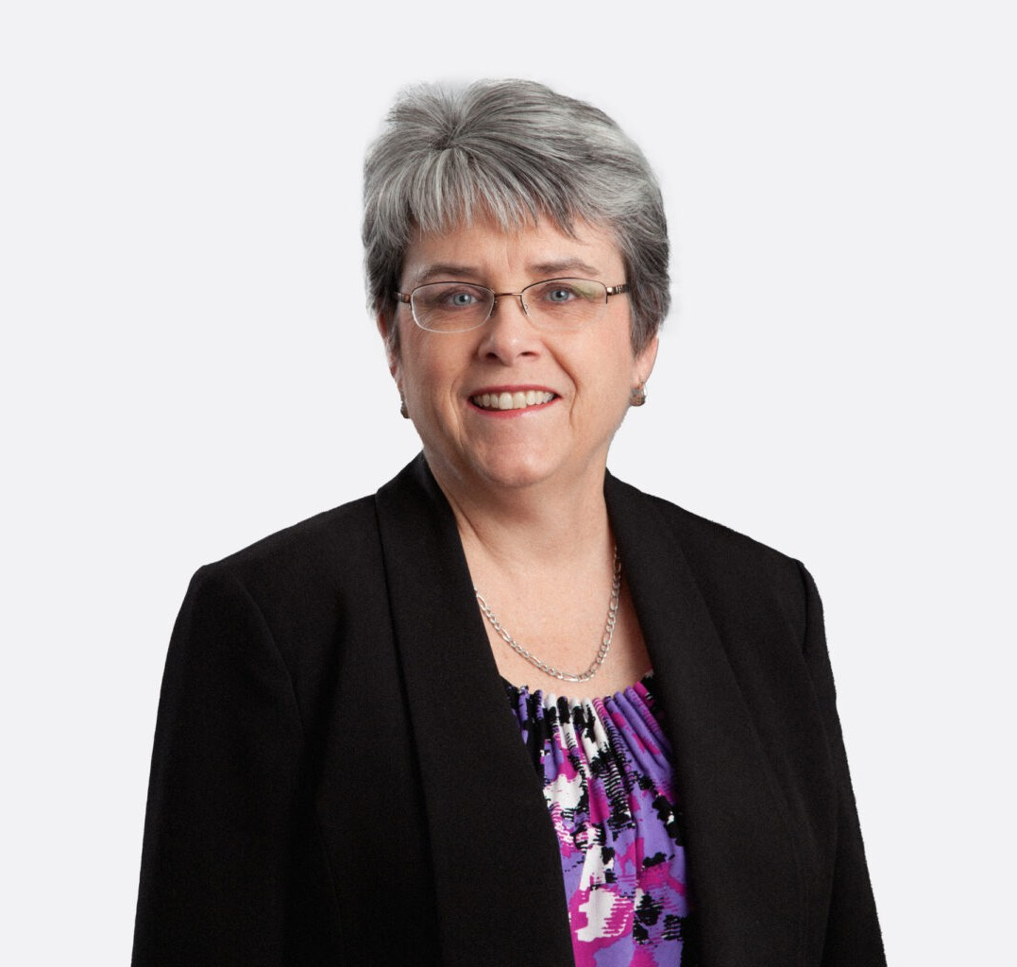

MARGARET GALLOGLY
Of Counsel
Natural Resources

Phoenix
P: 602.916.5436
mgallogly@fennemorelaw.com

MARGARET GALLOGLY
Maggie concentrates her practice in water law with an emphasis on drafting and negotiating complex agreements involving natural resource issues. She represents clients on numerous aspects of water supply and development, including the negotiation of water service
agreements, planning for the use and protection of water rights, obtaining Certificates of Assured Water Supply, negotiating with the Arizona Department of Water Resources, and advising clients on water legislation under consideration by the Arizona legislature.
Maggie has represented clients in the real estate development and mining industries. She has also had the opportunity to represent water providers. Over the past twenty-five years, Maggie has had a wide range of experience with Arizona’s assured water supply program and the Central Arizona Groundwater Replenishment District. She is a frequent lecturer on these
programs.

In addition to water law, Maggie also has experience in many aspects of real estate transactions.

AREAS OF PRACTICE
Natural Resources Tax Law

EDUCATION
J.D., Boston College Law School, cum laude
Editor-in-Chief, Boston College Environmental Affairs Law Review, 1981-1982 B.A., Catholic University of America, summa cum laude

REPRESENTATIVE CASES
Represents numerous developer clients each year in obtaining Certificates of Assured Water Supply.
Counsels master developers in water planning, negotiation of agreements with municipal and private water companies, and obtaining necessary water permits and approvals, including

Certificates of Assured Water Supply.
Represents numerous golf course developers in securing effluent for golf course development, working with municipalities and private wastewater treatment companies.
Counsels clients on compliance with water conservation requirements in connection with golf courses and other aspects of master-planned communities.

AWARDS & HONORS
Chambers USA, Leading Lawyers for Business, 2012-2018
Best Lawyers in America®, Water Law and Natural Resources Law, 2007-2018
Best Lawyers in America®,Lawyer of the Year, Natural Resources Law, 2017
AV® Preeminent™ Peer Review Rated (the highest rating available), by Martindale-Hubbell

ARTICLES AND PRESENTATIONS
Speaker, “What’s New in Water,” Fennemore Craig Environmental and Natural Resources Seminar Series, 2018

PROFESSIONAL AND COMMUNITY AFFILIATIONS
Member, State Bar of Arizona
Member, Maricopa County Bar Association Member, American Bar Association

ADMISSIONS
Arizona
U.S. Court of Appeals, Ninth Circuit
U.S. Tax Court

