
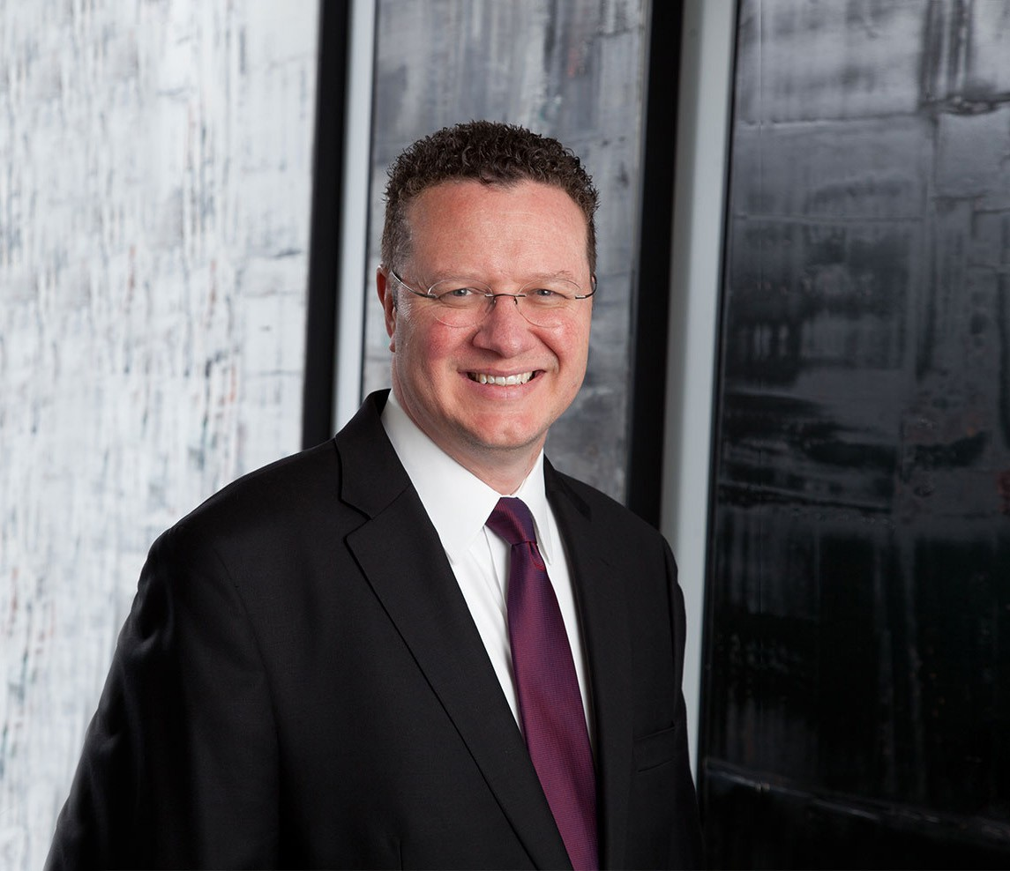
T. JAMES LEE
T. JAMES LEE
Director
Trusts & Estates
Phoenix
P: 602.916.5422 F: 602.916.5622
jlee@fennemorelaw.com
“
In my practice, I most enjoy working with individuals and families in discovering thoughtful and customized solutions to the particular challenges
associated with prosperity.
”
Terry James (“Jim”) Lee advises clients in estate planning, private wealth law, tax and business law, international matters, and real estate and commercial transactions. He also counsels business founders and their families on matters of family governance, privacy, and issues of especial importance to high-profile and ultra-high net worth families and individuals.
Jim leads our family office and private client attorneys, a specialized group of advisors providing multidisciplinary resources and bespoke solutions for sensitive and pressing family concerns, values-based wealth transfer, and business succession. Leveraging his background in business,
economics, and accounting, he assists clients with the structuring and implementation of trusts (such as dynastic IDGTs, GRATs, DAPTs, INGs, QPRTs, CRTs, CLTs, silent/quiet trusts, and aircraft
trusts), family offices, private trust companies, family limited partnerships, LLCs, corporations, private foundations, and other sophisticated tax and investment vehicles and techniques. Jim
also serves as family office general counsel. Coming full circle, he advises trustees and executors on their fiduciary responsibilities and tax implications in the administration and distribution of trusts and probate estates.
A testament to his abilities, Jim has a referral-only, concierge practice. He has developed a reputation for being an inventive, outside-the-box problem-solver, and for being fiercely loyal to his clients. This client-oriented approach means Jim designs estate and business plans to meet the needs of each family’s personal vision. As an example, trusts and business succession plans can be customized to provide incentives to beneficiaries and successors, such as children and grandchildren, to become productive and contributing members of society. Often known as the family’s lawyer, Jim develops long-term relationships that help promote continuity from generation to generation, while respecting individual thought and new perspectives.

Jim is fluent in Spanish, and many years ago, while living in a foreign country, he witnessed firsthand the impact attorneys can have helping others with their legal and familial goals and objectives. He cherishes opportunities to help people in his role as an analytical thinker, writer, and advocate.
Jim enjoys time with his family, composing music, and experiencing other cultures and
languages. For seven years he performed as a member of the Phoenix Boys Choir, entertaining and touring throughout the United States and abroad. “Because of those early eye-opening
experiences, the desire to meet and appreciate other people and their cultures and beliefs,” he says, “has never quite left me. When a guest in another country, I prefer not only to visit but also to interact with its people. They then become a part of you, and you become an ambassador of both your home country and that part of the world you have come to know. Phoenix, Arizona is my base camp.”
Married with six now-adult children, Jim once saw himself as “the roadie” and sound engineer for his kids’ mobile DJ business—a business Jim too once had back in high school. You might have found him playing at schools, weddings, and private events. His go-to song? Elvis Presley’s “Can’t Help Falling in Love.”
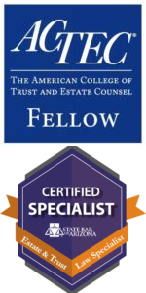
Jim is a fellow of the American College of Trust and Estate Counsel (ACTEC), a group of peer-elected trust and estate attorneys spanning the U.S. and abroad. He is also a published author, frequent lecturer to other attorneys and CPAs, and a Certified Specialist in trusts and estates through the State Bar of Arizona.

EDUCATION
J.D., with honors Brigham Young University, J. Reuben Clark Law School B.S., Business Management Brigham Young University
Top business school graduate in entrepreneurship, business composite minor (Accounting and Economics), and minor in Spanish
Brigham Young University Law Review, Editorial Board, 1995-1996; Member, 1994-1996 Extern, Honorable J. Kenneth Mangum, Superior Court of Arizona, 1994
AREAS OF PRACTICE

OTHER EXPERIENCE

Nonprofit and Tax-Exempt Organizations Trusts & Estates
Business & Finance Tax Law

Estate Litigation
Family Office & Private Client Attorneys Estate Planning
General Counsel Services

AWARDS AND HONORS
Best Lawyers in America®, Tax Law, Trusts and Estates, Litigation – Trusts and Estates, 2010-2026 Best Lawyers in America®, Lawyer of the Year, Trusts and Estates, 2017, 2021, 2024, 2026 Lawyer of the Year, Trusts and Estates, Phoenix Business Journal, 2026
Best Lawyers in America®, Lawyer of the Year, Tax Law, 2023
Eleanor ter Horst Distinguished Service Award, State Bar of Arizona, 2023 Recipient
Southwest Super Lawyers®, Estate Planning and Probate, 2008, 2010-2018, 2022-2026 Chambers HNW, Leading High Net Worth Advisors (Band 1), 2016-2025
Arizona’s Finest Lawyers, Regular Member, admitted as of 2011
AV® Preeminent™ Peer Review Rated (the highest rating available), by Martindale Hubbell

ARTICLES AND PRESENTATIONS
Co-Facilitator, “Is It a Cliff or Is It an Illusion: Planning for 2025 and Beyond,” Cambridge Forum on Private Wealth Law, Nashville, Tennessee, May 2025
Speaker, “New Rules, New Tools: Charitable Gifts of Closely Held Business Interests,” or How to Reduce Taxable Gains in a Business Sale, Southern Arizona Estate Planners Council (SAEPC), January 2025
Speaker, “Directing the Undirected — Directed Trust Alternatives,” Southern Arizona Estate Planners Council (SAEPC), January 2025
Panelist and Presenter, “Arizona Statutory Updates,” ACTEC Western Region Meeting, Koloa, Hawaii, August 2024
Presenter, “Directed Trusts and Arizona Law,” State Bar of Arizona, CLE by the Sea, Coronado, California, July 2024
Co-Presenter, “Money and Meaning: Legacy Planning,” ACF Forum Connects, April 2024
Co-Presenter, “Petter-Based Transactions—Gifts and Sales of Closely Held Businesses with Philanthropic Components”, Arizona Community Foundation (PAB Presentation), January 2024
Speaker, “Arizona Directed Trust Act?,” ACTEC, Arizona Chapter, December 2023
Co-Presenter, “Advanced Gifting Techniques that Encourage Philanthropy,” Arizona Charitable Gift Planners, October 2023
Program Co-Chair and Presenter, ARIZONA STATE BAR CONVENTION, “A Five-Course Meal of Estate Planning Issues, Case and Legislative Updates, Administration Practice Tips, Business and Tax Considerations, and Ethics,” Probate & Trust Law Section, June 2023
Co-Presenter, “Income Tax Exit Strategies for Privately Owned Businesses,” American Law Institute (ALI CLE), May 2023

Presenter, “Planning Techniques for Large Estates 2023,” American Law Institute (ALI CLE), April 2023
Co-Presenter, “Taxing Matters: Income Taxation of Trusts, Estates (advanced fiduciary income tax) and Inherited Retirement Accounts,” State Bar of Arizona, March 2023
Interview (podcast), “The Separate Share Rules and Their Nuances,” ACTEC, February 28, 2023
Presenter, Fiduciary Income Tax (Probate Administrator’s Guide to Fiduciary Income Tax (basic to intermediate)), State Bar of Arizona, February 2023
Co-Presenter, “When Grantor Trusts Become Non-Grantor Trusts,” Valley Estate Planners, January 2023
Co-Presenter, “Separate Share Rules,” Fall Meeting, ACTEC, San Francisco, California, 2022
Presenter, “Estate Planning for the Family Business Owner 2022,” American Law Institute (ALI CLE), October 2022
Speaker, “Estate Planning Updates: Gift, Estate, GST, and Fiduciary Income Tax,” Arizona Society of CPAs’ Annual Conference, November 2021
Co-author, “Arizona Estate Planning: Income, Estate, Gift, and GST Taxation,” DT Publishing Company, Vols. 1 and 2 supplements, 2020 and 2021
Presenter, “Qualified Small Business Stock,” AZCLE Entity Selection and Issues for the Estate Planner, sponsored by the State Bar of Arizona, October 13, 2020
Contributing author, “Recent Tax Developments – 2020 April – Refresher on Benefits Under The CARES Act,” Fennemore Client Alert, May 4, 2020
Co-author, “IRS and the Arizona Department of Revenue Extend Tax Filing Deadlines to July 15,” Fennemore Client Alert, March 26, 2020
Contributing author, “Recent Tax Developments – 2020 January – The SECURE Act (Individuals),” Fennemore Client Alert, January 9, 2020
Contributing author, “End of Year Tax Saving Moves – 2019,” Fennemore Client Alert, December 30, 2019
Contributing author, “Recent Tax Developments – December 2019,” Fennemore Client Alert, December 23, 2019
Presenter, “Estate Planning for the Family Business Owner 2019,” American Law Institute (ALI CLE), October 2019
Contributing author, “Recent Tax Developments – 2019 April,” Fennemore Client Alert, April 16, 2019
Co-author, “Arizona Estate Planning: Income, Estate, Gift, and GST Taxation,” DT Publishing Company, Vol. 1 supplement and new Vol. 2, 2019
Co-author, “End-of-year Business Advice for Northern Nevada Businesses (Opinion),” Northern Nevada Business View, December 11, 2018
Contributing author, “Recent Tax Developments – 2018 August,” Fennemore Client Alert, August 8, 2018
Contributing author, “Recent Tax Developments – 2018 July,” Fennemore Client Alert, July 2, 2018
Interview, “The New Partnership Audit Rules and Why They Are So Important For Estate Planners,” ACTEC, June 12, 2018

Speaker, “Digital Assets,” The Arizona Fiduciaries Association 2018 Spring Conference, April 20, 2018
Co-author, “Recent Tax Developments – 2018 January,” Fennemore Client Alert, January 23, 2018
Speaker, “Partnership Audit Rules,” Summer Meeting, ACTEC, Chicago, Illinois, 2018
Contributing author, “Tax Planning Checklists – 2017 End of Year,” Fennemore Client Alert, October 16, 2017
Contributing author, “Recent Tax Developments – 2017 April,” Fennemore Client Alert, April 12, 2017
Speaker, 2017 Women’s Financial Forum, Arizona Bank and Trust, 2017
Speaker, “Hot Topics in Contemporary Estate Planning (including Ron Aucutt),” sponsored by the State Bar of Arizona, 2017
Speaker and Panelist, various trusts, estates, and tax seminars, National Video Broadcasts, NBI, 2016-present
Contributing author, “Tax Planning Checklists – 2016 End of Year,” Fennemore Client Alert, November 4, 2016
Contributing author, “Recent Tax Developments – October 2016,” Fennemore Client Alert, October 26, 2016
Contributing author, “Valuation Discounts: Going, Going,…” Fennemore Client Alert, September 19, 2016
Speaker, Moderator, and Seminar Chair, “Probate and Estate Law, and Elder and Mental Health Care Law: A Multi-Disciplinary Approach (Practical Estate Planning and Administration; Estate Planning with Corporations, LLCs, and Partnerships; Elder and Special Needs Planning for the Modest and the Affluent; and Digital Assets),” CLE by the Sea, Coronado, California, sponsored by the State Bar of Arizona, July 2016
Speaker, “Partnership Tax Allocations, and Implications of the Repeal of TEFRA,” Business Planning Committee, Summer Meeting, ACTEC, Boston, Massachusetts, 2016
Speaker, “Section 642(c) Charitable Deduction and Tracing,” Fiduciary Income Tax Committee, Annual Meeting, ACTEC, Las Vegas, Nevada, 2016
Co-author, “Best Practices for Structuring Trusts and Estates,” Thomson Reuters (Aspatore), 2016 edition
Co-author, “Recent Tax Developments – January 2016,” Fennemore Client Alert, January 14, 2016
Contributing author, “Surface Transportation and Veterans Health Care Choice Improvement Act of 2015,” Fennemore Client Alert, August 12, 2015
Contributing author, “2015 Second Quarter Tax Developments,” Fennemore Client Alert, July 20, 2015
Contributing author, “Tax Developments For First Quarter 2015,” April 29, 2015
Contributing author, “Families of Those With Disabilities: New ‘Able Accounts’,” Fennemore Client Alert, April 1, 2015
Contributing author, “Tax Developments in February 2015,” Fennemore Client Alert, March 1, 2015

Contributing author, “Tax Developments in 2015,” Fennemore Client Alert, January 12, 2015
Co-author, “Arizona Estate Planning: Income, Estate, Gift, and GST Taxation,” DT Publishing Company, Vol. 1, 2015 supplement
Speaker, “Sophisticated Estate Planning: GRATs, Sales to Grantor Trusts, CRTs, CLTs, Asset Allocations, Fiscal Year Planning, and DNI,” Valley Estate Planners, 2015
Contributing author, “Tax Developments in 2014,” Fennemore Client Alert, December 15, 2014
Contributing author, “Tax, Business and Estate Planning,” Fennemore Client Alert, December 15, 2014
Speaker, “Estate Planning for the Novice,” sponsored by KJZZ/K-BACH Radio, 2014
Co-author, “Arizona Estate Planning: Income, Estate, Gift, and GST Taxation,” DT Publishing Company, Vol. 1, 2014 supplement
Speaker and Seminar Chair, “Advanced Estate Planning and Trust/Probate Administration,” CLE by the Sea, Coronado, California, sponsored by the State Bar of Arizona, 2014
Seminar Chair and Moderator, “Effect of U.S. v. Windsor on DOMA in Estate Planning, Update on T&E Litigation and Legislation (Federal and Arizona), Resolving Probate and Trust Disputes Without Protracted Litigation, and the Continuing Evolution of the Arizona Probate Rules and Procedures,” sponsored by the State Bar of Arizona, 2014
Seminar Co-Chair and Moderator, “Unraveling Estate Planning Issues after Windsor (DOMA) and Other Advanced Planning Topics,” State Bar of Arizona, Probate & Trust Law Section, 2013
Speaker, “Understanding Consequences of Transfers of Title in Unfamiliar Jurisdictions,” Western Region Meeting, ACTEC, Half Moon Bay (San Francisco), California, 2013
Speaker, “Wealth Transfer Tax Legislation, Estate Planning Techniques, and Current
Developments,” CLE by the Sea, Coronado, California, sponsored by the State Bar of Arizona, 2013
Co-author, “Arizona Estate Planning: Income, Estate, Gift, and GST Taxation,” DT Publishing Company, Vol. 1, 2012
Seminar Co-Chair, “Arizona Probate Practice in 2012 – ¡Cuidado!”, Probate & Trust Law Section, Arizona State Bar Convention, 2012
Speaker, “The Good, Bad and the Ugly in Decanting in Arizona,” Arizona Community Foundation, Professional Advisory Board, 2012
Speaker, “Unexpected Complexity of Marital Deductions,” National Teleconference, Lorman Education Services, 2012
Speaker, “Decanting (What now, pourover “trusts”?),” East Valley Estate Planning Council, 2012
Seminar Chair and Moderator, “Advanced Probate and Trust,” State Bar of Arizona, Probate and Trust Law Section, 2011
Author, “Decant or Not Decant (in Arizona)?,” Probate and Trust Law Newsletter, State Bar of Arizona, 2011
Author, “Marital Deduction Formula and GST Tax Severance Planning — Income Tax
Consequences,” Estate Planning, Thomson Reuters (Warren, Gorham & Lamont), New York, Nov. 2010

Speaker, “Recent Developments and Hot Topics: Apportionment of Estate Taxes and Administrative Expenses,” sponsored by the Jewish Community Foundation of Southern Arizona, 2010
Speaker, “Decant or Not Decant? That Is the Question,” Arizona State Bar Convention, 2010
Speaker, “Important and Hot Estate Planning and Related Tax Planning Topics,” State Bar of Arizona, Probate and Trust Law Section, 2009
Speaker, “Steeping Marital Deduction Bliss in Your GS Tea (Advanced Formula Planning),” Tucson Tax Study Group, 2009
Speaker, “Advanced Generation-Skipping Transfer Tax and Marital Deduction Planning,” National Teleconference, NBI, 2009
Speaker, “Drafting for the Arizona Trust Code,” Maricopa County Bar Association, 2009 Speaker, “GSTT and Marital Deduction Formula Planning,” VEP, 2009
Speaker, “New Trust Code and Probate Rules Take Effect: Are you Ready?” State Bar of Arizona, Elder Law and Mental Health Section, 2009
Speaker, “Arizona Trust Code,” Maricopa County Bar Association, 2008
Speaker, “Trust and Estate Distributions: Income Tax Implications and Planning Alternatives,” State Bar of Arizona, Taxation Section, 2008
Speaker, “Trust and Estate Income Taxation,” Tucson Tax Study Group, 2007 Speaker, “Income Taxation in Estate Planning,” Valley Estate Planners, 2007
Speaker, “Estate Planning and Subchapter J Issues,” East Valley Estate Planning Council, 2006 and various commercially sponsored lectures

PROFESSIONAL AND COMMUNITY ACTIVITIES
Member, American Bar Association Member, State Bar of Arizona Member, Utah State Bar
Member and Past Chair, Executive Council, Probate and Trust Law Section, State Bar of Arizona
Member, Professional Advisory Board and Gift Acceptance Committee, Arizona Community Foundation
Trustee, Phoenix Boys Choir
Volunteer, in affiliation with local chapters of House of Refuge and Habitat for Humanity Fellow, The American College of Trust and Estate Counsel, ACTEC
Member, Fiduciary Income Tax Committee, Business Planning Committee, ACTEC Inaugural Member, TGen Ambassadors, Translational Genomics Research Institute Member, Committee on Estate and Gift Taxes, Taxation Section, American Bar Association Past Chair and Member, Estate and Trust Advisory Commission, State Bar of Arizona
Past Chair, Professional Education Series Planning Committee, Arizona Community Foundation Past Officer, Board of Directors, Ballet Arizona

Past Chair of the Planned Giving Committee, Past Executive Committee Member, Arthritis Foundation, Greater Southwest Chapter
Past Council Officer, Past Executive Board Member, Boy Scouts of America, Grand Canyon Council
Past Member, Professional Advisory Committee, Jewish Community Foundation Past President, Past Board Member, Valley Estate Planners
Past President, Past Board Member, East Valley Estate Planning Council

ADMISSIONS
Arizona Utah
U.S. District Court, District of Arizona
Trust and Estate Specialist (Board Certified, State Bar of Arizona)

