
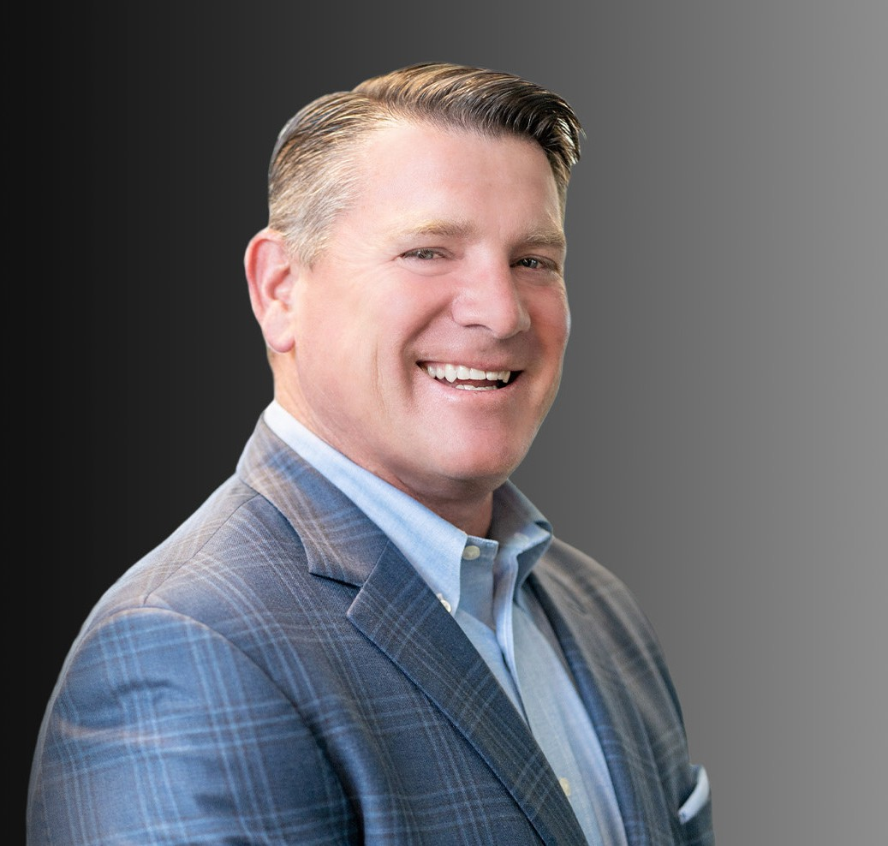
A multi-faceted litigator, Buddy has a track record of resolving complex business and real estate issues. He has approximately 30 years of experience representing an array of businesses and
WILLIAM
“BUDDY” ROWELL
Director
Business Litigation
Oakland
P: 510.834.6600 F: 510.834.1928
browell@fennemorelaw.com
“
It’s not whether you get knocked down. It’s whether you get up.
Vince Lombardi
WILLIAM "BUDDY" ROWELL
”
public entities, including developers, property owners, major retailers, universities, school districts, and utilities. He serves as the firm’s Northern California Managing Partner, and previously served as Fennemore’s Chair of Litigation.
Buddy brings significant industry experience to the firm’s well-established real estate, environmental, and construction practices. He handles a wide range of litigated matters, including business and partnership disputes, premise and product liability, and construction
defect, with a substantial expertise in real estate, catastrophic injury, and errors and omissions cases.
Buddy is known for being pragmatic, but also for fighting doggedly for his clients when the situation calls for it. This combination of traits may be due to the fact that he is the sixth of seven children and had to be both conciliatory and fiercely determined from a young age to navigate the dynamics of such a large family.
He is a member of the Public Agency Risk Management Association (PARMA), the Claims & Litigation Management Alliance, and the Defense Research Institute.
Married for over 30 years, he and his wife Alicia have three children, Robby, Lexi, and Claire. In his spare time, Buddy likes to travel, play golf, and spend time with family. He also coaches high school freshman football, serving as offensive coordinator. Ask him about his offense only if you have a long time to talk.
Business Litigation

EDUCATION
J.D., University of San Francisco School of Law, McAuliffe Honor Society, magna cum laude
B.A., University of California, Berkeley

AREAS OF PRACTICE

OTHER EXPERIENCE

Public Agency
Real Estate Litigation Business Litigation

ARTICLES AND PRESENTATIONS
Author, “What’s driving Bay Area litigation in 2025 — and how to stay ahead,” San Francisco Business Times, August 11, 2025
Author, “Attorney Buddy Rowell offers an update on Fennemore Wendel, Bay Area commercial real estate vacancies and litigation activities,” San Francisco Business Times, August 1, 2024
Author, “U.S. Commercial Real Estate Occupancy Rates Were Hit Hard in 2023,” Fennemore Blog, January 23, 2024
Interview, “Top Lawyers: William “Buddy” Rowell of Fennemore Wendel on the 5 Things You Need to Become a Top Lawyer in Your Specific Field of Law,” Medium Authority Magazine, January 2023

PROFESSIONAL AND COMMUNITY ACTIVITIES
Member, Alameda County Bar Association Member, Public Agency Risk Management Alliance Member, Claims & Litigation Management Alliance Northern California ReLiEF Defense Panel, ReLiEF

ADMISSIONS
California
U.S. Court of Appeals, Ninth Circuit
U.S. District Court, Central District of California
U.S. District Court, Eastern District of California
U.S. District Court, Northern District of California

