
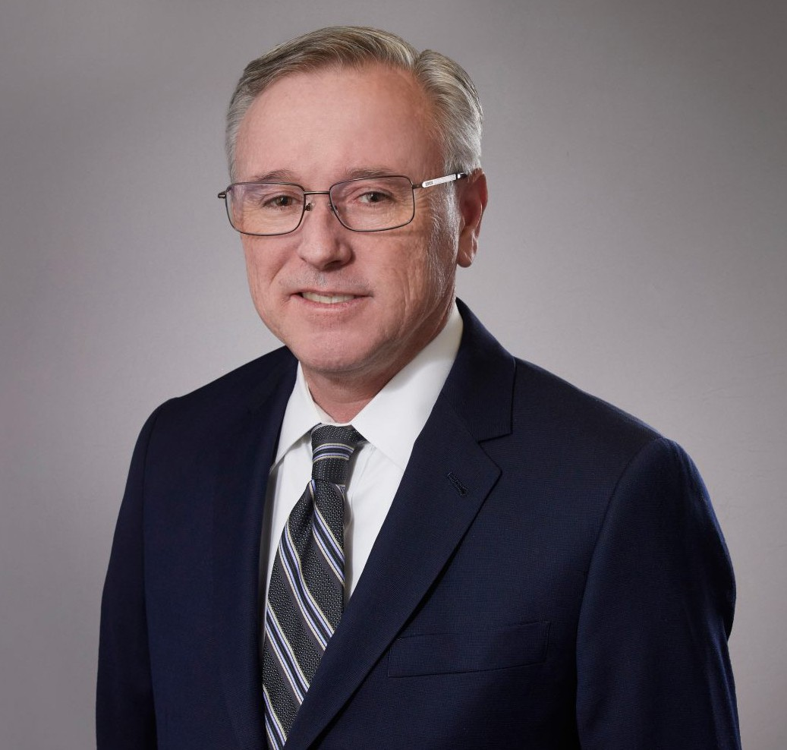
PHILIP M. SAVAGE IV
PHILIP M. SAVAGE IV
Director
Trusts & Estates
Inland Empire
P: 909.890.4499
F: 909.890.9877
psavage@fennemorelaw.com
“
“At his best, man is the noblest of all animals; separated from law and justice
he is the worst.”
- Aristotle
”
Phil Savage is a director in our San Bernardino office where his practice focuses on business
succession, estate planning and trust administration. He works with his clients to create business succession and estate transfer plans that preserve wealth and enhance family relationships. His clients include corporations, charities, high net worth families and individuals, and fiduciaries.
Phil enjoys providing personalized estate planning, estate administration, and business succession counsel. He provides clients with a practical approach to achieve their planning
objectives, including the planning and preparation of revocable and irrevocable trusts, and the administration of trusts and estates involving estate and gift tax issues. He also advises and counsels individuals and charitable organizations on planning and implementing charitable gifts.
A certified specialist in estate planning, trust, and probate law by the State Bar of California Board of Legal Specialization, Phil is a past chair of the Estate Planning, Trust, and Probate Law Advisory Commission of the State Bar of California Board of Legal Specialization. He has presented estate planning seminars to many organizations.

EDUCATION

J.D., Loyola Law School, Los Angeles B.A., Stanford University

AREAS OF PRACTICE

Trusts & Estates Business & Finance Tax Law
Estate Planning

ARTICLES AND PRESENTATIONS

Estate Planning – The Basics and Pitfalls to Avoid, Crafton Hills College, January 2019 First Steps in Trust Administration, 2018 Bench-Bar Symposium, June 2018
Estate Planning for Digital Assets, Orange County Estate Planning Council, September 2017 Estate Planning and Charitable Planning, San Bernardino Valley College, January 2016 Estate Planning for Digital Assets, Riverside Estate Planning Council, March 2015
Estate Planning Basics, California State University San Bernardino, June 2014 Estate Planning Basics, University of California Riverside, April 2014

PROFESSIONAL AND COMMUNITY ACTIVITIES

American Bar Association, Real Property, Probate & Trust Section, member The State Bar of California, Estate Planning, Probate & Trust Section, member Inland Empire Estate Planning Seminar, member board of directors
Loma Linda University Children’s Hospital Foundation, board member, past chair The Inland Empire Community Foundation, past chair
Estate Planning Council of Riverside, member Riverside Sunrise Rotary, member, past president
San Bernardino Community Scholarship Association, board member
University of California, Riverside, Planned Giving Advisory Board, past board member University of California Riverside Foundation, past member board of trustees
California State University San Bernardino Philanthropic Foundation, past board member

ADMISSIONS

California

