
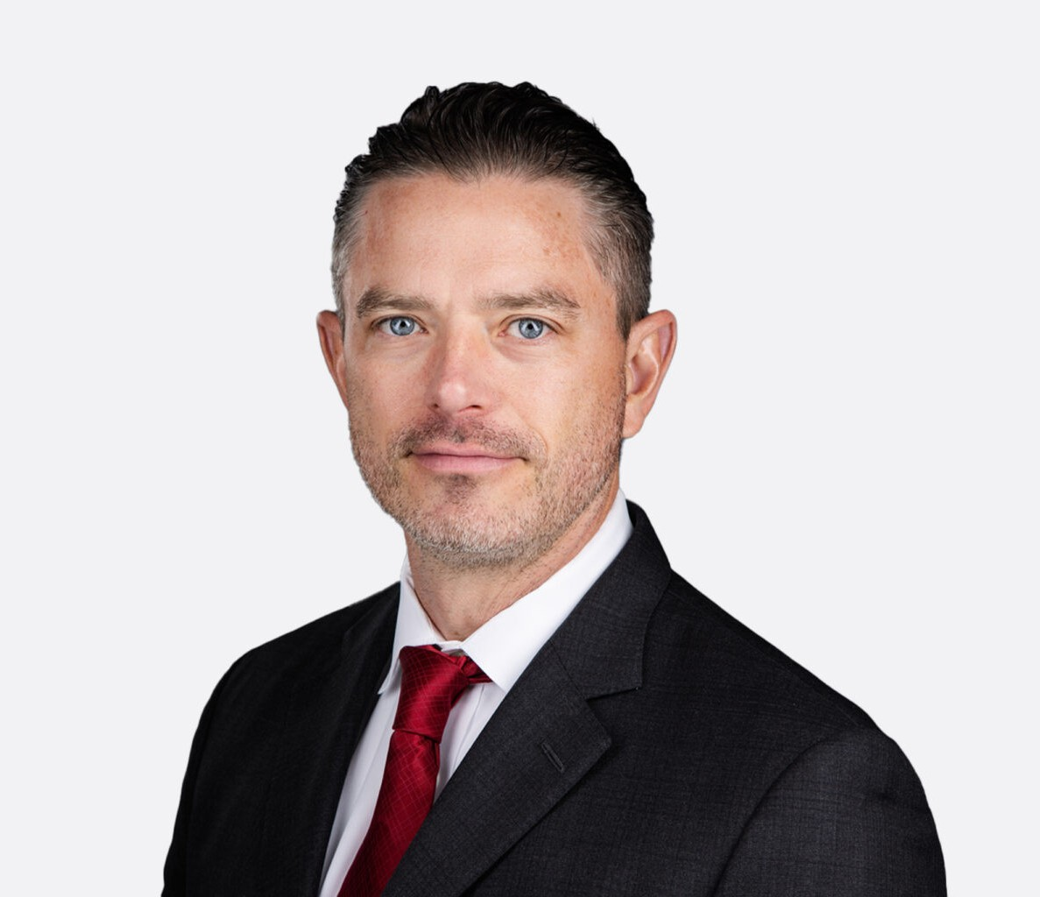
Sean chairs the firm’s water law practice, one of the preeminent water groups in the Western United States. A water lawyer and litigator, Sean has been recognized as “Lawyer of the Year” and a Band 1 practitioner by Chambers USA. He has an established strong track record of success in the courtroom (see Representative Cases, below) and in achieving advantageous settlements.
SEAN T. HOOD
Director
Water Law
Phoenix
P: 602.916.5475 F: 602.916.5675
shood@fennemorelaw.com
“
The best way out is always through.
Robert Frost (as quoted by the Arizona Supreme Court in Gila III)
SEAN T. HOOD
”
He has more than two decades of experience advising Fortune 500 companies and other businesses on a broad range of disputes involving water rights, environmental permitting, “business divorce” and other disputes involving partnership and shareholder interests, breach of contract, business torts, and real estate.
Sean helps his clients acquire and protect their surface water and groundwater supplies used for mining, real estate development, M&I, and agriculture. He has in-depth experience litigating
complex water rights disputes including federal reserved water right claims, subflow, safe yield determinations, and the Assured Water Supply program. These disputes are highly technical, often involving numeric groundwater modeling. He also litigates issues arising under various environmental laws, and has successfully defended land ownership interests in navigability for title proceedings under the Equal Footing Doctrine.
He has wide-ranging trial experience in complex water rights litigation in state and federal court, and served as lead counsel in each of the first several trials to resolve contested water right claims in the Gila River General Stream Adjudication.
Sean advises clients on a wide range of Western water rights issues, including adjudication of
Arizona and California water rights and Colorado River issues, and he handles cases throughout the West. Sean practices regularly at the trial and appellate levels in state and federal courts, as well as before a variety of administrative boards and commissions.

He is also an author and commentator on various water resources topics, including California’s Sustainable Groundwater Management Act (SGMA), Arizona groundwater management,
desalination, and the Colorado River.

When not in a court room, Sean is spending time with his wife and three children, coaching flag football, playing guitar with one of his bands, or rooting for the Notre Dame Fighting Irish.

EDUCATION
J.D., with honors, Notre Dame Law School B.S., Santa Clara University

AREAS OF PRACTICE
Water Law Business Litigation Natural Resources Mining Law Agribusiness

REPRESENTATIVE CASES
Served as legal counsel to the City of Chandler in City of Chandler v. Roosevelt Water Conservation District, No. CV-24-0267-PR, 2026 WL 1141802 (Ariz. Apr. 28, 2026), where the Arizona Supreme Court declared that the one-year statute of limitations in A.R.S. § 12-821
does not apply to claims by a government-entity plaintiff against another government entity, helping secure a ruling that preserves flexibility for public entities to resolve disputes without the pressure of a strict one-year deadline.
Successfully litigated Phase 1 of the Indian Wells Valley groundwater basin adjudication, designated for quantification of the Navy’s federal reserved right for Naval Air Weapons Station China Lake (China Lake). China Lake is a Naval Base located in the Western Mojave Desert region of California. The Navy claimed a water right totaling nearly 7,000 acre-feet per year (AFY). After an eight-day bench trial in April and May 2025, the court agreed with our
client that the water right must be limited to 2,008 AFY. Case No. 30-2021-01187275, Superior Court of California, Orange County. See the order here. Phase 2 is now underway, which will establish the safe yield of the groundwater basin.
Successfully opposed the United States’ over-broad federal reserved right claim for Fort
Huachuca, an Army base in southeastern Arizona. The United States claimed nearly 7,000 acre-feet per year (AFY) of groundwater. Following several years of litigation and several weeks of trial, the United States’ right was restricted to 1,548 AFY, i.e. approximately an 80% reduction from its claimed quantity. In re Fort Huachuca, No. W1-11-605, Superior Court of Arizona, Maricopa County. See the order here.
Successfully opposed the United States’ claims to broad federal reserved water rights for the San Pedro Riparian National Conservation Area (SPRNCA). The trial court adopted our clients’ position concerning what stream flows are appropriate to meet the SPRNCA’s “minimal need” for water for the SPRNCA’s riparian vegetation, native fish, and avian populations. The court rejected the United States’ claims to significantly greater stream flows and water from other sources. In re San Pedro Riparian National Conservation Area, No. W1-11-232, Superior Court of Arizona, Maricopa County. See the order here.

Represents California water users with adjudicating basin-wide groundwater rights.
Represents California groundwater water users in connection with regulation by Groundwater Sustainability Agencies (GSAs) pursuant to the Sustainable Groundwater Management Act
(SGMA).
Represents Arizona developers in connection with regulation by the Arizona Department of Water Resources (ADWR) under the Assured Water Supply (AWS) program.
Represents landowners in connection with the establishment of groundwater use restrictions imposed through the recent establishment of an Irrigation Non-Expansion Area (INA).
Represents a number of industrial and agricultural water users in separate water rights settlement efforts involving an array of competing water users.
Defeated in their entirety dozens of individual federal reserved right claims asserted for a wilderness area by the federal government. Obtained summary judgment on separate claims to 34 individual water sources. Proceeded to trial on the claims that survived summary judgment, and defeated each remaining claim. See the order here.
In proceedings concerning the test to estimate whether a well’s cone of depression has the potential to deplete stream flow, presented technical evidence successfully demonstrating that a numeric MODFLOW model should be used rather than a less-sophisticated (i.e. less
accurate) analytical model. Successfully argued that the cone of depression test does not shift the burden of proof to the well owner to prove that its well is not pumping subflow. See the order here.
Represented an industrial water user in litigation concerning water beneath the San Pedro River that should be treated as groundwater rather than subflow. Through the presentation of expert testimony, demonstrated that the water beneath the stream alluvium must not be included in the Arizona Department of Water Resources’ (ADWR) representation of subflow, and must instead be treated as groundwater. See the order here.
Recently represented a real estate developer blocked from selling lots due to the sanitary district’s wrongful refusal to approve service. Conducted an expedited evidentiary hearing and demonstrated for the Court that the district’s action constituted an illegal moratorium. Complete relief was obtained for the client within weeks of filing the complaint. See the order here. Sean then prevailed in the Court of Appeals, and secured separate attorneys’ fees awards in both courts. See full Court of Appeals decision here.
Acted as lead counsel in the first trial to resolve a set of contested water right claims in the 44 year history of the Gila River General Stream Adjudication. Defeated a host of federal reserved right claims, including the Federal Government’s claim to all of the water that flows naturally within the wilderness area. In re Aravaipa Canyon Wilderness Area, No. W1-11-3342, Superior Court of Arizona, Maricopa County. See full ruling here.
Secured judicial determinations in another case concerning (1) the federal reserved right claimant’s obligation to account for available surface water supplies before obtaining a right to groundwater and (2) the limitations on the water sources available to, and places of use for, federal reserved rights.
Successfully defended a large private landowner against the State of Arizona’s claims of
ownership of lands pursuant to the Equal Footing Doctrine. The dispute involved five separate proceedings requiring the development of extensive historic evidence and technical reports, the presentation of expert witness testimony, the cross-examination of various adverse expert witnesses during several weeks of hearings. Based on these proceedings, it was determined
that the State of Arizona does not own the lands at issue. In Re: Determination of Navigability

of the San Pedro River, the Santa Cruz River, the Gila River, the Verde River, and the Salt River, Before the Arizona Navigable Stream Adjudication Commission.
Represented an industrial client in successfully opposing a legal challenge to the Aquifer Protection Permit issued to the client by the Arizona Department of Environmental Quality. The case involved complex competing expert testimony concerning hydrologic issues and groundwater modeling. In re Aquifer Protection Permit No. : P-106100, Nos. 12-002-WQAB, 12-003-WQAB, and 12-004-WQAB (Consolidated), In the Office of Administrative Hearings.
Represented a national business in connection with an antitrust investigation concerning a merger involving the client’s two largest competitors. The representation involved the
development of evidence of relative market share and coordination with federal regulators to expose the ramifications of common ownership of the two competitors. The result of the investigation was a successful settlement requiring divestiture of one of the competing
businesses.

AWARDS AND HONORS
Best Lawyers in America®, Commercial Litigation, Litigation – Environmental, Water Law, 2019-2025
Lawyer of the Year, Best Lawyers in America®, Water Law, 2023
Chambers USA, Water Rights – Band 1, 2022-2024 Chambers USA, Leading Lawyers for Business, 2019-2022 Southwest Super Lawyers®, Business Litigation, 2021-2026 Benchmark Litigation, Future Star, 2019
Benchmark Litigation, Top Litigator Under 40, Future Star, 2017-2018
Benchmark Litigation, 40 & Under Hot List, 2016, 2018 Southwest Rising Stars®, Business Litigation, 2012-2018 Benchmark, Rising Stars, 2016
AV® Preeminent™ Peer Review Rated (the highest rating available), by Martindale-Hubbell

ARTICLES AND PRESENTATIONS
Commentator on Arizona Water Issues and Impacts on Phoenix-Area Development, Compass’s The Review Morning Show, August 25, 2025
Presenter, “Quantifying the Federal Reserved Right Claims for Naval Air Weapons Station China Lake // Interplay with the Sustainable Groundwater Management Act (SGMA);
Compare and Contrast with the Claims for Fort Huachuca,” CLE International Arizona Water Law Conference, August 8, 2025
Presenter, “The San Pedro Riparian National Conservation Area (‘SPRNCA’), Discussion of the Adjudication Court’s Decision Concerning the United States’ Federal Reserved
Right Claims for the SPRNCA,” CLE International Arizona Water Law Conference, August 9, 2024
Presenter, “Status of Navigability for Title Proceedings – Application of The Equal Footing Doctrine to Arizona’s Watercourses,” CLE International Arizona Water Law Conference, August 4, 2023

Featuring, “Top 10 Arizona Water Rights Lawyers Influencing Environmental Law in 2023,” Business Today, July 14, 2023
Author, “Here’s how Arizona’s water future depends on new water supplies,” AZ Big Media, June 20, 2023
Author, “Arizona’s water future: We must plan solutions for a host of challenges,” Phoenix Business Journal, June 15, 2023
Presenter, “The Future of Arizona Water: Panel with Local Leaders,” May 16, 2023 Featured, “Law Rocks,” Lawrocks.org, October 7, 2022
Quoted, “Arizona Must Develop New Water Supplies Now,” Arizona Capitol Times, September 16, 2022
Presenter, “California’s Sustainable Groundwater Management Act (SGMA),” CLE International Arizona Water Law Conference, August 11-12, 2022
Quoted, “Sustaining Profits: The Environment and Its Challenges Are Driving Business Success,” inBusiness, August 2, 2022
Quoted, “Despite one plant’s failure, desalination works,” Arizona Capitol Times, February 18, 2022
Author, “Colorado River shortage: How does it affect California?” Daily Journal, August 20, 2021
Author, “California’s Colorado River Water Users do not have Traditional Water Rights,”

California Ag Today, December 7, 2020
Interview, “Abatti vs. IID: KMJ Interview & California Ag Today Op-ed,” KMJ Now, December 3, 2020
Presenter, “Implementation of California’s Sustainable Groundwater Management Act (SGMA),” CLE International Arizona Water Law Conference, August 2020
Author, “The pipeline saga may have ripple effects far beyond Las Vegas and rural Eastern Nevada,” The Nevada Independent, August 13, 2020
Author, “Is California Willing to Solve Its Water Crisis?” Ag Funder News, April 8, 2020
Quoted, “Farmers Lawyer Up as ‘Massive’ Aquifer Cuts Loom,” Greenwire, January 28, 2020
Author, “Today is the day: GSPs for critically overdrafted high- and medium-priority basins are due to DWR,” LinkedIn, January 31, 2020
Presenter, “Understanding Arizona Surface Water Rights,” Arizona Water Laws and Regulations Seminar, January 2020
Author, “How California’s New Water Regulations Will Affect Users in 2020 and Beyond,” SGMA Update, October 2019
Author, “SGMA Updates,” Fennemore Client Alert, May 7, 2019
Author, “California Wine Country May See Increased Water Use Regulation,” LinkedIn, August 16, 2018
Author, “Three Ways to Protect Your Interests as a Groundwater User in California,” Water Deeply, June 13, 2018

PROFESSIONAL AND COMMUNITY ACTIVITIES

Guitarist, Retro-Active, performing to benefit Alice Cooper’s Solid Rock Teen Center. See clip here.
Guitarist, IC/DC, performing to benefit Sentinels of Freedom (a nonprofit assisting wounded veterans complete their higher education). See clip here.
Notre Dame Club of Phoenix, Member
Trial Practice Section, State Bar of Arizona, Member
Environmental and Natural Resources Section, State Bar of Arizona, Member Colorado Bar Association, Member
Environment and Natural Resources Section, State Bar of Nevada, Member Notre Dame Club of Phoenix Board of Directors, past Member
St. Matthew’s Interactive Learning Experience, past Chair
Mining and Mineral Extraction Committee, American Bar Association, past Vice Chair-Membership

ADMISSIONS
Arizona
California (pro hac vice) Colorado
Nevada
U.S. District Court, District of Arizona
U.S. District Court, District of Nevada
U.S. Court of Appeals, Ninth Circuit

