
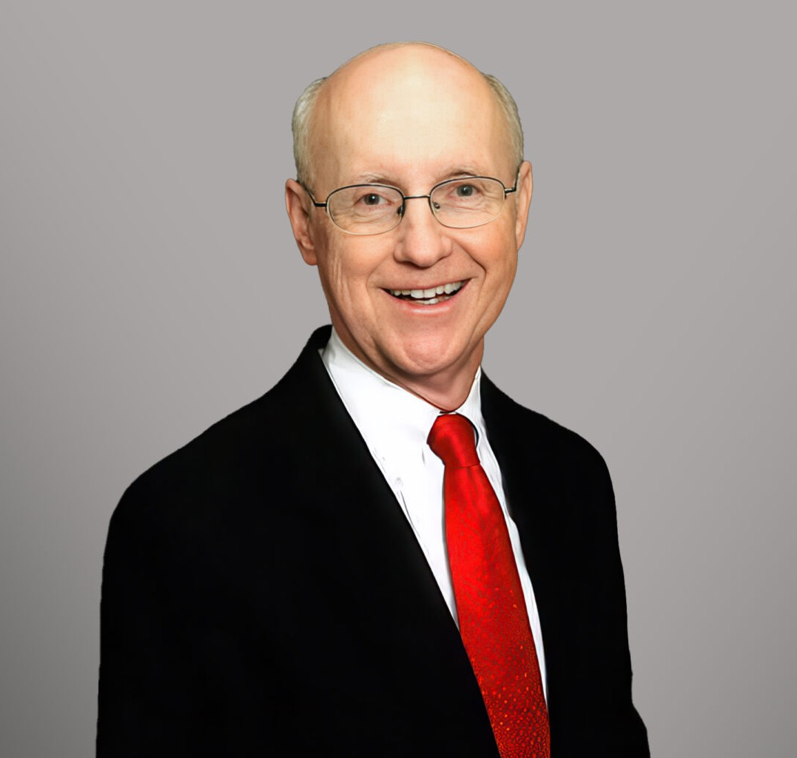
A. EMORY WISHON III
A. EMORY WISHON III
Of Counsel
Business & Finance
Fresno
P: 559.446.3281
F: 559.432.4590
ewishon@fennemorelaw.com
Emory Wishon III is an Attorney in Fennemore’s Business & Finance practice group, where he counsels clients on estate planning, real estate, and business matters. With decades of
experience, Emory provides comprehensive guidance in structuring and managing business
enterprises, including partnerships, corporations, limited liability companies, and joint ventures.

His real estate practice encompasses purchase and sale transactions, escrow matters, real estate development ventures, and representation of both borrowers and lenders in financing for residential, office, commercial, and industrial projects. In addition, Emory has developed a
robust estate planning practice, advising clients on estate tax minimization, probate, trust
administration, charitable giving, and lifetime planning services such as wills, living trusts, and powers of attorney. His thoughtful counsel helps individuals and families preserve and transfer wealth across generations.
Beyond his legal practice, Emory is deeply engaged in the Central Valley community, where he has held numerous leadership roles. As a Member of the Board of Governors for Fresno State since 1996, he served as Chair in 2008 to 2011 and as Investment Committee Chair for 19 years, He has been a Board Member of Murphy Bank since 2000 and contributes his insights in regional entrepreneurial activities through Fresno State and other groups.

EDUCATION

J.D., Stanford Law School
M.B.A., Finance, University of California, Berkeley B.S., Brown University

AREAS OF PRACTICE

Business & Finance Real Estate
Estate Planning

PROFESSIONAL AND COMMUNITY ACTIVITIES

Chairman, California State University Fresno, Foundation Board of Governors, 2008–2011; Board Member, 1996–Present
Chairman, Investment Committee, California State University, Fresno, Foundation Board of Governors, 2000–2008, 2015–Present
Board Member, Murphy Bank, 2000–Present Board Member, HubUx, 2020
Board Member, Solar Negotiators, Solar Maintenance Pros, 2019 to Present
Chair, New California Ventures LLC (a Fresno State venture investment fund), 2016–2019
Chair, Central Valley Angel Group (a regional entrepreneurial investment group), 2015–Present Chairman, CSUF School of Social Sciences Advisory Committee, 1994–2006
Board Member, Kenneth Maddy Institute, CSUF, 1999–2005 Board Member, Fresno Business Council, 1999–2001
Committee Chair, Capital Campaign, Ronald McDonald House, 1999–2000 Board Member, Court Facilities Foundation of Fresno County, 1998–2004 Board Member, Central Sierra Historical Society, 1997– Present
President, Fresno Chamber of Commerce, 1997, Board Member, 1994–1999 Chair, San Joaquin Country Club 1983-1985, Board Member 1981-1985 Trustee Emeritus, Past President, Fresno Metropolitan Museum, 1995–2008 President, Fresno Historical Society, 1984

ADMISSIONS

California

