
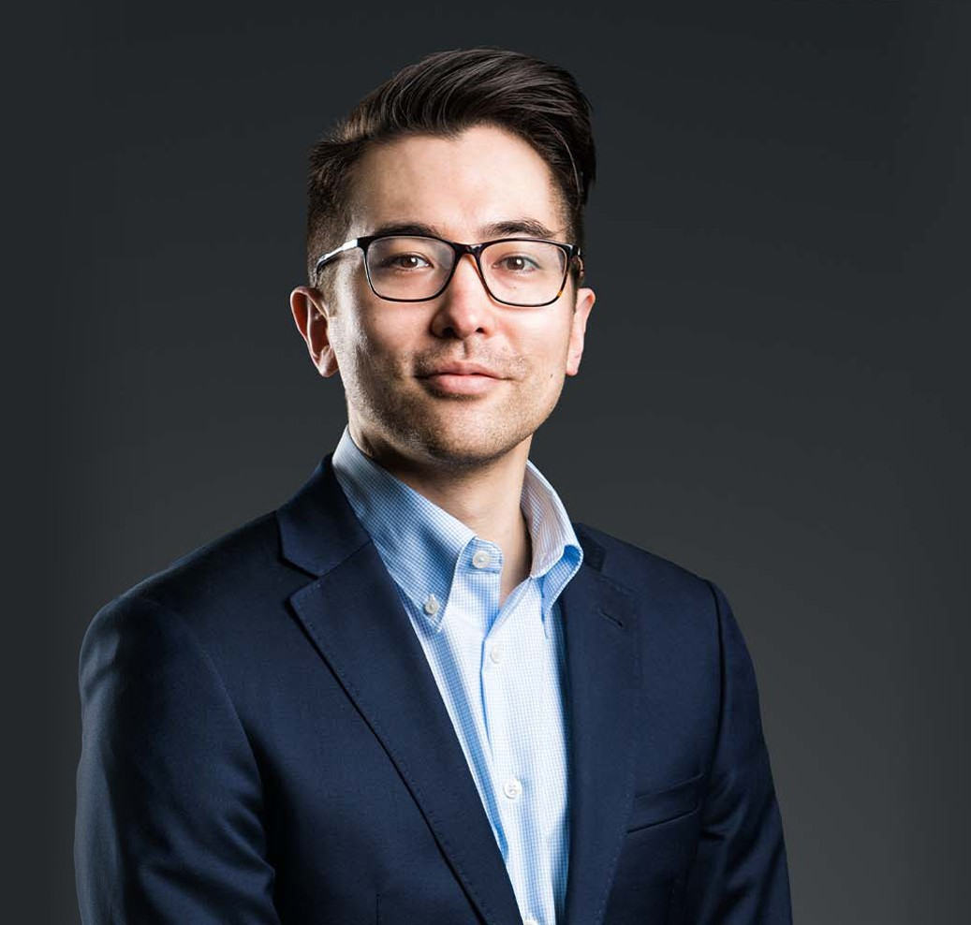
Brandin A. Inouye is an associate in Fennemore’s Fresno office and a member of the firm’s Business & Finance and Intellectual Property practice groups. He is a transactional attorney who works with clients on business transactions, commercial contracts, mergers and acquisitions, venture capital transactions, secured lending, corporate governance, and regulatory compliance matters.
BRANDIN A. INOUYE
Associate
Business & Finance
Fresno
P: 559.446.3234
F: 559.432.4590
binouye@fennemorelaw.com
“
The Devil is in the details, but so is salvation.
- Adm. Hyman G. Rickover
BRANDIN A. INOUYE
”
Brandin represents companies, business owners, investors, and lenders in drafting, reviewing, and negotiating transaction documents and commercial agreements. His work includes financing
documents, acquisition agreements, and other contracts that support business operations and strategic transactions. He also advises on regulatory issues, including matters involving the California Department of Insurance, and intellectual property considerations that arise in commercial transactions.
Before becoming a lawyer, Brandin served for six years in the U.S. Navy, where he operated nuclear power plants aboard the USS Enterprise. He later worked in the power plant construction industry in Chicago. Brandin earned his J.D. from Georgetown University Law Center and his bachelor’s degree from the University of California, Los Angeles.
Outside of work, Brandin enjoys spending time with family, reading, and traveling.

EDUCATION

J.D., Georgetown University Law Center B.A., University of California, Los Angeles

AREAS OF PRACTICE

Business & Finance Intellectual Property Apparel & Fashion Mergers & Acquisitions

AWARDS AND HONORS
Northern California Super Lawyers® Rising Stars®, 2025-2026
Best Lawyers in America®, Ones to Watch, Mergers and Acquisitions Law, 2024-2026, – Business Organizations (including LLCs and Partnerships),
Corporate Law, Intellectual Property Law, 2026

ARTICLES AND PRESENTATIONS

Interview, “The attention to detail developed in the nuclear navy helped prepare me for the legal profession.,” Fennemore Blog, November 11, 2021

ADMISSIONS

California

