
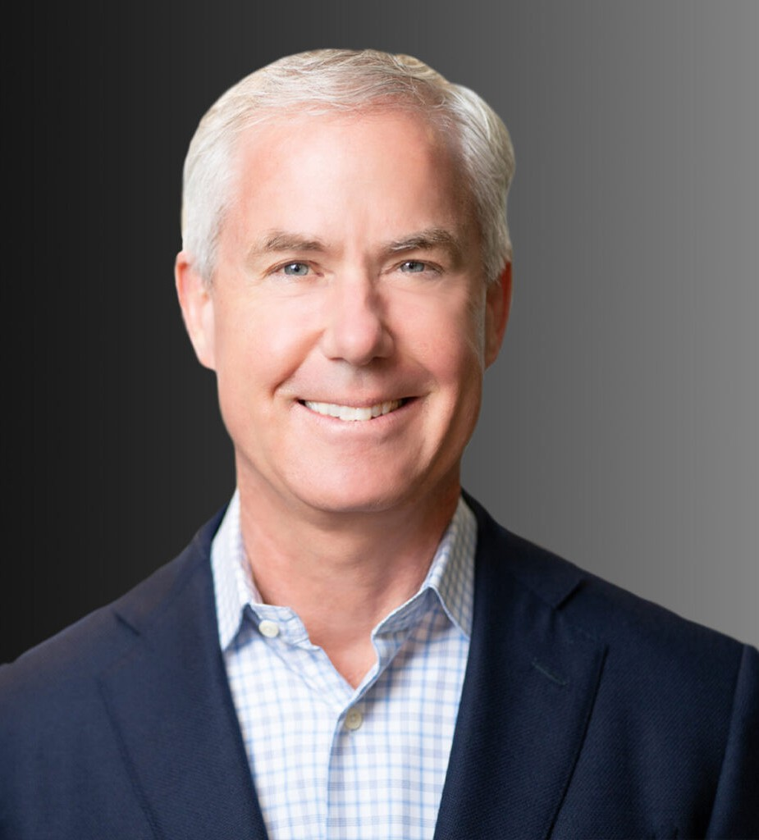
Carl has a diverse background as a trial lawyer, with a particular focus on real estate matters, business entity disputes, and representations involving investment funds. As a real estate litigator, he represents commercial landlords and tenants, developers and homebuilders, title and escrow companies, property managers, and purchasers and sellers of real property. Carl also has substantial experience in matters involving the ownership and management of business entities and investment funds, including prosecuting and defending breach of fiduciary duty claims. He previously served as General Counsel to a $5 billion SEC Registered Investment Adviser. Carl speaks frequently on subjects relating to his practice.
CARL D. CIOCHON
Director
Business Litigation
Oakland
P: 510.622.7536 F: 510.834.6600

Phoenix
P: 602.916.5000 F: 602.916.5000
cciochon@fennemorelaw.com
“
Run when you can, walk if you have to, crawl if you must; just never give up.
- Dean Karnazes
CARL D. CIOCHON
”
Following law school, he clerked for the Hon. Richard M. Bilby, United States District Judge, District of Arizona. Carl is a competitive distance runner and completed seven consecutive Boston Marathons from 2009 – 2015.

EDUCATION

J.D., University of California College of the Law, San Francisco, cum laude
B.A., University of California, Los Angeles, cum laude
Order of the Coif

AREAS OF PRACTICE

OTHER EXPERIENCE

Real Estate Litigation Title Insurance
Business Litigation Estate Litigation Real Estate

REPRESENTATIVE CASES

Obtained unanimous jury verdict in favor of commercial landlord in lease dispute with one of California’s largest cannabis companies.
Obtained dismissal of lawsuit alleging that escrow holder owed duties to purchaser beyond those specified in the escrow instructions.
Successfully prosecuted claim that owner of apartment complex breached development agreement by selling the property prior to completion of the project.
Obtained dismissal of federal RICO class action alleging that residential property manager improperly withheld tenant security deposits. Subsequently settled related state court class action entirely through insurer contributions.
company.
Tried to successful conclusion homebuilder’s claims against neighboring gun club for trespass and nuisance, obtaining $2.3 million judgment and permanent injunctive relief. Successfully defended judgment on appeal.
Obtained dismissal of extended family members’ claim to $60+ million share of proceeds from the sale of family business.
In pro bono matter, won summary adjudication that hard-money lender’s loan to elderly widow violated California’s Anti-Predatory Lending Law.
Obtained dismissal of lawsuit against national fitness center alleging breach of purported contract to operate spa on fitness center premises.
Procured emergency injunctive relief preventing state agency from improperly revoking client’s approval to operate EMT training programs.

AWARDS AND HONORS

Northern California Super Lawyers®, 2015-2023
San Francisco Lawyers’ Committee for Civil Rights, Keta Taylor Colby Award, 1996

ARTICLES AND PRESENTATIONS

Author, “Commercial Evictions in the Era of COVID-19”, JDSupra, June 2020 Presenter, “Guarantor Liability 2020,” Law PracticeCLE, February 2020 Presenter, “Guarantor Liability 101,” myLawCLE, February 2019

Presenter, “Fundamental of Real Estate Title & Conveyance,” myLawCLE, March 2018
Presenter, “It’s a Jungle Out There: Minimizing Litigation Risks in Your Commercial Real Estate Deals,” Wendel Rosen LLP, October 2017
Presenter, “Guarantor Liability 2017,” myLawCLE, October 2017

PROFESSIONAL AND COMMUNITY ACTIVITIES

Member, California Land Title Association Member, American Business Trial Lawyers
Member, Former Executive Committee, Trial Practice Section, Alameda County Bar Association Member, Board of Directors, Carma Technologies, Ltd.

ADMISSIONS

California
U.S. District Court, Central District of California
U.S. District Court, Eastern District of California
U.S. District Court, Northern District of California
U.S. Court of Appeals, Ninth Circuit

*Licensed to practice in California only

