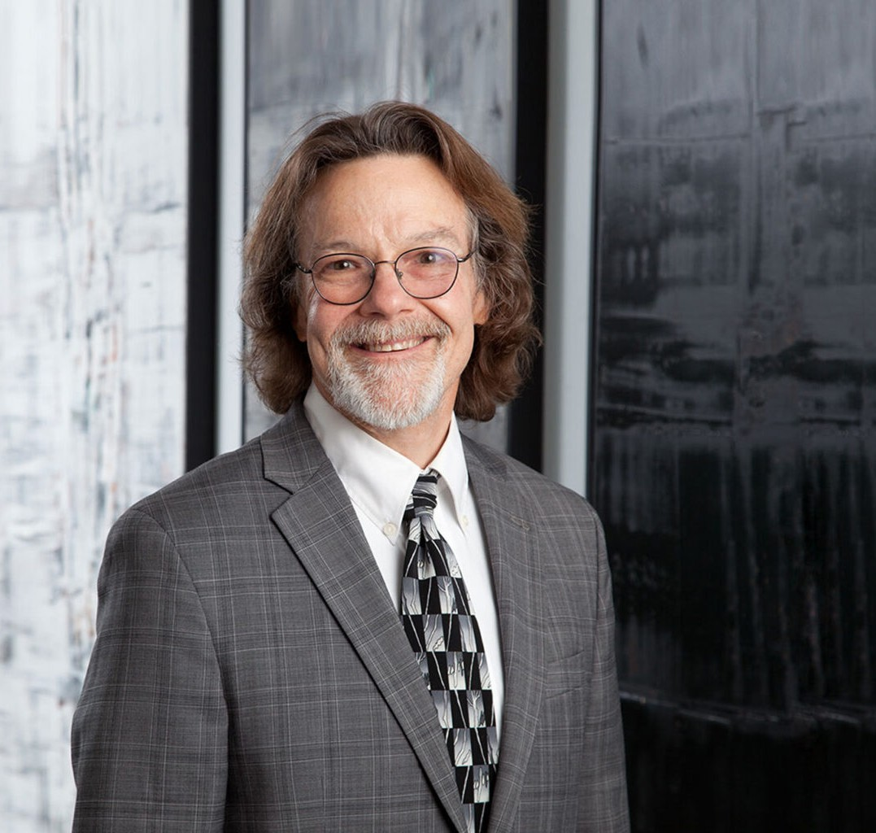

CHRISTOPHER L. CALLAHAN
Director
Business Litigation

Phoenix
P: 602.916.5310 F: 602.916.5510
ccallahan@fennemorelaw.com

CHRISTOPHER L. CALLAHAN
Chris practices in the areas of environmental, toxic tort and commercial litigation. He has extensive experience with complex, multi-party, multi-claim litigation, including class actions and mass actions. He has represented product manufacturers, waste disposal entities and employers in a variety of toxic tort and environmental matters involving groundwater contamination, airborne emissions and workplace exposure to toxic chemicals. In these contexts, Chris has counseled clients and has defended claims for personal injuries, medical surveillance damages and property damage.
Chris also has extensive experience in the representation of private clubs. This experience involves not only litigation, but also representation on transactional matters involving governance documents and member relations.
In addition, Chris has defended clients against governmental enforcement actions and citizen suits under various federal and state environmental statutes, including but not limited to the Comprehensive Environmental Response, Compensation and Liability Act (CERCLA), the Water Quality Assurance Revolving Fund (WQARF), the Clean Water Act, the Safe Drinking Water Act and the Underground Storage Tank Act. He has assisted his clients in obtaining insurance coverage for various types of claims, including those involving environmental and toxic tort
liabilities.

Chris has also represented clients for more than thirty years in various forms of dispute resolution involving prescriptive rights, property diminution claims and issues arising from commercial and residential real estate development. Chris served as a Judge Pro Tempore for the Maricopa County Superior Court for approximately 20 years, where he gained extensive experience as a mediator. He supplemented this experience with studies at the Strauss Institute for Dispute Resolution at Pepperdine University.
Away from work, Chris enjoys watching Sun Devil football, and enjoying all of the outdoor activities offered by the great State of Arizona.

EDUCATION

J.D., University of California, Los Angeles School of Law

B.S., Arizona State University Order of the Coif
Internship, The Honorable William Matthew Byrne, U.S. District Court, Southern District of California, 1983
Clerkship, The Honorable Anthony M. Kennedy, U.S. Court of Appeals, Ninth Circuit, 1984-1985

AREAS OF PRACTICE

OTHER EXPERIENCE

Business and Personal Injury Torts Litigation
Mediation and Arbitration Product Liability
Real Estate Litigation

Business Litigation Professional Liability Construction Law Natural Resources

AWARDS AND HONORS
Best Lawyers in America®, Commercial Litigation, Litigation – Environmental, Mass Tort Litigation, Class Actions – Defendants, Product Liability Litigation – Defendants, 2013-2025
Southwest Super Lawyers®, Environmental Litigation, 2014-2021
Benchmark Litigation, Local Litigation Star, 2012-2019
Best Lawyers®, Lawyer of the Year, Mass Tort Litigation/Class Actions-Defendants, 2015
Arizona’s Top Lawyers, Alternative Dispute Resolution, AZ Business Magazine, 2014
AV® Preeminent™ Peer Review Rated (the highest rating available), by Martindale-Hubbell

ARTICLES AND PRESENTATIONS
Best Lawyers in America®, Mass Tort Litigation/Class Actions – Defendants, 2023 Quoted, “Business Briefcase,” Peoria Times, May 21, 2020

PROFESSIONAL AND COMMUNITY ACTIVITIES

Member, State Bar of Arizona
Former Judge Pro Tempore, Maricopa County Superior Court

ADMISSIONS
Arizona
U.S. District Court, District of Arizona
U.S. Court of Appeals, Ninth Circuit

