
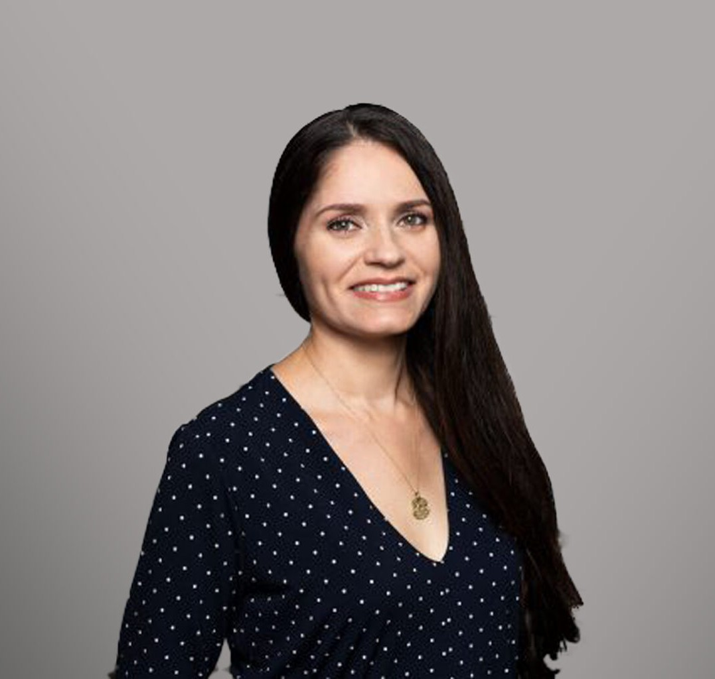
CLAUDINE LALONDE
Paralegal
Business Litigation

CLAUDIN“E LALONDE
Fresno
P: 559.432.4500 F: 559.432.4590
clalonde@fennemorelaw.com

Be curious. Be present. Embrace uncertainty. - Anonymous ”

Claudine Lalonde is a paralegal for our firm, providing professional work product with attention to detail in a timely manner. She attended the City College of San Francisco, California, and received her Paralegal Certificate from Cañada College, in Redwood City, California. Claudine is a member of the Fresno County Legal Professionals Association, a former member of the
Fresno County Women Lawyers, and a former member of the Central California Bankruptcy Association.
With a passion for helping people, Claudine began her legal career in the Bay Area while working as a receptionist and filing clerk. She was amused by the legal papers she read, which inevitably ignited her curiosity in personal injury and family law matters, thus leading her on a path redirecting her focus from architecture/interior design coursework to paralegal studies. She takes great pride in knowing that at the end of the day she can provide top-notch work and assurance in helping our clients with their legal needs.
Claudine recharges while reading or being in nature, and exercise always helps boost her mood. She enjoys cultural foods and art, and spending time with like-minded people.

EDUCATION

B.A., City College of San Francisco Paralegal Certification, Cañada College

AREAS OF PRACTICE

Business Litigation

Financial Restructuring

PROFESSIONAL AND COMMUNITY ACTIVITIES

Fresno County Legal Professions Association, 2014-present Fresno County Women Lawyers, 2019-2020
Central California Bankruptcy Association, 2011-2018

ADMISSIONS

*Not licensed to the practice of law

