
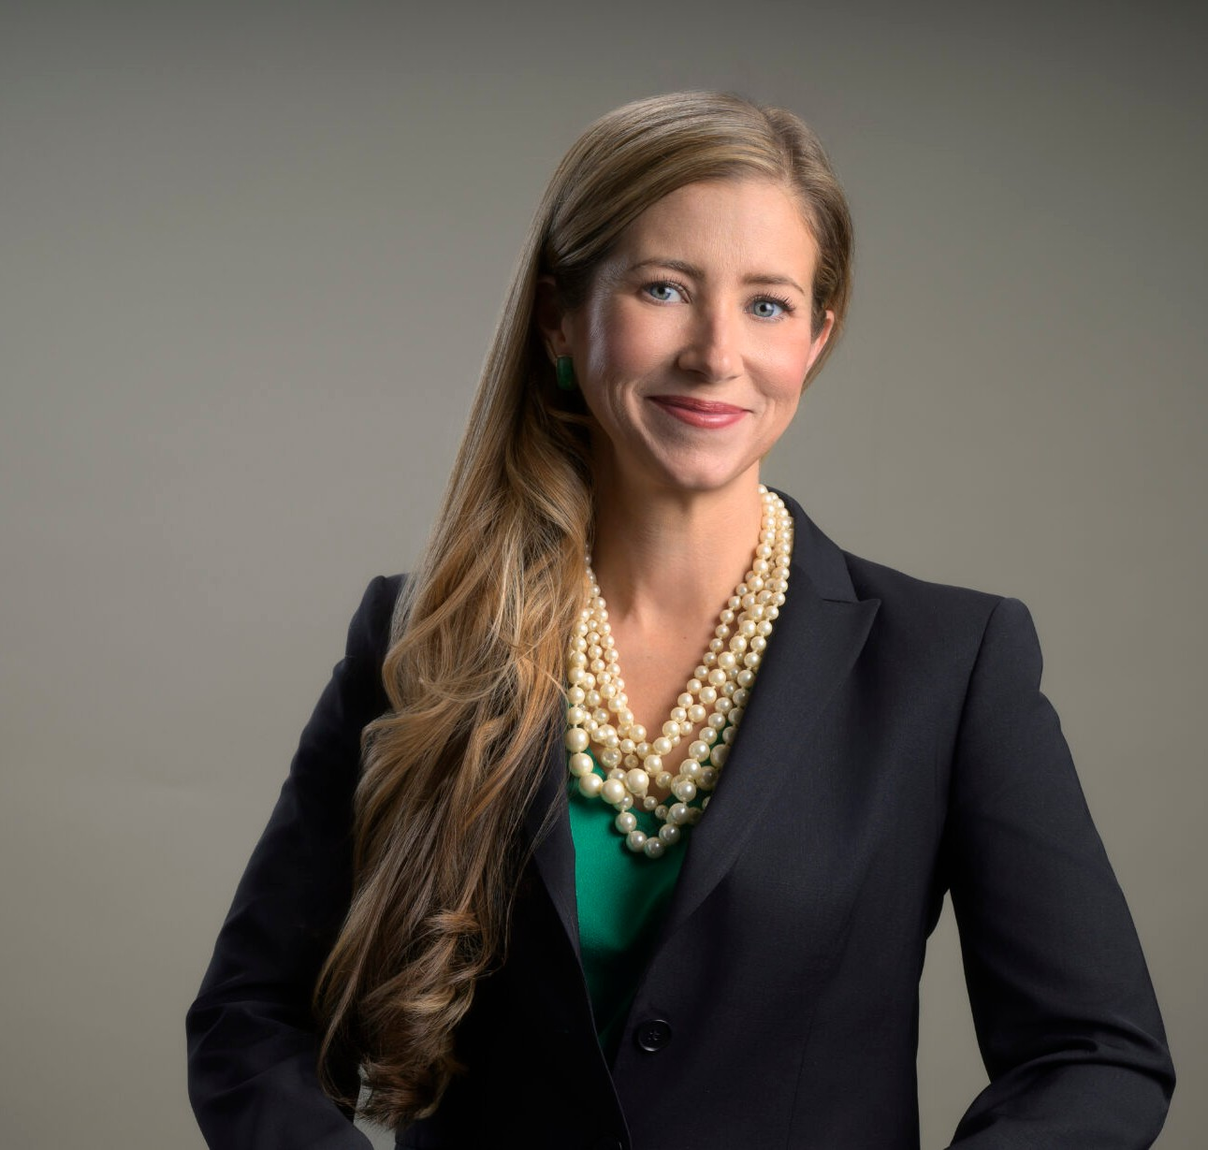
Courtney is a director in our Reno office, and her practice focuses on business litigation,
COURTNEY MILLER O’MARA
Director
Business Litigation
Reno
P: 775.788.2205
F: 775.788.2206
comara@fennemorelaw.com
“
Even paradise must have rules.
-Mary Oliver, Long Life
COURTNEY MILLER O'MARA
”
creditors’ rights and bankruptcy litigation, and trusts and estates matters, including planning, administration, and litigation
In recent years, her practice has included substantial litigation involving rights under commercial loans, both inside and outside of bankruptcy. She has also worked extensively on litigation matters involving contract and business disputes.
Courtney approaches each case like a puzzle; while some are more complex than others, it is the challenge of solving the puzzle that intrigues her. She takes a practical approach to the law, and carefully outlines options and obligations to her clients.
Courtney is experienced in helping clients navigate civil discovery, including depositions and expert issues. She has helped obtain many favorable results for her clients, including millions of dollars in judgments, dismissal of claims through dispositive motions, favorable settlements and other victories.
In her spare time, Courtney enjoys gardening, running, the beauty of Lake Tahoe and spending time with her family.

EDUCATION

- J.D., University of Southern California, Gould School of Law
- B.A., University of Notre Dame, magna cum laude

- Judicial Clerkship, Honorable Robert A. McQuaid, Jr., United States Magistrate for the District of Nevada
- Judicial Extern, Honorable Justice Michael Nott, California Court of Appeal, 2nd District
- Production Editor, The Southern California Review of Law and Women’s Rights

AREAS OF PRACTICE

OTHER EXPERIENCE

- Commercial Contingency Litigation
- Litigation
- Mediation and Arbitration
- Real Estate Litigation
- Trust and Estate Litigation

- Business Litigation
- Estate Litigation
- Estate Planning
- Financial Restructuring
- Trusts & Estates

AWARDS AND HONORS
- Best Lawyers in America®, Lawyer of the Year, Litigation – Real Estate, 2026
- Best Lawyers in America®, Commercial Litigation, 2020-2026
- Outstanding Woman Attorney, Northern Nevada Women Lawyers Association, and the Washoe County Bar Association, 2026
- 2025 Top Rank Attorney List, Nevada Business Magazine
- Mountain States Super Lawyers®, Business Litigation, Estate Litigation, Estate Planning, Financial Restructuring, Trusts & Estates, 2024-2025
- “Legal Elite,” Nevada Business Magazine, 2011-2022
- Benchmark Litigation, 40 & Under Hot List, 2018-2020
- Mountain States Super Lawyers Rising Stars®, 2010, 2015-2020
- Twenty Under 40, Reno Tahoe Young Professional Network/Reno Gazette-Journal, 2015
- Nevada Women’s Fund Woman of Achievement, 2013

ARTICLES AND PRESENTATIONS

- Co-Author, “Planning for the digital future: Cryptocurrency in estate planning,” Las Vegas Review-Journal, September 15, 2025

- Interview, “Inspiring the Next Generation of Female Attorneys: A Conversation with Courtney Miller O’Mara,” Fennemore Blog, March 27, 2025
- Interview, “Empowering Women in the Legal Arena: A Conversation with Courtney Miller O’Mara,” Fennemore Blog, March 8, 2024
- Featured, “Woman Suing Parents for Secretly Spending Her College Fund Backed Online,” Newsweek, March 23, 2023
- Interview, “A Conversation On Leadership & Life In The Law With Courtney Miller O’Mara,” Fennemore Blog, November 17, 2022
- Interview, “Death Disputes/Post-Mortem Creditor Claims,” KKOH, February 4, 2021
- Quoted, “Eviction Moratorium Phase-Out Begins,” Nevada Public Radio, July 8, 2020
- Speaker, “Forms of Administration and When They Are Used,” “First Steps and Notices, Executor Duties, Opening the Estate,” “Marshalling the Assets,” “Estate and Trust Contests, Disputes,
Challenges,” Estate Administration Bootcamp, National Business Institute Seminar, August 5-6, 2019
- Speaker, “Probate and Trust Essentials for Realtors,” June 13, 2019
- Speaker, “What Every Realtor Should Know About Probate,” May 23, 2019
- Speaker, “What Every Realtor Should Know About Probate Trusts & Powers of Attorney,” April 4-5, 2019
- Speaker, “Levitate Probate: What Every Nevada Realtor Should Know About Probate,” Master Class, August 7, 2018
- Interview, “Lawyers in Love,” The Good Life, July 2018
- Author, “Document Preservation Obligations When Litigation is on the Horizon,” Northern Nevada Law Journal, November 6, 2017
- Speaker, “Maintaining the Estate and Preparing Assets for Distribution,” “Beneficiary
Distributions, Final Account and Closing of the Estate,” National Business Institute Seminar, September 12, 2017
- Interview, “Grow Nevada Team Radio,” KFOY (Reno, Nevada), October 14, 2015

PROFESSIONAL AND COMMUNITY ACTIVITIES

- Member, Washoe County Bar Association
- Member, Probate Bar Association of Washoe County
- Member, Northern Nevada Women Lawyers Association
- Member, Probate Section, State Bar of Nevada
- Board Member, Development Committee, Nevada Discovery Museum
- Secretary and Member of the Board of Trustees, Casa de Vida, 2013-2017
- Co-President, Northern Nevada Bankruptcy Bar Association, 2013-2015
- Member, Local Rules Committee, United States Bankruptcy Court for the District of Nevada, 2015
- Graduate, Chamber of Commerce’s Leadership Reno-Sparks program, 2010

- Member, Bruce R. Thompson Chapter, American Inns of Court, Associate, 2006-2008, 2010; Barrister, 2011-2014
- Social Chair, Young Lawyers Section, State Bar of Nevada, 2007-2010
- Notre Dame Club of Northern Nevada, President, 2007-2010; Service Chair, 2006-2007

ADMISSIONS

- Nevada

