
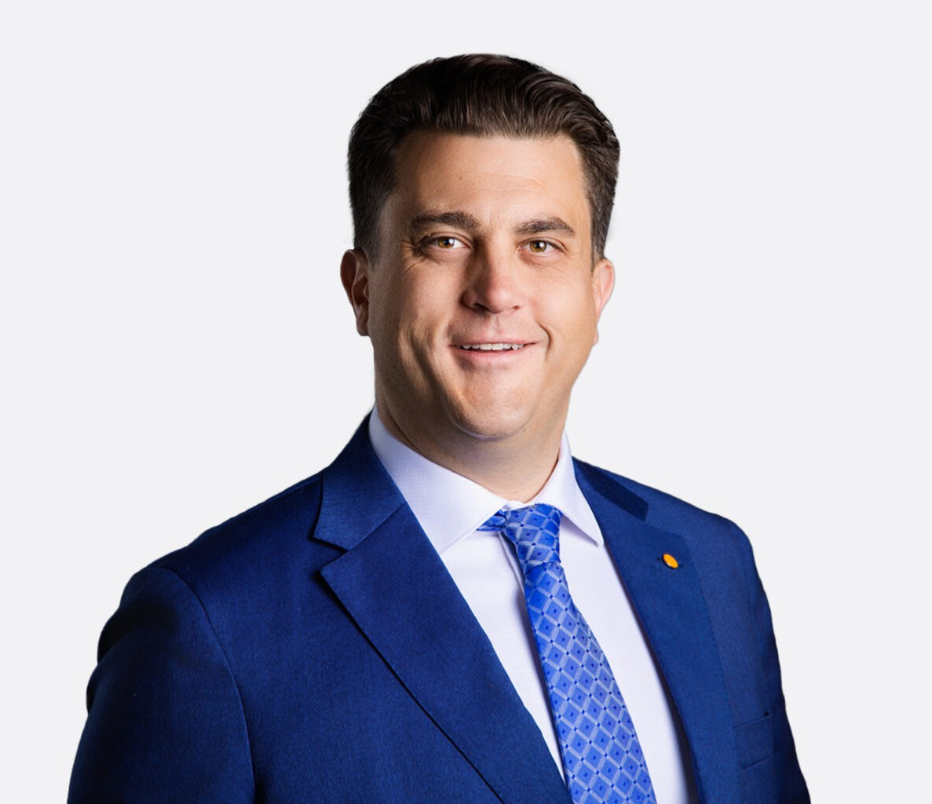
DAVID REIGNIER
DAVID REIGNIER
Associate
Business & Finance
Vacaville
P: 707.399.4282
F: 707.207.7955
dreignier@fennemorelaw.com
David Reignier is a California business and estate planning attorney at Fennemore, representing business owners, entrepreneurs, and families throughout the Bay Area on legal strategy, business operations, succession planning, and wealth transition. Based in Northern California and raised in Vallejo, he brings a strong local perspective and a practical understanding of the legal needs facing closely held businesses and individuals.
David advises clients on business formation, entity selection, corporate governance, and ongoing compliance, as well as real estate and real property agreements. He also assists with wealth transfer through comprehensive estate planning, trust creation, and succession
strategies. His practice focuses on helping clients manage risk, maintain compliance, and build sustainable plans for growth and succession.
Working with clients at all stages—from startup formation to established operations—David provides guidance tailored to each phase of the business lifecycle. He regularly counsels business owners across the Bay Area on structuring operations, navigating legal obligations, and integrating business and estate planning goals.
Before joining Fennemore, David practiced at a boutique estate planning firm in Napa, California, where he handled a range of business and estate planning matters for individuals and families throughout the region. David earned his Juris Doctor from the University of San
Francisco, School of Law, and is admitted to the State Bar of California. During law school, he served as a law clerk to the Honorable Daniel J. Healy of the Solano County Superior Court, where he gained experience in courtroom proceedings and judicial decision-making.
In addition to his legal practice, David has served as Chief Executive Officer of the D’Lonier Foundation since 2009, a nonprofit organization dedicated to advancing public education. Under his leadership, the foundation has supported international education initiatives, funded scholarships, and established a university endowment for study-abroad programs.
David remains actively involved in the local community through mentorship and service, including work with the Jesse Bethel High School Law Academy in Vallejo, the American Foundation for Suicide Prevention, and the Rotary Club of Benicia.

EDUCATION

J.D., University of San Francisco, School of Law M.A., Northeastern University
Study Abroad, The Politics of Global Conflict Resolution, Université de Genève – Uni Mail B.A., University of California, Davis

AREAS OF PRACTICE

Business & Finance Trusts & Estates

REPRESENTATIVE MATTERS

Assisted in Seller representation of a $30 million acquisition of a company.

AWARDS AND HONORS

Departmental Citation for academic excellence in Political Science, University of California, Davis

ARTICLES AND PRESENTATIONS

Presenter,” The Use of Blockchain Technology and Artificial Intelligence as a Mechanism to Prevent Corporate Fraud,” Blockchain Symposium, University of San Francisco, School of Law

PROFESSIONAL AND COMMUNITY ACTIVITIES

Chief Executive Officer, D’Lonier Foundation Mentor, Jesse Bethel High School Law Academy
Volunteer, American Foundation for Suicide Prevention Member, Rotary Club of Benicia
Member, State Bar of California

ADMISSIONS

California

LANGUAGES

Italian

