
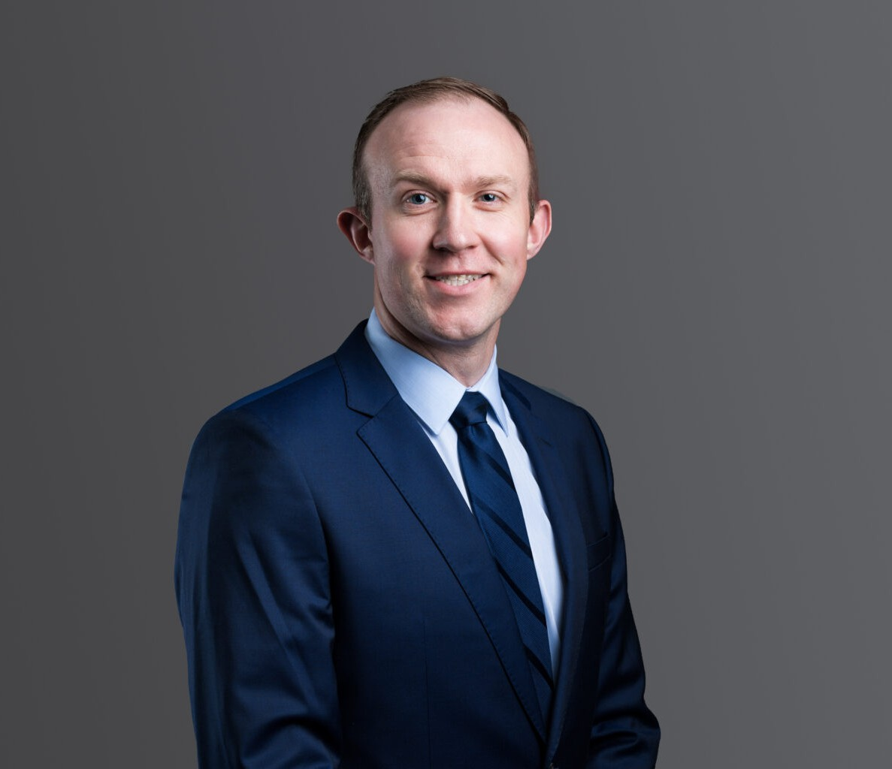
DAVID SIECK
DAVID SIECK
Associate
Labor & Employment
Phoenix
P: 602.916.5334 F: 602.916.5999
dsieck@fennemorelaw.com
“
We choose to go to the Moon this decade and do the other things, not because they are easy, but because they are hard.
John F. Kennedy
”
David Sieck is an Associate attorney in the firm’s Labor & Employment and Employee Benefits/ERISA practice groups based in the Phoenix office. His practice encompasses both litigation and counseling on behalf of management across a broad range of labor and
employment matters, as well as employee benefits and ERISA-related issues.

David’s employment practice focuses on litigation involving discrimination and retaliation claims, disability accommodation matters, wage and hour disputes, and other claims arising under applicable federal, state, and local statutes. In addition to litigation, he regularly advises employers on the development and implementation of workplace policies, employee
handbooks, and employment agreements, with an emphasis on practical compliance and risk mitigation.
David also maintains a robust employee benefits practice. He represents employers, plan sponsors, and fiduciaries in litigation and counseling matters arising under the Employee
Retirement Income Security Act of 1974, as amended (ERISA), the Internal Revenue Code, and the Multiemployer Pension Plan Amendments Act. In his counseling role, David advises clients on plan governance and administration, including regulatory compliance for qualified retirement plans and welfare benefit plans. He regularly works directly with plan fiduciaries and has experience representing clients before the Internal Revenue Service and the United States
Department of Labor and in benefits related litigation matters. Prior to joining Fennemore, David represented a number of multiemployer pension (including 401(k) plans), health and welfare
plans, and apprenticeship plans. In that role, he developed significant experience in employer contribution issues, withdrawal liability, and plan administration matters.
Born and raised in Spokane, Washington, David considers himself a counselor at law. He’s comfortable in a room with employees on one side, and management on the other – and he

has the ability to understand, relate to and speak to both sides in a meaningful way that solves problems and finds solutions. His passion for employment and benefits law serve David well, and he enjoys the mix of transactional and litigation work needed by his clients – with an eye towards constantly improving and learning more.
Outside of work, you’d better be a warrior if you want to keep up with David. He’s a Triathlete who has completed several full-iron distance Triathlons and numerous half-iron distance races,
and he has his sights set on the world’s most famous triathlon: the Ironman World Championship. David enjoys adventuring and traveling with his wife and spending time with his Alaskan Malamute and tuxedo cat.

EDUCATION

J.D., Gonzaga University School of Law, magna cum laude
B.A., Washington State University

AREAS OF PRACTICE

Labor & Employment ERISA

REPRESENTATIVE MATTERS

Defended Walker Specialty Construction against more than $5 million in withdrawal liability payments related to its cessation of work within a union pension plan’s jurisdiction. As a result of a unanimous win in the Ninth Circuit Court of Appeals, Walker had no withdrawal liability and received reimbursement for the payments it made during the litigation, plus interest.

AWARDS AND HONORS

50 Emerging Leaders in Arizona Law to Watch, AZ Big Media, 2026
Super Lawyers® Rising Stars, 2020-2026

ARTICLES AND PRESENTATIONS

Speaker, “What Employers Need to Know About Immigration Compliance,” Greater Phoenix Chamber – AZ in Focus, March 12, 2026
Co-Author, “The ‘No Tax’ Overtime Myth: Employer Payroll and Reporting Obligations Under the One Big Beautiful Bill Act Explained,” Fennemore Blog, February 16, 2026
Presenter, “Employment & Employee-Benefits Issues in the Construction Industry – Federal &
Arizona Considerations, Arizona State Bar Construction Law Section Luncheon CLE,” January 13, 2026
Co-Author, “Navigating employment policy shifts in Trump 2.0,” AZ Big Media, November 17, 2025
Co-Author, “Trump 2.0 era brings pro-business, anti-DEI shift for employers,” AZ Capitol Times, November 7, 2025
Co-Author, “Policy Reset in Washington: What HR and In-House Counsel Must Do Now,” Greater Phoenix InBusiness Magazine, November 4, 2025

Co-Author, “Navigating Employment Policy Shifts in Trump 2.0,” Fennemore Blog, October 30, 2025
Presenter, “Navigating Current Challenges for Employers,” Fennemore’s Labor & Employment Insights, October 22, 2025
Co-Author, “The One Big Beautiful Bill: What Employers Need to Know,” Greater Phoenix Chamber, October 8, 2025
Speaker, “One Big Beautiful Bill: What Employers Need to Know,” Chandler Chamber of Commerce Public Policy Series, September 12, 2025
Co-Author, “One Big Beautiful bill: What employers need to know,” BLR, August 20, 2025
Speaker, One Big Beautiful Bill: What Employers Need to Know, Greater Phoenix Chamber – AZ in Focus, August 6, 2025
Co-Author, “‘One Big Beautiful Bill’ – what employers need to know,” AZ Big Media, July 26, 2025
Co-Author, “Supreme Court Makes It Easier For Plaintiffs To Sue Plan Fiduciaries,” Fennemore Blog, April 21, 2025
Co-Author, Justices Likely To Stay In ERISA’s Bounds On Pleadings, Law360, February 12, 2025
Co-Author, Buying Or Selling A Business? Don’t Forget To Look Out For These Employee Benefits Issues!, Fennemore Blog, June 26, 2024
Author, “California civil penalties await Arizona employers enforcing noncompete clauses across state lines,” Phoenix Business Journal, April 1, 2024
Co-Author “New 401(k) Plan Rules Impose Mandatory Eligibility Requirements for Part-Time Employees in 2024,” Fennemore Client Alert, October 5, 2023
Co-Author “Roth Catch-Up Contributions Under SECURE 2.0: The IRS Delays New Requirements to 2026,” Fennemore Client Alert, September 6, 2023
Co-Author “Health Plans Must Attest They Have No “Gag Clause” By End of 2023: It’s Time To Check Your Service Provider Agreement,” Fennemore Client Alert, August 24, 2023

PROFESSIONAL AND COMMUNITY ACTIVITIES

Board Member and Volunteer for Play for Gracie Foundation, Spokane, WA, 2014-2019

ADMISSIONS

Arizona Washington
U.S. District Court, District of Arizona
U.S. District Court, Eastern District of Washington
U.S. District Court, Western District of Washington
U.S. Bankruptcy Court, Eastern District of Washington
U.S. Bankruptcy Court, Western District of Washington
U.S. Courts of Appeals, 9th Circuit

