
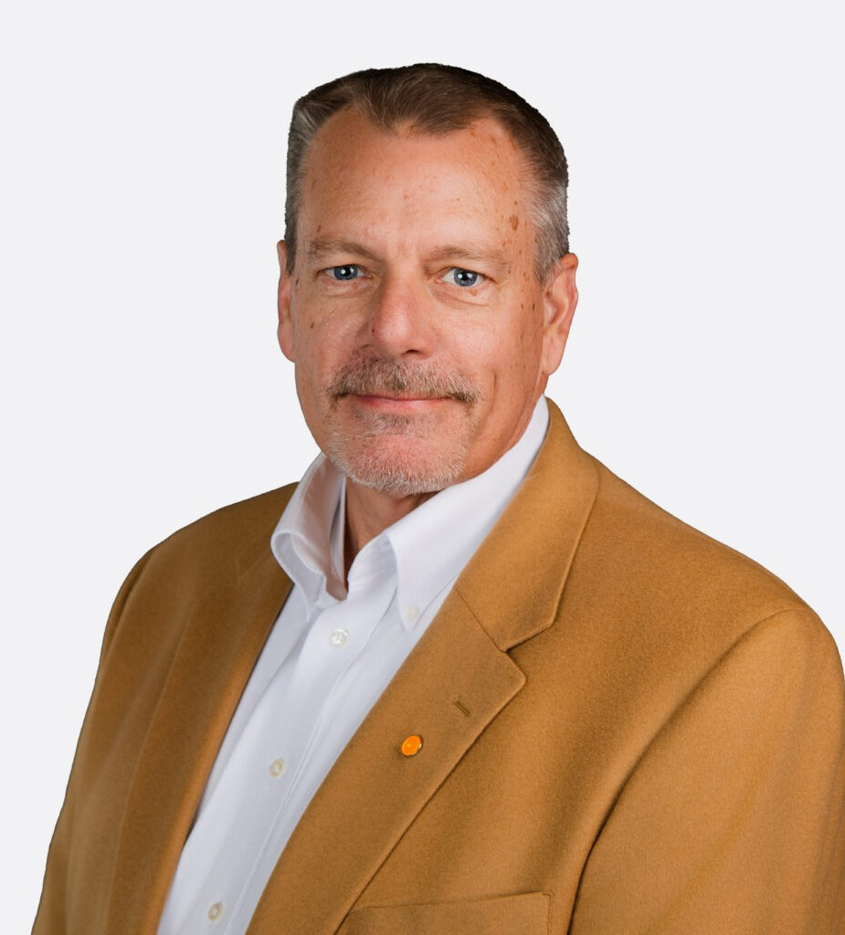
DOUGLAS C. SPLETTER
DOUGLAS C. SPLETTER
Of Counsel
Trusts & Estates
Sacramento
P: 707.432.4407
F: 707.207.7955

Vacaville
P: 707.432.4407 F: 707.207.7955
dspletter@fennemorelaw.com
Douglas C. Spletter is an attorney in Fennemore’s trusts and estates practice, advising
individuals, families, and business owners across California on estate planning, probate, and trust administration. Based in California, he provides guidance on protecting assets, planning for wealth transfer, and navigating the legal and tax considerations involved in estate and trust
matters.

He is a Certified Specialist in Estate Planning, Probate and Trust Law by the State Bar of California Board of Legal Specialization, a designation held by a limited number of attorneys in the state and recognized as a mark of advanced knowledge and experience in these areas.
Before joining Fennemore, Doug had a private practice in Oregon and California, later establishing his work in Solano County, where he built strong relationships with clients and the local community. He valued the opportunity to work directly with individuals and families on a wide range of legal matters. At Fennemore, he continues to serve clients throughout California, combining a personalized approach with the firm’s broader platform, technology resources, and forward-looking approach to legal services.

EDUCATION

Certified Specialist in Estate Planning, Trust & Probate Law, State Bar of California Board of Legal Specialization
LL.M, University of Washington School of Law J.D., Whittier Law School
B.A., Arizona State University

AREAS OF PRACTICE

Trusts & Estates

PROFESSIONAL AND COMMUNITY ACTIVITIES

Member, Solano County Bar Association Member, Vacaville Sunrise Rotary
Member, Roseville Chamber of Commerce Member, Roseville Rotary Club

ADMISSIONS

California
U.S. District Court for the Eastern District of California

