
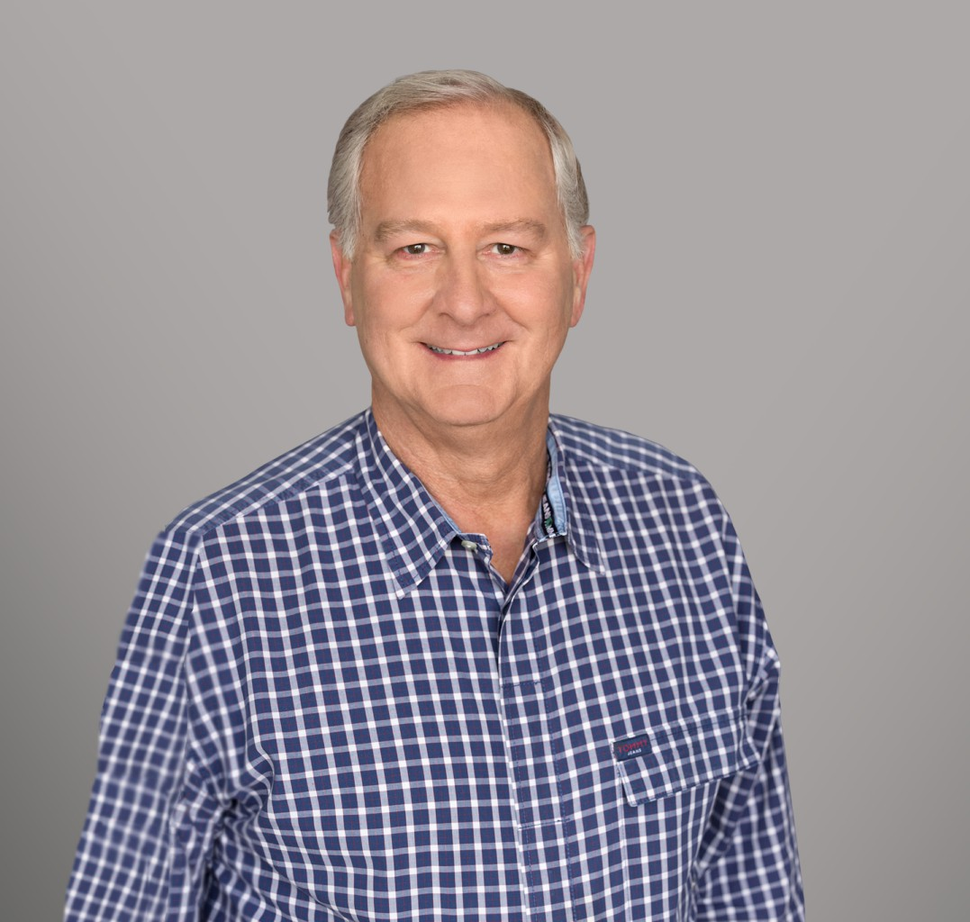
DOUGLAS L. YOUMANS
DOUGLAS L. YOUMANS
Director
Business & Finance
Sacramento
P: 916.920.5286
F: 916.920.5286
dyoumans@fennemorelaw.com
Douglas Youmans, with over 40 years of experience, practices in business, estate, real estate, and tax planning and controversy work. His practice is designed to offer comprehensive legal solutions, catering to the multifaceted needs of individuals, executives, and business owners navigating the legal system. This integrated approach ensures clients receive thorough legal advice, covering various aspects of their professional and personal legal requirements.
In addition to directly serving clients, Douglas offers legal services to primary attorneys,
accountants, financial advisors, and other representatives. His proactive legal risk management strategies are a cornerstone of his practice, aiming to foresee and mitigate legal issues before they arise, thus providing clients with peace of mind and safeguarding their interests.

EDUCATION

J.D., University of the Pacific, McGeorge School of Law M.B.A., Taxation, Golden Gate University
B.A., Temple University, magna cum laude

AREAS OF PRACTICE

OTHER EXPERIENCE

Tax Planning and Controversy Resolution
Business Planning, including Mergers & Acquisitions Trust Administration
Business & Finance Mergers & Acquisitions Real Estate
Tax Law

Trusts & Estates Estate Planning

AWARDS AND HONORS

AV Preeminent 5.0 Peer Review Rated by Martindale-Hubbell
Recipient of the 2015 V Judson Klein award, which the Tax Section of the California State Bar awards to a distinguished attorney, based on their achievements and service to the Bar
Northern California Super Lawyers®, Tax Law, 2014-2026

ARTICLES AND PRESENTATIONS

Co-Author, “Treasury Suspends Enforcement of Corporate Transparency Act & Proposes Narrowed Scope,” Fennemore Blog, March 5, 2025
Co-Author, “Client Alert: Corporate Transparency Act Compliance – New Filing Deadline & Compliance Tool,” Fennemore Blog, February 20, 2025
Co-Author, “Nationwide Injunction Temporarily Halts Corporate Transparency Act BOIR Filing Requirements: What You Need to Know,” Fennemore Blog, December 5, 2024

PROFESSIONAL AND COMMUNITY ACTIVITIES

Member, State Bar of California
Chair, Executive Committee of the Taxation Section of the State Bar of California, 2012-2013
Chair of the Corporations and other Business Entities Committee of the State Bar of California Taxation Section
Member, State Bar of California Probate, Practice Management and Tax Sections Member, American Bar Association
Member, Sacramento County Bar Association Member, Society of California Accountants (SCA) Member, California Society of CPAs (CALCPA) Member, American Institute of CPAs (AICPA)
Author and paper presenter for several of the California State Bar Taxation Section’s Annual delegations to Washington D.C.
Charter Member and Former Chair, Internal Revenue Service Sacramento District Practitioners Liaison Committee
Charter Member, Franchise Tax Board Advisory Group Adjunct Professor, Golden Gate University
Adjunct Professor, Sacramento State University

ADMISSIONS

California State Bar (Certified Specialist, Taxation Law)

U.S. Supreme Court
U.S. Courts of Appeal for the Seventh and Ninth Circuits
U.S. District Court, Eastern District of California
U.S. Tax Court

