
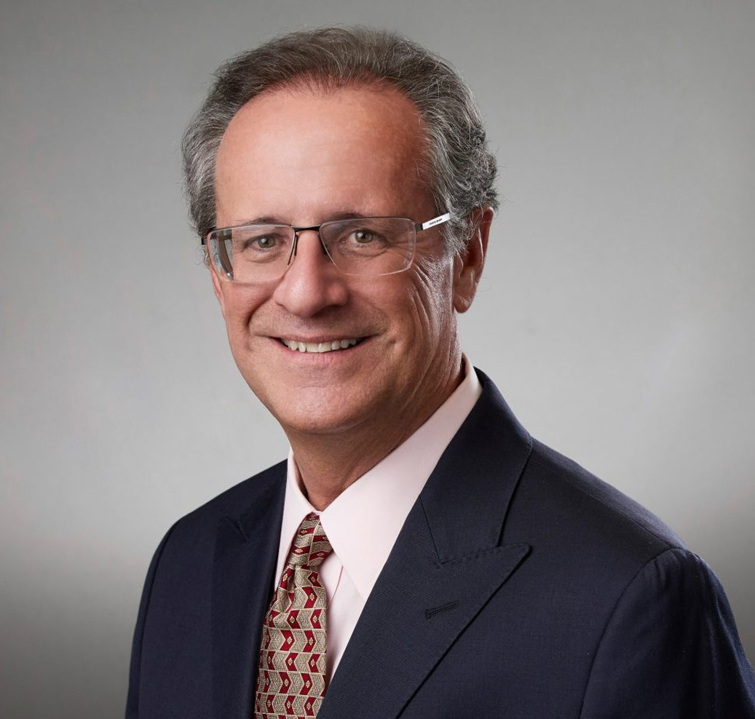
ERNEST E. RIFFENBURGH
ERNEST E.
RIFFENBURGH
Director
Real Estate
Inland Empire
P: 909.890.4499
F: 909.890.9877
eriffenburgh@fennemorelaw.com
“
Change is the law of life. And those who look only to the past or present are certain to miss the future.
- John F. Kennedy
”
Ernest (“Ernie”) Riffenburgh is a director in our San Bernardino office with extensive experience in the purchase, sale, leasing, and subdivision of commercial, industrial, mining, and recreation and resort real property, as well as the resolution of title issues, mapping, easements, licenses, and property rights derived from government agencies. His practice also includes analysis and appeal of real property tax assessments. Ernie is often called upon to analyze and resolve title and real property tax issues on behalf of national retail, railroad, commercial, industrial, and mining development clients. His in-depth knowledge and experience inspire his approach to
complex title and real property tax issues, leading to innovative and effective solutions.

Ernie brings the same drive to his community efforts apparent in his law practice. He is an active member of the Desert Valleys Builders Association serving the Coachella and Imperial Valleys.
During his chairmanship of the Board of Directors of the Ontario Chamber of Commerce, the highly successful Southern California Aviation Summit was established, bringing recognition to the Ontario Airport as a national transportation hub, drawing attendees from throughout the western United States, including representatives from the airline industry, major metropolitan cities and
agencies, as well as many well-known private enterprises.

Also established during Ernie’s chairmanship was the Government Affairs Council, advocating to government entities on behalf of the business community.

EDUCATION

J.D., University of Southern California, Gould School of Law

B.S., University of Southern California, cum laude

AREAS OF PRACTICE
OTHER EXPERIENCE

Real Property Taxation Real Estate Transactions

Real Estate

REPRESENTATIVE MATTERS

Lead counsel to developer of a major regional commercial airport
Local real estate general counsel to international convenience store retail chain.
Negotiate and document dozens of mining property acquisitions, sales, leases, and rights-of-way for major mineral development companies.
Lead counsel to two major private mining/industrial railroad lines.
Led team of attorneys and paralegals in extensive County, State and Federal records analysis.
Identify and resolve title and permit issues with private parties and local, State, and Federal agencies.
Title analysis and counsel regarding fee lands and patented and unpatented mining claims for major mineral development companies.
Led team of attorneys and paralegals in extensive County, State, and Federal records analysis.
Identify and resolve title and permit issues with private parties and local, State, and Federal agencies.
Lead real estate counsel to major Southern California medical practice (over 100 physicians), negotiating and documenting multiple Class A office building acquisitions and leases.
Negotiate and document parcel, easement, and well site acquisitions for major Southern California skiing/recreational facility.
General counsel to Southern California mutual water company for more than 25 years.

AWARDS AND HONORS

Best Lawyers, Inland Empire list, Inland Empire Magazine, 2008-2021 AV Preeminent rating, Martindale-Hubbell Peer Review

ARTICLES AND PRESENTATIONS

Interview, “Never Stop Perfecting Your Writing and Never Give Up,” Fennemore Blog, July 28, 2022

PROFESSIONAL AND COMMUNITY ACTIVITIES

Member, San Bernardino County Bar Association Member, State Bar of California
Member, American Bar Association Member, Desert Valleys Builders Association
Member, S. Green Building Council, Inland Empire Chapter, 2009 – 2013, including Board of Directors, Fall 2010 – Spring 2011; Pacific Regional Council Co-Liaison, Spring 2011; Coachella Valley Branch Liaison, Fall 2010
Member, Ontario Chamber of Commerce, 1998 – 2008, including Board of Directors, Immediate Past-Chair, 2007 – 2008; Board of Directors, Chairman, 2006 – 2007; Board of Directors, Chair-Elect, 2005 – 2006; Vice Chair, Business Division, 2004 – 2005; Board of Directors, 2001 – 2008; Chair, Business Retention & Development Committee, 1999 – 2004
Member, Rotary Club of San Bernardino Crossroads, 1986 – 2000, including President, 1992 – 1993; Fundraising Chair, 1993 – 1994; Board of Directors, 1989 – 1997
Board of Directors, San Bernardino Executives Association, 1996 – 1997 Board of Directors, Project Home Run, 1992 – 1995
Board of Directors, Senior Citizens Foundation of San Bernardino, 1991 – 1994
Delegate, Moscow Conference on Law and Bilateral Economic Cooperation, 1990 Member, USC Legion Lex Inn of Court, 1985 – 1991; Executive Committee, 1988 – 1991

ADMISSIONS

California
U.S. District Court, Central District of California

