
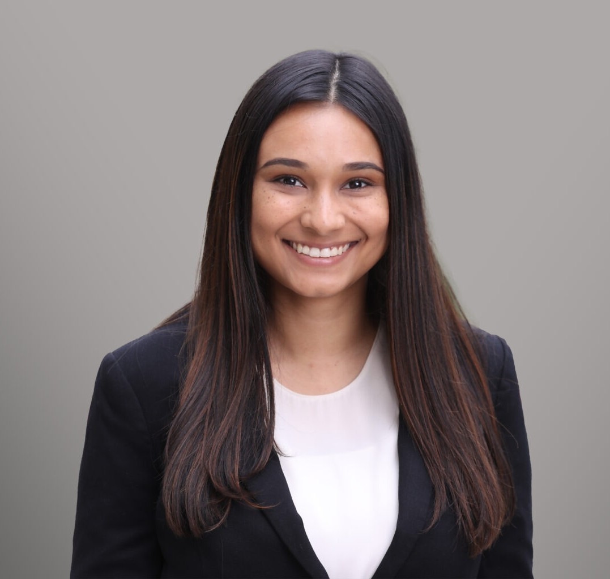
FELICITY A. BARNES
FELICITY A. BARNES
Associate
Business Litigation
Fresno
P: 559.446.3270
F: 559.432.4590
fbarnes@fennemorelaw.com
Felicity Barnes is an associate in attorney in Fennemore’s Business Litigation group. In her practice she represents businesses and employers in civil litigation matters related to commerical disputes, employment/labor disuptes, negligence, and contracts.
Prior to joining Fennemore, Felicity worked as an associate attorney for a small commercial law firm in Fresno, California. While in law school, Felicity worked at the Northern California Innocence Project assisting supervising attorneys with writs of habeas corpus, analyzing policy,
legislation, and its applicability to pending cases; and reviewed and summarized transcripts and discovery materials. Additionally, she worked as an intern for the Fresno County District Attorney’s office, and she interned for the Honorable Judge Whitehead in the Fresno Superior
Court.

EDUCATION

J.D., Santa Clara University School of Law
B.A., cum laude, California State University, Fresno

AREAS OF PRACTICE

Business Litigation

AWARDS AND HONORS

Santa Clara Law Trial Team Competitor, 2020 – 2023
First Place, San Francisco Trial Lawyers Association Competition, 2021 Semi-finalist, Texas Young Lawyers Association Competition, 2023
Fresno State Mock Trial Competitor 2017-2020 Opening Round Championship competitor, 2018
Fresno State Dog Pound Outstanding Attorney, 2018

Fresno State Dog Pound Outstanding Attorney, 2019 Fresno State Moot Court
Competed in California Western Regional, Sweet Sixteen Competitor, Quarter Finalist, 2018-2019

PROFESSIONAL AND COMMUNITY AFFILIATIONS

Role, ASI Legal Committee, 2018

ADMISSIONS

California
United States District Court for the Eastern District of California

