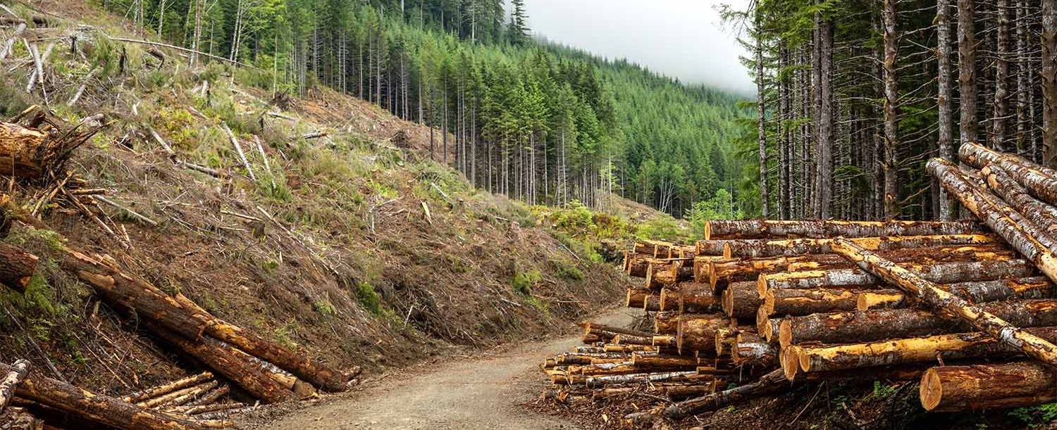

Forest Industry Law

Helping clients across the working forest economy protect land value, manage operational risk, evaluate contracts, keep operations moving, and plan for long-term growth.

LEADERSHIP


BUSINESS LITIGATION

GENERAL COUNSEL SERVICES

Lindsey Morgan
Of Counsel
Coeur d'Alene
PH 208.956.0137
FX 602.916.5999
lmorgan@fennemorel aw.com

REAL ESTATE


BUSINESS & FINANCE

Peter J. Smith IV
Idaho Managing Partner
Coeur d'Alene
PH 208.956.0145
peter.smith@fennemor elaw.com

INTRODUCTION
Fennemore’s Forest Industry group advises clients across the working forest economy, including timberland owners, forest products companies, sawmills, wood products manufacturers, forestry companies, logging contractors, haulers, biomass and restoration ventures, investors, lenders, and related service providers. Our attorneys help clients address the legal issues that arise from owning, managing, harvesting, transporting, processing, financing, and commercializing forest resources. We advise on real estate and access issues, contract review and negotiation,
transactions, succession planning, governance, labor and employment, workplace safety, insurance recovery, operational risk, and disputes. The group brings together attorneys across business, real estate, natural resources, land use, labor and employment, insurance coverage, mergers and acquisitions, and litigation. That coordinated approach allows Fennemore to
support forest industry clients with practical legal guidance tailored to land-based businesses, natural resources operations, and the commercial realities of the forestry sector.

WHAT WE DO
Fennemore helps timberland owners, operators, investors, lenders, contractors, manufacturers, and related businesses make informed decisions, reduce disruption, and protect the long-term value of their land and operations.
Our team advises on

Contract review, drafting, and negotiation

Timber supply agreements
Logging, hauling, and transportation agreements Mill service contracts
Biomass, biochar, carbon, restoration, conservation, and other forest revenue agreements Title, access, easements, boundaries, and road use
Land acquisitions, divestitures, and financing Succession planning and ownership transitions Governance and closely held business issues Conservation easements and land use constraints Regulatory compliance and natural resources issues Labor, employment, and workplace safety matters Wildfire, casualty, and operational losses
Insurance coverage and recovery
Indemnity, risk transfer, and contract disputes Restructuring and creditor issues Commercial litigation and dispute resolution
We also help clients evaluate emerging revenue opportunities involving biomass, biochar, carbon, restoration, conservation, mitigation, and other forest-related agreements. These agreements can create new value, but they can also affect title, access, financing,
management discretion, tax planning, succession, and long-term ownership. Our attorneys help clients understand those implications before they sign.
Forest industry legal issues rarely fit within one practice area. A land issue can affect operations. A contract term can affect production. A succession plan can affect governance. A biomass, biochar, carbon, or conservation agreement can affect future land value and financing. A workplace injury, fire loss, access dispute, or supply interruption can create immediate operational and legal consequences. Fennemore’s platform allows clients to work with a coordinated team that understands those connections. Our attorneys serve clients in markets with significant forestry, wood products, biomass, land management, transportation, agriculture, and natural resources activity, including Idaho, Washington, Oregon, California, and other western states.
Fennemore helps clients across the forest products sector protect land value, manage operational risk, execute transactions, review and negotiate contracts, resolve disputes, and pursue long-term opportunities across the working forest economy. If you are a timberland owner, operator, investor, or forest products business, we welcome the opportunity to talk about how Fennemore can help.

