
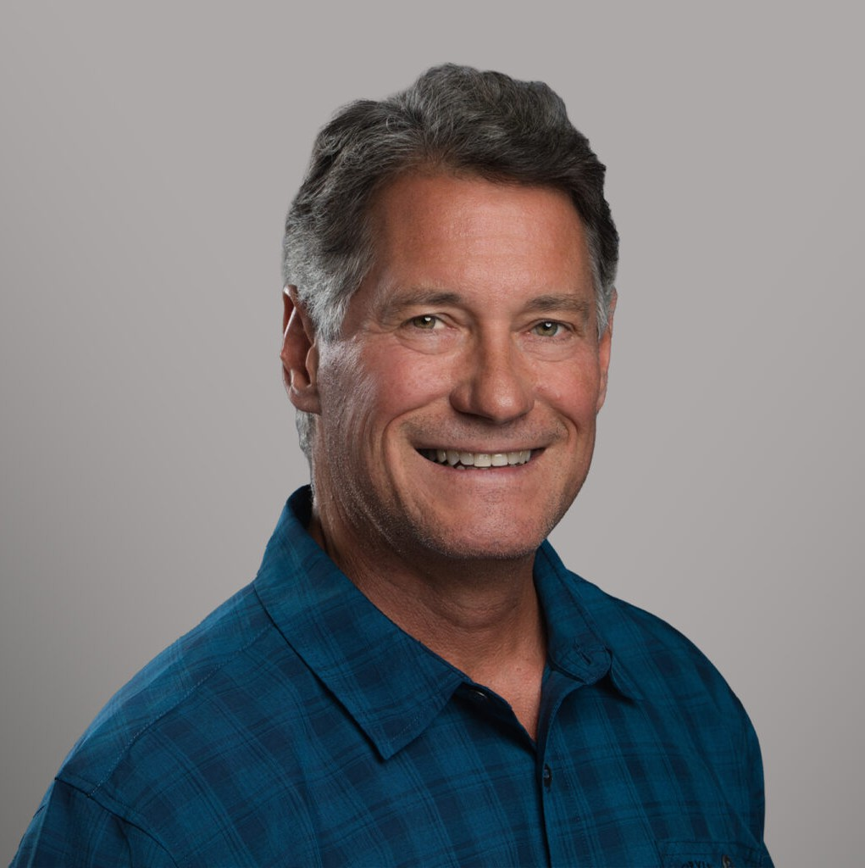
GREGORY N. MISKULIN
GREGORY N. MISKULIN
Chief Practice Group Officer

Gregory N. Miskulin
Fennemore Forward
P: 559.432.4500 F: 559.432.4590
gmiskulin@fennemorelaw.com
“
Rivers, lakes and ocean will attack you. Mountains are different. They wait for you to make a mistake.
- Tom Stienstra
”
Greg Miskulin serves as Fennemore’s Chief Practice Group Officer and is a member of the firm’s C-Suite leadership team. In this role, Greg helps guide the business performance, operational effectiveness, and strategic growth of the firm’s practice groups.
Greg works at the intersection of law firm leadership, business strategy, attorney development, and client service. He functions much like a chief operating officer at the practice group level, helping each group operate as a focused business unit with clear goals, disciplined execution, and measurable progress.
Working closely with Practice Group Leaders, Greg supports business planning, productivity analysis, staffing strategy, project management, succession planning, and operational
improvement. He also helps identify opportunities for stronger collaboration across offices and practice areas, with a particular focus on internal cross-selling, client expansion, and coordinated business development. Greg also leads the firm’s Practice Group Business
Development team, helping attorneys turn relationships, market opportunities, and client needs
into practical growth strategies. His work is grounded in a simple principle: strong law firms do not grow by accident. They grow through clarity, accountability, teamwork, and consistent
execution.

Before joining Fennemore, Greg spent 15 years in the restaurant industry as an owner-operator of a major national brand franchise. He oversaw 15 locations across California’s Central Valley and led a workforce of more than 150 employees. That experience gave him firsthand insight into the pressures business owners face every day, including operations, personnel, financial
performance, customer service, risk management, and legal decision-making.

That business background continues to shape Greg’s approach to law firm leadership. He understands that attorneys succeed when they have both strong legal skills and strong operational support. His role is to help build the structure, systems, and culture that allow lawyers, practice groups, and business professionals to perform at a high level. Greg’s leadership philosophy is practical, direct, and ownership-driven. He believes in preparation, clear
expectations, disciplined follow-through, and helping teams solve problems before they become obstacles. Whether working with attorneys, staff, or firm leadership, Greg is focused on helping people move from ideas to action and from action to results.
Outside the office, Greg is an experienced outdoorsman and mountaineer. He has spent years operating in demanding environments, from desert terrain to high-elevation alpine conditions.
He is drawn to remote places, difficult objectives, and the kind of challenge that requires
preparation, endurance, judgment, and calm decision-making. For Greg, the outdoors reflects many of the same principles that guide his professional life: plan carefully, trust the team, adapt quickly, and keep moving toward the summit.

EDUCATION

J.D., San Joaquin College of Law

ARTICLES AND PRESENTATIONS

Author, “Turning Talent into Teamwork: How Fennemore Transforms Individual Strengths into Practice Group Success,” Fennemore Blog, May 20, 2025
Author, “How to Write a Business Plan,” Fennemore Blog, December 2, 2022
Interview, “Fennemore’s Swiss Army Knife,” Fennemore Blog, October 28, 2021

PROFESSIONAL AND COMMUNITY ACTIVITIES

Member, State Bar of California Eagle Scout

ADMISSIONS

California

