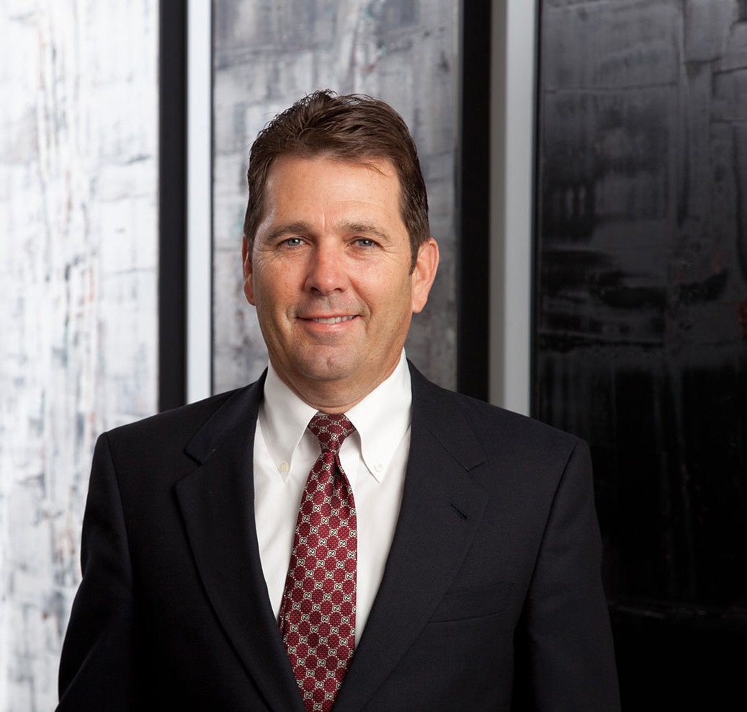

JOHN R. JEFFERIES
Director
Business Litigation

Phoenix
P: 602.916.5313 F: 602.916.5513
rjefferies@fennemorelaw.com

JOHN R. JEFFERIES
Randy practices in the areas of federal and state procurement and government contract law, as well as building and construction law. He has negotiated and litigated construction claims at the city, county, state and federal levels on behalf of general contractors and specialty
subcontractors. At the federal level, Randy has litigated claims involving defective
specifications, constructive changes, acceleration, excusable and compensable delays, differing site conditions, terminations for default, and structured settlements for terminations for the convenience of the government. He also has been involved with bid protests before the Comptroller General of the General Accounting Office, having represented both awardees and protestors.
At the local level, Randy has pursued claims against city, county and state entities in Arizona, California, New Mexico, Utah and Nevada, and has been involved in a number of bid protests involving the Arizona Procurement Office and the Arizona Department of Transportation. He also handles private construction litigation and arbitration matters involving disputes between
owners, general contractors and subcontractors, as well as performance and payment bond claims.

EDUCATION

J.D., University of Utah, S.J. Quinney College of Law B.A., University of Notre Dame
Order of the Coif

AREAS OF PRACTICE

OTHER EXPERIENCE

Litigation

Business Litigation Construction Law

Real Estate

AWARDS AND HONORS
Best Lawyers in America®, Commercial Litigation, Construction Law, Litigation – Construction, Litigation – Real Estate, 2005-2026
Best Lawyers in America®, Lawyer of the Year, Construction Law, 2018, 2026 Chambers USA, Construction: Arizona, 2026
Southwest Super Lawyers®, Construction Litigation, 2009-2016, 2020
Arizona’s Top Lawyers, Construction Litigation, AZ Business Magazine, 2014
AV® Preeminent™ Peer Review Rated (the highest rating available), by Martindale-Hubbell

PROFESSIONAL AND COMMUNITY ACTIVITIES

Member, Public Contracts Section, American Bar Association Member, State Bar of Arizona
Member, State Bar of Nevada
Past Member, Board of Governors, Construction Law Section, State Bar of Arizona

ADMISSIONS

Arizona Nevada

