
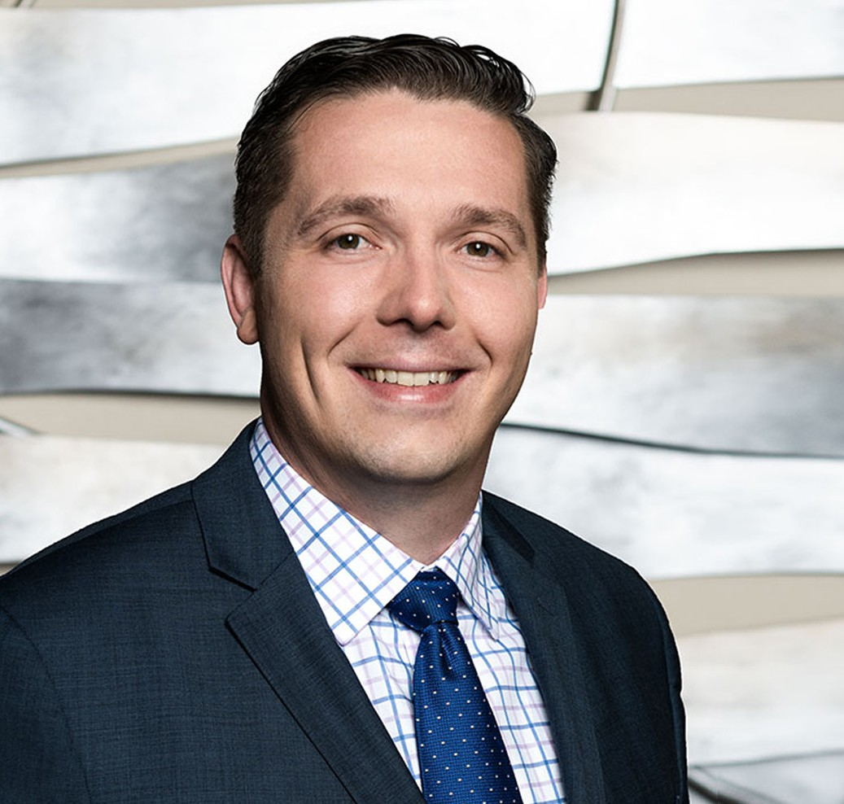
JOSEPH H. ZIMMERL
JOSEPH H. ZIMMERL
Director
Business & Finance
Fresno
P: 559.432.4500
F: 559.432.4590
jzimmerl@fennemorelaw.com
Joe Zimmerl is an attorney working out of our Fresno office where his practice focuses on agribusiness, business transactions, financing, estate planning, and trust administration.
Taking great pride in his accessibility and availability to his clients, most, if not all of his clients have his cell-phone number. In today’s business world, clients expect near instant responses to their requests, and he wants to make sure he is available to serve their needs. Joe takes great pleasure in helping his clients accomplish their goals.
Outside of work, you’ll probably find Joe spending time with his family – or heading toward the beach.

EDUCATION

- J.D., Georgetown University Law Center
- B.A., Loyola Marymount University
- Staff Member, Georgetown Environmental Law Journal

AREAS OF PRACTICE

- Business & Finance
- Estate Planning
- Trusts & Estates

ARTICLES AND PRESENTATIONS

- Featuring, “A Conversation On Life In The Legal Profession With Attorney Joseph Zimmerl,” Fennemore Blog, July 13, 2023

PROFESSIONAL AND COMMUNITY ACTIVITIES

- Member, State Bar of California, Business Law Section and Estate Planning Section
- Member, Fresno County Bar Association, Estate Planning and Business Section
- Member, Los Angeles Bar Association, Business Section and Estate Planning Section
- President, Fresno Sunset Rotary, 2019-2020

AWARDS AND HONORS

- Best Lawyers in America®, Ones to Watch, Corporate Law, Trusts and Estates, 2024-2026, Business Organizations (including LLCs and Partnerships), Project Finance Law, 2026
- Rising Star, Northern California Super Lawyers®, 2024-2025
- Northern California Super Lawyers®, 2023

ADMISSIONS

- California
- U.S. District Court Eastern District of California
- U.S. District Court Northern District of California

LANGUAGES

- Slovenian, Conversant

