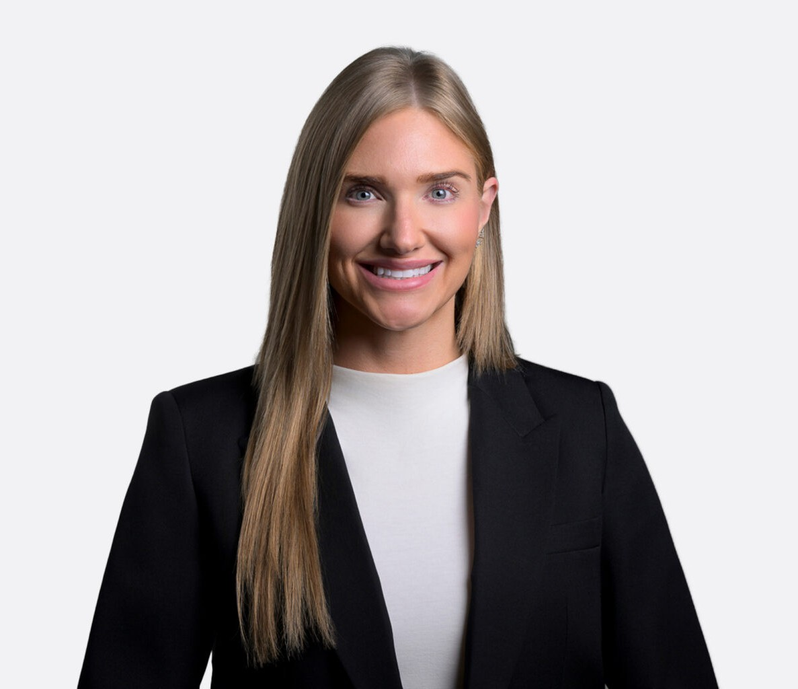

KELCI S. BINAU
Of Counsel
Gaming & Hospitality

Reno
P: 775.788.2275 F: 775.786.1177
kbinau@fennemorelaw.com

KELCI BINAU
Kelci S. Binau is a gaming and business transactions attorney at Fennemore who helps guide U.S. and international owners and operators of casinos, pari-mutuel wagering facilities, hotels and
resorts, nonrestricted and restricted gaming licensees, operators of online gaming, mobile
gaming, social gaming, sports betting and sportsbooks, skill-based gaming, manufacturers and distributors, service providers, travel centers, private equity firms, traditional and non-traditional investors, Native American tribes, and executives and key employees and gaming employees through licensing, compliance, regulatory proceedings, and complex transactions.
Clients turn to Kelci when they need a trusted advocate to represent them in licensing, approvals, and compliance assistance in the development, management, acquisition, and restructuring of gaming projects in the casino and online gaming markets. She helps clients obtain and maintain business, gaming, and liquor licenses and approvals and provides guidance throughout all steps of the process, including initial applications, investigations and
interviews, public hearings on suitability, and ongoing obligations to update regulators. She has experience with waivers or exemptions from licensing requirements on behalf of clients that do not exert the required control over the gaming enterprise.
She has assisted clients with designing their corporate structure, domesticating, merging and converting foreign and domestic entities, and acquiring state and city business licenses. She also assists with gaming trusts.
Kelci supports regulated firms with transactions, operational compliance, and licensing, permitting, and other proceedings before administrative agencies or other government bodies. She also has experience with assisting brokers and realtors with licensing and compliance requirements with the Nevada Real Estate Division, and Commercial and Residential lenders with compliance requirements with the Nevada Division of Mortgage Lending.

EDUCATION

J.D., University of the Pacific, McGeorge School of Law with Great Distinction (Top 10%), Tax and Business Concentration
The Order of the Coif, Traynor Honor Society, GPA 3.71
Law Review, Primary Editor 2017, Comment Staff Writer 2016-2017, Legislative Staff Writer 2016

Witkin Awards: Wills & Trusts, Taxation of Partnerships and S Corps, Taxation of Real Estate Transactions
Dean’s List: 2015-2016, 2016-2017, 2017-2018
Master of Education in Elementary Education, University of Nevada, Reno
Bachelor of Arts in Speech Communication, Minor in Women’s Studies, University of Nevada, Reno

AREAS OF PRACTICE

Gaming & Hospitality Business & Finance

AWARDS AND HONORS

Chambers USA, Gaming & Licensing: Nevada, 2026
Partner in Diversity, Equity and Inclusion, State Bar of Nevada, 2023-2026
The Next Generation of Women Leaders: Magnificent 7 in Legal, Compliance and Responsible Gaming, GamblingIQ, 2026
Emerging Leaders of Gaming 40 Under 40 Class of 2026, Global Gaming Business, published September 2025
The Next Generation – The Future Leaders of the Law, Lawdragon 500 X, 2025, 2024
The Best Lawyers in America®, Gaming Law, 2024-2026
The Best Lawyers in America®, Administrative & Regulatory Law, 2022-2026 Top Rank Attorneys, Nevada Business Magazine, 2024
Best In Business awards – Up & Coming Businessperson, Northern Nevada Business Weekly, 2024, 2023
10 Women Rising in Gaming Under 40, CDC Gaming, 2023 Women of Achievement Honoree, Nevada Women’s Fund, 2023

ARTICLES AND PRESENTATIONS

Quoted, “Penn Entertainment seeks technology-related licensing for M Resort,” CDC Gaming, December 9, 2025
Panel Presenter, “Sweeping Changes: The Longevity and Legacy of Sweepstakes Casinos,” NEXT.io iGaming and Sports Betting Summit, March 12, 2025
Panel Presenter, “Technology’s Impact on Gaming Compliance Programs,” Global Gaming Expo, October 7, 2024
Author, “Artificial Intelligence in the Gaming Industry – The Use We Give it, For Good or Evil,” Nevada Gaming Lawyer, 2024
Panel Presenter, “Grey Markets as a Business Plan: risks and rewards of expanding into grey markets when scaling a business,” NEXT.io iGaming and Sports Betting Summit, March 7, 2024

Quoted, “Nevada Gaming Control Board Site May Have Been Hacked,” Bonus.com, January 29, 2024
Feature Interview: “The Lady Behind the Label,” Meritas Women’s Leadership Congress, 2024
Author, “New Cybersecurity Regulations from the Nevada Gaming Commission,” Communiqué magazine, Clark County Bar Association publication, November 2023
Roundtable Leader, Sip & Social event hosted by Global Gaming Women, Global Gaming Expo, October 12, 2023
Panel Presenter, “Self-regulation for Emerging Gaming Verticals, including Esports”, International Masters of Gaming Law Spring Conference, April 26-28, 2023
Panel Presenter, “The Future of eSports in Nevada’s Gaming Industry: Betting on the Next
Generation”, Gaming Law Conference 2022, Gaming Law Section of the State Bar of Nevada, November 18, 2022
Author, “Recent Leadership and Position Changes within the Nevada Gaming Control Board,” Nevada Gaming Lawyer, September 2022
Contributor, The WRIT, Millennial Minute column, Washoe County Bar Association publication
Author, Chapter 568: Saving our Voiceless Companions, One Life at a Time, 48 U. Pac. L. Rev. 475 (2016) (University of the Pacific, McGeorge School of Law)

PROFESSIONAL AND COMMUNITY ACTIVITIES

Executive Committee, Gaming Law Section, State Bar of Nevada, 2025-2028 Board of Directors, Global Gaming Women, 2026-Present
Chair, Nominating and Governance Committee, Board of Directors, Global Gaming Women, 2026-Present
General Counsel to the Board of Directors, Global Gaming Women, January 1, 2024 – December 31, 2025
Moderator, Professional Mentorship and Career Development Lean-In Circle, Global Gaming Women
Communications and Content Liaison, Marketing Committee, Global Gaming Women Member, International Masters of Gaming Law
Member, International Association of Gaming Advisors Member, Women in Sports and Events, Las Vegas Chapter Member, Young Lawyers Division, American Bar Association Member, Northern Nevada Women Lawyers Association Member, Washoe County Bar Association
Member, Clark County Bar Association Member, State Bar of California

ADMISSIONS

California

Nevada

