
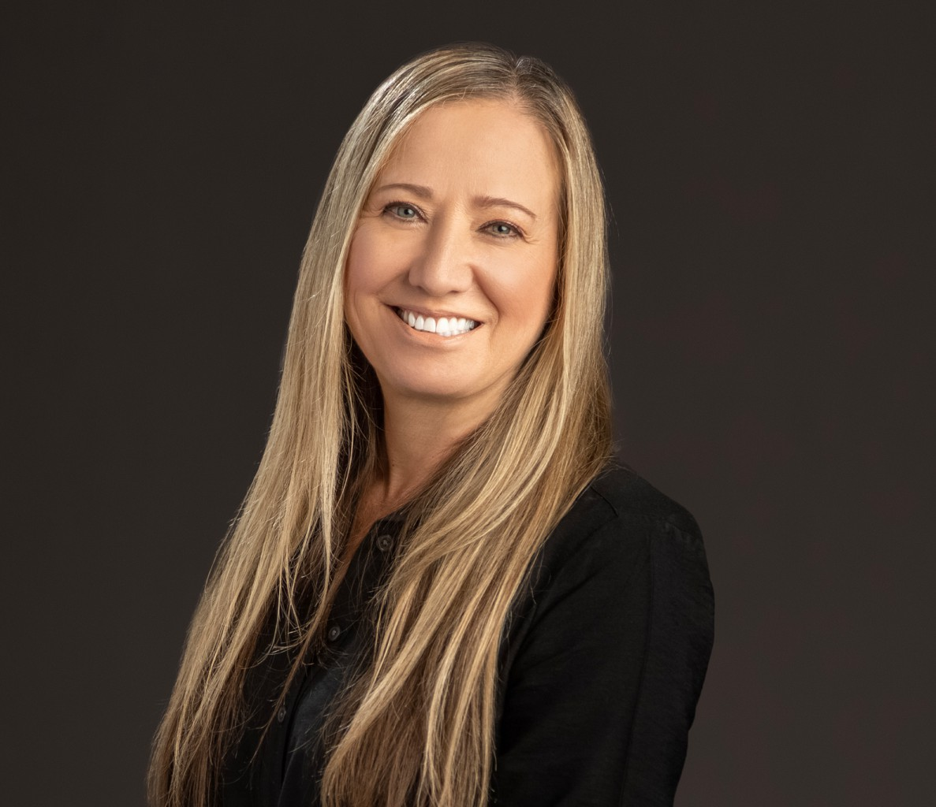
Kellene Peirsol is a paralegal who works out of our Fresno Office. Her work focuses on trust
KELLENE PEIRSOL
Paralegal
Trusts & Estates
Fresno
P: 559.432.4500
F: 559.432.4590
kpeirsol@fennemorelaw.com
“
Work smarter not harder.
Allen F. Morgenstern
KELLENE PEIRSOL
”
administrations, probate, estate planning, real estate, and trust accountings – and she loves working with numbers.
She began her career in the legal profession as a junior legal secretary, and originally wanted to be a lawyer, but decided that she was better suited for paralegal work. Kellene enjoys helping clients go through the transition of managing their estate after losing a spouse and/or parent.
She takes great pride in establishing a personal relationship with her clients – working with them, not for them.
Outside of the office, Kellene reads, works crossword puzzles (she loves to expand her vocabulary), and goes to the coast as often as possible, spending time with her family.

EDUCATION

Foothill College, Los Altos, CA
Paralegal Certificate, University of Hawaii

AREAS OF PRACTICE

Trusts & Estates Estate Planning

ADMISSIONS

*Not licensed to the practice of law

