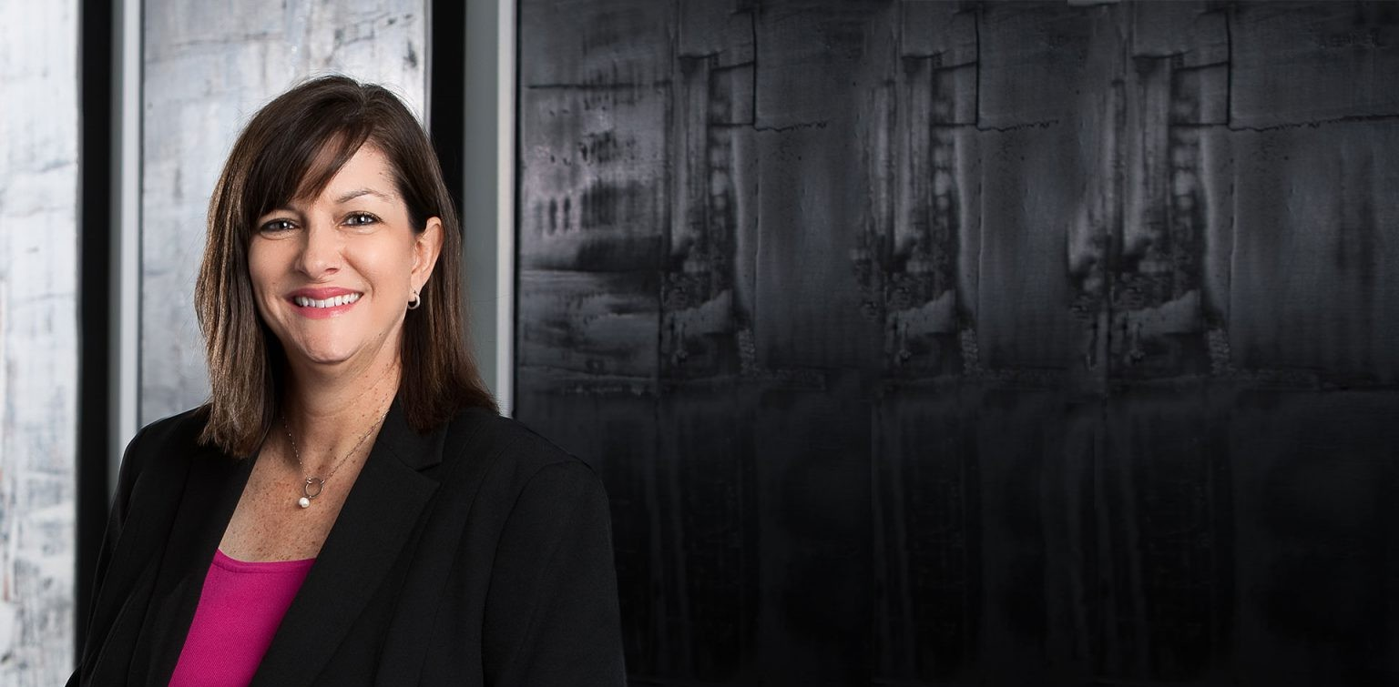

LAURA ZILMER
Pronouns: she/her
Sr. Legal Talent Administrator

Laura Zilmer

Phoenix
P: 602.916.5272 F: 602.916.5957
lzilmer@fennemorelaw.com
LAURA ZILMER
As our Sr. Legal Talent Administrator, Laura works closely with the Chief Talent Officer in managing the firm’s recruiting efforts. She serves as the firm’s main contact for law schools, search firms, and industry organizations. Laura seeks to identify, recruit, hire and develop attorneys at all levels of their careers, from summer associates to lateral hires. She helps administer the firm’s summer associate program and manages the orientation, training, mentoring, and evaluation programs of attorneys. She also assists with diversity initiatives throughout the firm.

EDUCATION

B.A., Organizational Communication, Arizona State University

ARTICLES AND PRESENTATIONS

Interview, “We look for the candidates with special sauce,” Fennemore Newsletter, October 19, 2023

PROFESSIONAL AND COMMUNITY ACTIVITIES

Member of The National Association for Law Placement (NALP)

ADMISSIONS

*Not licensed to the practice of law

