
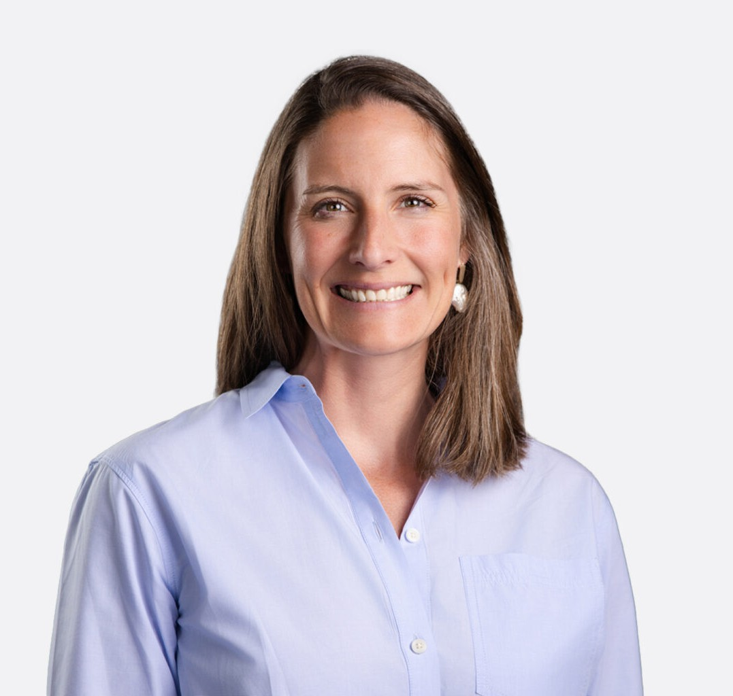
LINDSEY MORGAN
LINDSEY MORGAN
Of Counsel
Business Litigation
Coeur d’Alene
P: 208.956.0137
F: 602.916.5999
lmorgan@fennemorelaw.com
Lindsey Morgan is an Of Counsel Attorney in Fennemore’s Business Litigation practice group. She represents businesses, business owners, and industry participants in complex disputes, with a practice focused on ownership and control conflicts, commercial litigation, real estate and land related disputes, insurance issues, and outside general counsel support. She regularly handles matters involving fiduciary duties, governance failures, professional liability, insurance coverage, and business breakups. Lindsey is a leader in Fennemore’s developing Forest Industry initiative, which helps timberland owners, forest products businesses, and other working forest economy participants protect land value, manage operational risk, and execute transactions across the West.
Prior to joining Fennemore, Lindsey litigated complex commercial matters in California and Washington and served as outside general counsel for closely held businesses and professionals, advising on litigation risk, governance issues, contracts, and dispute avoidance. She has extensive experience representing insurers and insureds in insurance coverage litigation and defending real estate brokerages and their employees and agents in civil litigation. That experience informs her approach to risk allocation, dispute prevention, and active litigation
strategy.

Lindsey is admitted to practice in California, Washington, and Idaho. She is an active member of the Rotary Club of Coeur d’Alene, where she serves as co-chair of the grants committee.
Through the Idaho Academy of Leadership for Lawyers, she is also developing Coeur
Foundations, an initiative that helps North Idaho nonprofits build strong legal and governance infrastructure.
Outside of her practice, Lindsey enjoys CrossFit, golf, and gardening, and tries to keep up with her sons.

EDUCATION

J.D., University of Southern California Gould School of Law B.A., University of California, Los Angeles

AREAS OF PRACTICE

Business Litigation General Counsel Services

REPRESENTATIVE MATTERS

Oversaw representation of a privately held company in its acquisition of an $8.6 million commercial property in Tucson, Arizona, including purchase agreement negotiation, title and survey review, escrow and closing coordination, and transaction management through funding and recording.
Represented a timberland owner in a quiet title action involving disputed real property interests.
Acted as outside counsel to a forestry company and handled the preparation, review, and negotiation of commercial agreements supporting its ongoing operations, with an eye to risk management and dispute avoidance.
Represents clients in real estate and land related disputes, including matters involving title, access, easements, and ownership rights.
Represented national and regional real estate brokerages, insurance brokerages, and individual professionals in high-exposure errors and omissions and professional liability matters, including pre-litigation risk assessment, coverage analysis, and trial defense.
Defended corporate clients in multi-million-dollar commercial real estate disputes involving complex causation, insurance allocation, and cross-jurisdictional issues.
Served as defense counsel for a privately owned public utility in San Francisco, managing dozens of coordinated property damage and personal injury claims.
Obtained summary judgment for a national real estate brokerage and its agent in a non-disclosure action in Alameda County, California.
Defended a corporate executive on appeal in a breach of contract action involving international jurisdiction and enforcement of foreign judgments.
Represented a national real estate brokerage and a high-profile individual agent in a multi-million-dollar commission dispute.
Acted as liaison counsel for insurer defendants in Montrose v. Canadian Universal Insurance Co., a pollution allocation matter decided by the California Supreme Court addressing horizontal versus vertical allocation at the excess insurance level.

ARTICLES AND PRESENTATIONS

Co-Author, “From Access to Advancement: Mentorship and Sponsorship for Women Lawyers in Idaho by Lindsey A. Morgan, Kathleen M. Carr, Alycia Moss, Catherine Renshaw, and Katie
Sheftic,” Idaho State Bar Magazine, June 8, 2026
Author, “Read Before You Sign: What Forestland Owners Need to Know About Biomass, Biochar, Carbon, and Other Forest Revenue Agreements,” Fennemore Blog, June 4, 2026
Author, “Private Forest Landowners Face a Convergence of Legal and Business Risk,” Fennemore Blog, May 19, 2026
Guest Lecturer, “Legal Accountability,” North Idaho College Nursing Program, Feb. 2024

Presenter, Risk Management Seminar, Contra Costa Association of Realtor, 2019-2020

PROFESSIONAL AND COMMUNITY ACTIVITIES

Member, 2025-2026 class of the Idaho Academy of Leadership for Lawyers (IALL) Co-Chair, Grants Committee, Rotary Club of Coeur d’Alene
Member, Idaho Women Lawyers
Member, Magnet Committee, Sorensen Magnet School

ADMISSIONS

Idaho (state and federal) California (state and federal) Washington (state and federal) Ninth Circuit

