
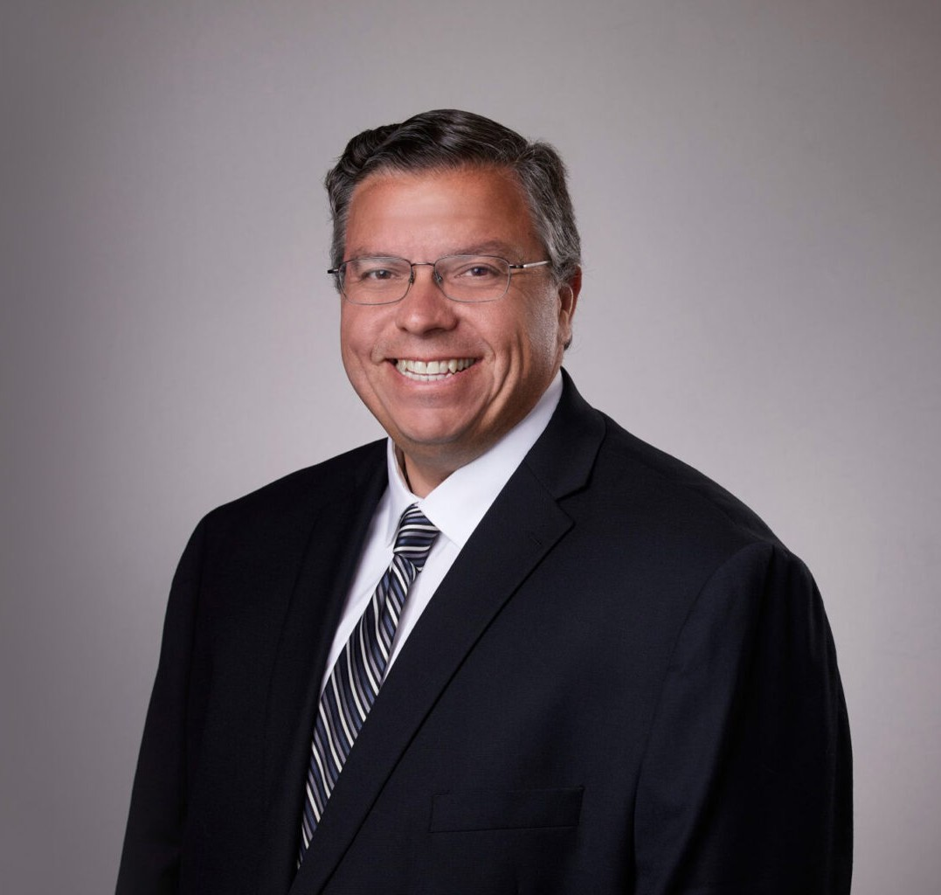
MACK ANDERSON
MACK ANDERSON
Director
Real Estate
Inland Empire
P: 909.723.1838
F: 909.890.9877
manderson@fennemorelaw.com
Mack Anderson is a director who works in our Real Estate practice group out of the firm’s San Bernardino office. His practice involves all aspects of real estate transactions, including the
acquisition, development, construction, leasing, ownership, financing, management and disposition of industrial, commercial, retail and office properties. Mack has extensive experience representing real estate developers and corporate tenants in complex industrial projects. Mack has assisted his clients to develop more than 10 million square feet of industrial space. In
addition, Mack has extensive commercial experience, representing national retail and corporate tenants with the acquisition of their properties and the negotiation of their leases.
A seasoned veteran, Mack’s lease materials are in use for commercial and retail properties throughout California and the west coast. Mack is adept at negotiating, drafting and successfully closing purchase and sale agreements, leases, development and construction agreements, reciprocal easement agreements declarations of covenants, conditions and restrictions, and loan and finance agreements.
Mack often coordinates and manages real estate development teams on behalf of his clients, including brokers, architects, engineers, consultants and contractors. Mack’s experience enables him to routinely advise clients regarding business entity formation, operations, title
matters, environmental due diligence and entitlements matters.

- Real Estate

EDUCATION

- J.D., University of Southern California Gould School of Law
- B.S., Occidental College, Biochemistry

AREAS OF PRACTICE

- Real Estate

PROFESSIONAL AND COMMUNITY ACTIVITIES

- Member, State Bar of California
- Member, San Bernardino County Bar Association

ADMISSIONS

- California
- U.S. Court of Appeals, Ninth Circuit
- U.S. District Court, Central District of California

