
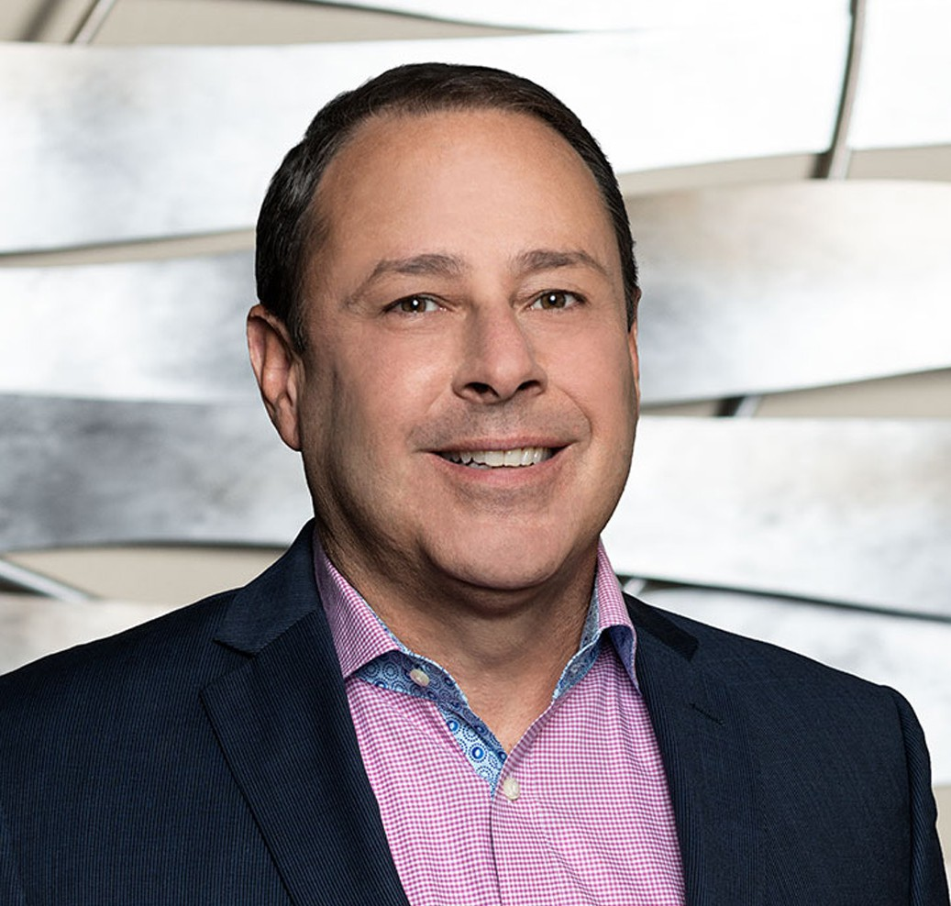
ROBERT D. TOOKOIAN
ROBERT D. TOOKOIAN
Of Counsel
Business & Finance
Fresno
P: 559.432.4500
F: 559.432.4590
rtookoian@fennemorelaw.com
Rob represents a broad range of clients in general business, transactions, contracts, healthcare law, privacy compliance, and real estate transactions. His diverse and extensive legal and business background allows Rob to counsel business owners and management providing
practical, business-oriented solutions to complex legal problems. His clients include such varied industries and service groups as healthcare providers, government entities, and food processors, as well as agribusiness, technology, and health benefit companies.
Rob serves as the firm’s Co–Chief Privacy Officer. He advises organizations on building and operating practical privacy and compliance programs that match how the business actually runs—translating fast-changing requirements into durable governance, contract and workflow solutions. Rob also serves on the Executive Committee of the Privacy Law Section of the California Lawyers Association, contributing to the strategic development of one of the most active bar-association privacy law communities in the United States. In this role, he collaborates with practitioners, regulators, and academics on education, governance, legislative tracking, and publications that support privacy professionals across California and beyond. Additionally, Rob serves as Co-Editor of the Privacy Law Journal published by the California Lawyers Association Privacy Law Section for the 2024, 2025, and volumes.
Rob began practice in the San Francisco Bay Area as counsel and General Counsel to internet and “high-tech” companies. He has been in-house counsel for start-ups, early-stage, and public companies, working on complex service and licensing agreements, compliance, real property
transactions, IP, and corporate governance, among other services.

Rob has spent the last 20-plus years working with small and midsize organizations to provide
strategic guidance on growth and transactions, as well as complex litigation, compliance, and public entity defense. In his healthcare practice, Rob assists clients with formation, contract negotiation and preparation, growth strategies, employment matters, regulatory and contractual compliance, and risk mitigation. Rob regularly counsels his clients about HIPAA,
Stark, Anti-kickback, CCPA, and other compliance matters.

Outside of work, Rob and his wife stay busy keeping up with young adult children living in three different states. He keeps active by skiing, hiking, golfing and playing and coaching rugby. Rob grew up in Fresno and has served on the boards of several local non-profit organizations,

including The United Way of Fresno County (Secretary), Charlie Keyan Armenian Community School, and CenCal Youth Sports (Chair).

EDUCATION

- J.D., Golden Gate University School of Law
- M.B.A., Golden Gate University, Ageno School of Business
- B.S., Political Economy of Natural Resources, University of California, Berkeley
- B.A., History, University of California, Berkeley

AREAS OF PRACTICE

OTHER EXPERIENCE

- Commercial Transactions
- Privacy
- Real Property
- Technology

- Business & Finance
- Labor & Employment
- Health Care
- Privacy & Data Security
- Mergers & Acquisitions
- Apparel & Fashion
- General Counsel Services

ARTICLES AND PRESENTATIONS

- Co-Editor, California Lawyers Association Privacy Section Journal, 2024 and 2025
- Author, “Privacy and Data Security Trends: Ensuring Compliance in the State of California in 2024,” Fennemore Blog, January 23, 2024
- Author, “California Attorney General Signals Enforcement of CCPA Regulations on HR Data Following Temporary Exemption’s End,” Fennemore Blog, July 27, 2023
- Author, “California Attorney General Signals Enforcement of CCPA Regulations on HR Data, Following Temporary Exemption’s End,” Fennemore Client Alert, July 27, 2023
- Presenter, “Privacy Law for Fennemore Lawyers: What you need to know,” May 19, 2023
- Interview, “A Conversation With Attorney Rob Tookoian On Lessons Learned and Life In The Legal Profession,” Fennemore Blog, March 24, 2022
- Panelist, “Understanding Data, Decision making, and Design,” CPRA Law + Tech Series
- Interview, “Pharma Group Sues Government to Keep Drug Prices Secret,” Verywell Health, October 20, 2021

- Author, “Providers Beware: The Office For Civil Rights is Making an Example of Providers That Fail to Deliver Patient Records,” Fennemore Client Alert, February 2, 2021
- Author, “SCOTUS Brings the Hammer Down on Pharmacy Benefit Managers,” Fennemore Client Alert, December 17, 2020
- Presenter, “California Consumer Privacy Act’s Application to Employers”
- Presenter, “Handling Contract Performance Issues During COVID”
- Author, “Coronavirus Aid Relief and Economic Security CARES Act Overview”
- Author, “A Brief Overview of the Paycheck Protection Program, a 100% Forgivable Loan”
- Author, “Franchises, Hotels and Restaurants, Oh My: PPP Progress”
- Author, “SBA Warns Borrowers to Double Check That They Qualify for a PPP Loan”
- Author, “SBA Clarifies Effect of Laid-off Employees in Calculating PPP Loan Forgiveness”
- Author, “SBA Provides Safe Harbor Guidance for Some PPP Loan Recipients”
- Author, “SBA Publishes PPP Loan Forgiveness Application and Some Clarifications”

PROFESSIONAL AND COMMUNITY ACTIVITIES

- Member, International Association of Privacy Professionals
- Member, Fresno County Bar Association
- Member, Executive Committee, Privacy Law Section of the California Lawyers Association
- Member, State Bar of California
- Member, California Society for Healthcare Attorneys
- Member, American Health Law Association
- Board Member, Cal Alumni of Central California
- Board Member, CenCal Youth Sports

ADMISSIONS

- California
- U.S. District Court, Central District of California
- U.S. District Court, Eastern District of California
- U.S. District Court, Northern District of California

