
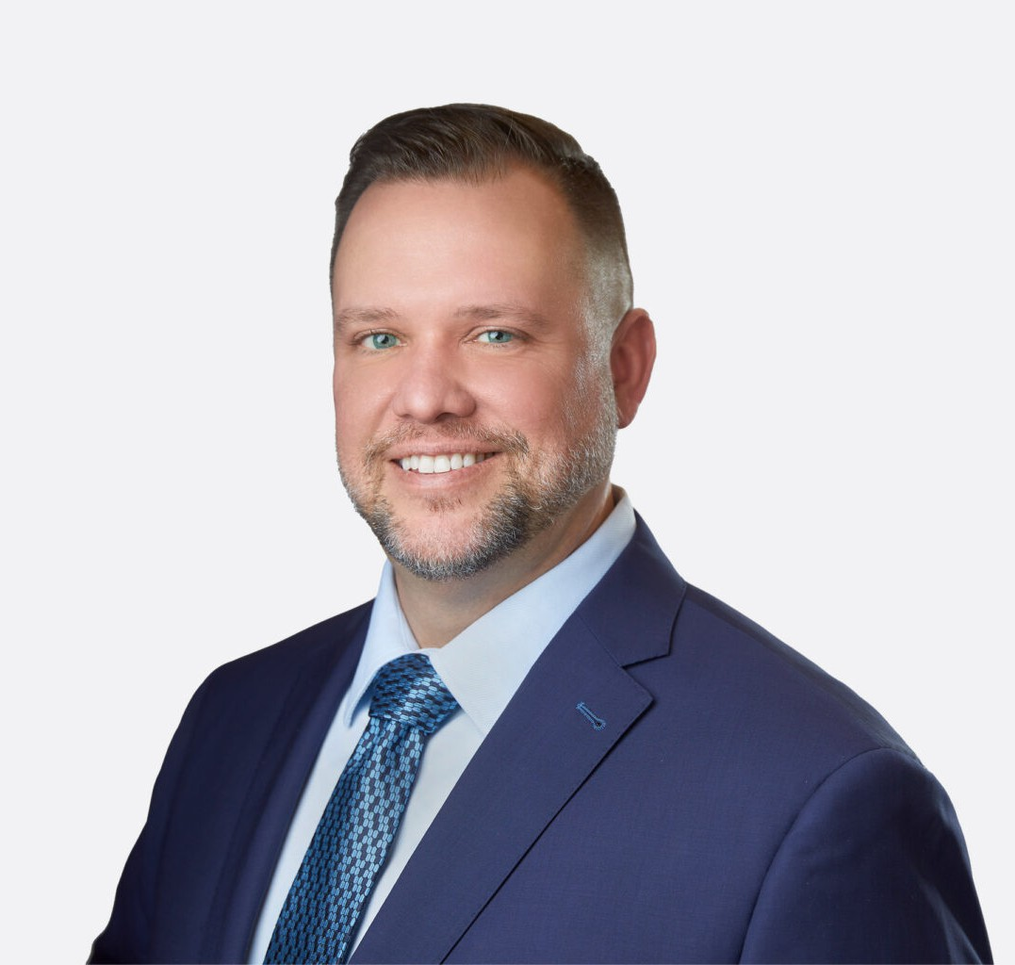
ROBERT E. MCPEAK
ROBERT E. MCPEAK
Director
Real Estate
Las Vegas
P: 702.692.8034
F: 702.692.8099
rmcpeak@fennemorelaw.com
Robert’s areas of practice include real estate, real estate finance, and energy project development and finance. His comprehensive real estate practice covers all aspects of
property acquisition, financing, development, management, leasing, and sales. He has worked with a wide range of commercial property types, including retail, office, industrial, multifamily, planned communities, condominiums, mixed-use developments, casinos, hotels, and time-share projects throughout the State of Nevada. He is well-known for providing practical legal guidance on operational issues.
Additionally, Robert focuses on issues related to the advanced energy transition, and the opportunities available to his clients throughout Nevada and surrounding states concerning the development of solar, wind and geothermal resources. In this sector, he represents developers,
lenders, and tax equity investors in connection with project development, permitting and financing of renewable energy projects across the southwest.
Further, Robert advises Nevada corporations, limited liability companies and partnerships and their shareholders, members, managers, and partners on matters of entity formation, governance and ongoing operations, including commercial credit and equipment finance.
Robert’s knowledge and skills are acknowledged by Chambers USA, The Best Lawyers in
America, and National Law Journal Trailblazers. He has earned the AV Preeminent Peer Review Rating™ from Martindale-Hubbell, marking him as a top-rated professional in his field. Feedback from clients to Chambers’ researchers highlights Robert as “clear, measured, and solution-oriented,” praising his ability to “distill complex issues into actionable guidance while maintaining appropriate rigor.” Others note his “vast experience across the state, responsiveness, and serious approach to matters.” Praised for his “knowledge beyond his years, especially in development projects,” he is considered highly respected. Clients find Robert to be a “smart and pleasant lawyer to work with” who is “fantastic from a technical perspective.”
In addition to serving on the Board of Directors of Legal Aid Center of Southern Nevada (LACSN), Robert also lends his legal skills to support LACSN’s Vegas Strong Resiliency Center which has grown into The Resiliency & Justice Center (resiliencyandjustice.org). Here, Robert assists LACSN with site acquisition, development matters, and the negotiation of design and construction contracts for The Resiliency & Justice Center’s new campus, which will house comprehensive

services and resources to support all survivors of violent crime in Nevada. Robert also serves as pro bono counsel to the Forever One Memorial (foreveronememorial.org), which upon completion will serve as a permanent memorial forever remembering the victims of the One October tragedy. Robert also serves as co-chair of the Fennemore’s Pro Bono Committee.

EDUCATION

J.D., Boston University School of Law, cum laude
Managing Editor of the Annual Review of Banking and Finance Law Honors concentration in business organizations and finance law
A.B., University of Michigan, with distinction

AREAS OF PRACTICE

Real Estate Advanced Energy Natural Resources Business & Finance

REPRESENTATIVE MATTERS
REAL ESTATE & FINANCE

Represented a Las Vegas-based industrial developer in connection with site acquisition,
development, leasing and disposition of multiple industrial and logistics-focused projects in Henderson, Las Vegas, and North Las Vegas, Nevada
Represented a leading developer of luxury multifamily communities in connection with site-acquisition and construction financing for several thousand units
Represented the buyer in connection with the acquisition and financing of multiple Class A office buildings in Las Vegas, Nevada
Represented a buyer in the $46 million acquisition of two single-tenant NNN-leased outpatient medical facilities in Clark County, NV and assumption of existing CMBS loan
Represented an investment management firm in the acquisition, financing and disposition of multiple unit value-add apartment complexes in Las Vegas, Nevada
Represented a global investment manager in nationwide leasing matters for a start-up healthcare portfolio company, including the negotiation of master construction and architectural contracts
Represented a major telecommunications company in the lease of a 104,000 square-foot facility in Las Vegas, Nevada
Represented borrowers, guarantors and lenders in commercial real estate loan transactions, including the borrowers in the acquisition of the underlying real property collateral
Represented the seller in the $27 million disposition of a 325-unit apartment complex in Reno, Nevada
Represented borrowers, guarantors, note-buyers, lenders, and loan servicers in workout and enforcement matters, including receivership sales, REO management, and disposition

engagements involving over $3 billion of distressed commercial real estate loans in Arizona, California, and Nevada
Represented a syndicate of senior secured lenders in the workout and restructuring of a $470 million construction loan secured by a mixed-use retail and office center in Las Vegas Nevada
Represented a national homebuilder with the formation of common-interest communities and the negotiation of development agreements, shared-entry agreements, public offering statements and other sales-related disclosures in southern and northern Nevada
Represented a national homebuilder in connection with state and local regulatory matters relating to its acquisition of another homebuilder
Represented a national homebuilder in the restructuring of its Nevada holdings
Represented a national developer of a master-planned community in various homebuilder bankruptcies and defaults under development and profit participation obligations
ADVANCED ENERGY + NATURAL RESOURCES

Nevada counsel for the developer in connection with the debt and tax equity financing of a 690 MW solar photovoltaic generating facility and 380 MW battery energy storage located in Clark County, Nevada, the largest single project of its kind to begin construction in the U.S.
Represented the developer, as local counsel, in connection with the financing of a 70 MW solar PV generation project, the financing of a 20 MW utility-scale solar power project, and the financing of and title issues with 5 MW solar project
Nevada counsel for the tax equity investor in connection with the successful closing of its
investment in a 300 MW solar photovoltaic generating facility located on tribal land in Clark County, Nevada
Nevada counsel for the tax equity investor in connection with the successful closing of its
investment in a 180 MW solar photovoltaic generating facility located in Boulder City, Nevada
Nevada counsel for the tax equity investor in connection with the successful closing of its investment in the repowering of a 37.1 MW geothermal plant located in Washoe County, Nevada
Nevada counsel for the developer in connection with project re-financing of a 152 MW wind power project located in White Pine County, Nevada — the largest project of its kind in Nevada
Nevada counsel for the tax equity investor in connection with the successful closing of its
investment in a 101 MW solar photovoltaic generating facility and 100 MW battery energy storage located in Humboldt County, Nevada
Nevada counsel for the tax equity investor in connection with the successful closing of its
investment in a 250 MW solar photovoltaic generating facility located in Boulder City, Nevada
Nevada financing counsel for the developer in connection with the successful construction financing of a 100 MW solar photovoltaic generating facility located in Clark County, Nevada, which will power the operations on a sizeable portion of the resorts on the Las Vegas Strip
Nevada counsel for the tax equity investor in connection with the successful closing of its
investment in a 250 MW solar photovoltaic generating facility located in Clark County, Nevada
Nevada counsel for the tax equity investor in connection with the successful closing of its
investment in a 179 MW solar photovoltaic generating facility located on tribal land in Clark County, Nevada

Nevada counsel for the developer in connection with a tax equity investment in a 20 MW solar photovoltaic generating facility located in Churchill County, Nevada
Nevada counsel for the tax equity investor in connection with the successful closing of its investment in a 24 MW geothermal plant located in Churchill County, Nevada
Represented the developer in connection with development and construction permitting of a 14 MW solar photovoltaic generating facility located in Henderson, NV

ARTICLE AND PRESENTATIONS

Author, “Mixed-use development emerges as partial fix for Las Vegas’ housing crunch,” Las Vegas Review-Journal, October 15, 2025
Presenter, “Real Estate Development Legal Boot Camp,” National Business Institute, Las Vegas, Nevada, October 15, 2025
Presenter, “Nevada Real Estate Law 2025,” National Business Institute, Las Vegas, Nevada, August 15, 2025
Feature Q&A Interview, “Nevada Energy Attorney Sees Activity Uptick In Renewables Projects,” Law360 Real Estate Authority, July 27, 2023
Quoted, “Biden Eyes New Funds for Housing, End of 1031 Tax Program,” Law360, March 9, 2023 Quoted, “Interest Rates Top Real Estate Pros’ Federal Agenda for 2023“, Law360, Jan. 2, 2023
Leadership Interview, “Pay It Forward” (Globest.com, Nov. 22, 2022) and “How I Made Partner” (Law.com, Nov. 21, 2022)
Moderator, Shopping Center Business and Western Real Estate Business magazines webinar, “Las Vegas Retail Outlook: How is the Las Vegas Retail Sector responding to COVID-19,” Sept. 3, 2020
Moderator, NAIOP Workshop, “Building Bricks with Blockchain: The Latest in CRE and·Technology,” Oct. 12, 2018
Presenter, “Avoiding the Industry’s Top Legal Pitfalls,” ICSC ReCon, Las Vegas, Nevada, May 21, 2017
Presenter, “Inception to Courtroom: Legal Issues Facing Development Projects,” NAIOP Southern Nevada, Las Vegas, Nevada, Nov. 3, 2016
Presenter, “Landlord-Tenant Law from Start to Finish,” Sterling Educational Services, Las Vegas, Nevada, March 23, 2016
Presenter of continuing legal education seminars covering commercial real estate·transactions, title insurance matters, and distressed loans and portfolio management

AWARDS AND HONORS

Chambers USA: America’s Leading Lawyers for Business – Real Estate Law: Nevada, 2020-2026 Martindale-Hubbell – AV Preeminent Peer Review Rating, 2013-present
Best Lawyers in America® – Construction Law (2021-2026), Construction Litigation (2021-2026), Corporate Law (2025-2026), Land Use and Zoning Law (2025-2026), Real Estate Law (2021-2026)
National Law Journal – Real Estate/Construction Law Trailblazers, 2022

Vegas Inc – “Top Lawyers” in Southern Nevada in Environmental Law, 2023, 2022, the only lawyer on the Environmental Law list
Business Today – “Top 10 Influential Nevada Real Estate Lawyers Making Waves in 2023”
Mentor in Real Estate Recognition, Lied Center for Real Estate, Lee Business School at the University of Nevada-Las Vegas (UNLV), 2023-present
Mountain States Super Lawyers Magazine – Rising Star, 2012-2017 Desert Companion’s Southern Nevada’s Top Lawyers

PROFESSIONAL AND COMMUNITY ACTIVITIES

NAIOP (Commercial Real Estate Development Association), Southern Nevada Chapter Member, Board of Directors (2025 – present)
Member, Programs Committee and Education Committees Graduate, Developing Leaders Institute, Class of 2014
Graduate, Developing Organizational Leadership Institute, Class of 2025 Legal Aid Center of Southern Nevada
Member, Board of Directors (2025 – present)
General Counsel (2016-2023)
Adjunct Professor, Lied Center for Real Estate, Lee Business School at UNLV Member, American Bar Association, Real Property, Trust and Estate Law Section Member, State Bar of Nevada,
Member, Real Property Law Section
Member, Continuing Legal Education Committee (2005-2014)

ADMISSIONS

Nevada

