
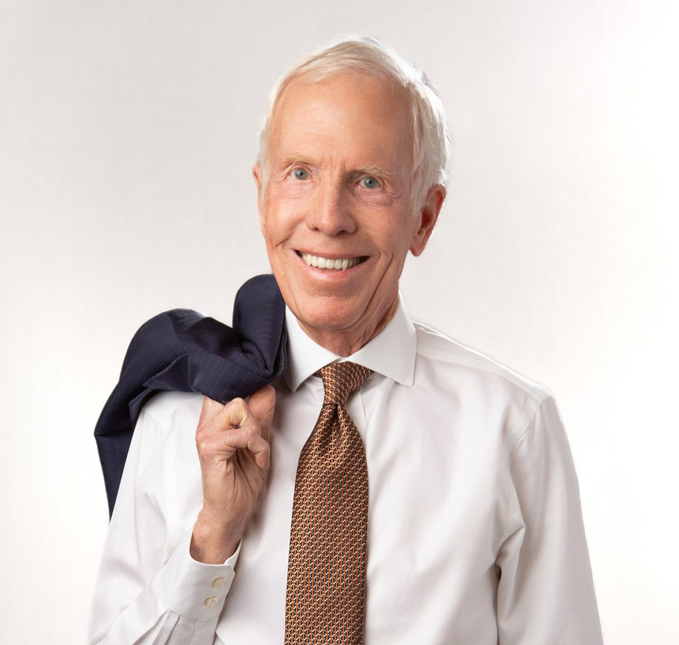
ROBERT L. SULLIVAN, JR.
ROBERT L.
SULLIVAN, JR.
Of Counsel
Trusts & Estates
Fresno
P: 559.753.2801
F: 559.753.2800
rsullivan@fennemorelaw.com
Robert L. Sullivan, Jr. is an Of Counsel attorney in our Fresno office where his practice focuses on estate planning, trust and estate administration, taxation, and litigation support in trust and estate matters. He has guided clients through an array of estate planning, trust administration, business planning, succession planning, and related tax matters throughout a distinguished career spanning over 50 years.
A leader in the field, Bob has held the position of Chair of the California State Bar’s Estate
Planning, Trust, and Probate Law Section, an influential group comprising over 4,000 esteemed estate planning attorneys and probate judges. He is a long-standing fellow of the American College of Trust and Estate Counsel and has also been an academician of the International Academy of Estate and Trust Law.
His dedication to advancing the profession is evident through his collaborative efforts with lawmakers and academia to enhance legislative procedures for informal administration of
decedents’ estates. Bob has received dual certifications from The State Bar of California Board of Legal Specialization as a specialist in Estate Planning, Trust and Probate Law, and as a
specialist in Taxation Law.

EDUCATION

- J.D., University of San Francisco School of Law
- B.S., University of California, Berkeley

AREAS OF PRACTICE

OTHER EXPERIENCE

- Litigation Support in Trusts and Estates Matters

- Trusts & Estates
- Tax Law

- Estate Planning

REPORTED CASES

- Dorothy Schwartz Rojas and Estate of Charles R. Schwartz, deceased v. Commissioner of Internal Revenue Service, 901 F.2d 810 (9th Cir. 1990)
- Edmond of Fresno v. MacDonald Group Ltd, 171 Cal. App. 3d 598 (1985)

AWARDS AND HONORS

- Member of the McAuliffe Honor Society at the University of San Francisco School of Law
- AV® Preeminent™ Peer Review Rated with Martindale-Hubbell
- Northern California Super Lawyer in the field of Estate Planning & Probate, 2006-2025

ARTICLES AND PRESENTATIONS

- The Southern California Tax and Estate Planning Forum
- The University of Southern California Tax Institute
- Annual programs of the Estate Planning
- Probate Trust Law Section of the California State Bar
- Education Institutes Section of the State Bar of California Continuing Education Program
- Drafted a Proposal for the Enactment of Informal Administration of Decedent’s Estate in California on behalf of The State Bar of California
- Course Outline, CEB Impact of California’s Probate Code Reform
- Course Outline, CEB Recent Developments in Estate Planning and Administration
- Course Outline, Programs on The Tax Reform Act of 1986
- Course Outline, CEB Recent Developments in Estate Planning and Administration, 1/88
- Course Outline, CEB Recent Developments in Estate Planning and Administration, 1/89
- Course Outline, CEB Recent Developments in Estate Planning and Administration, 1/90
- Course Outline, CEB Recent Developments in Estate Planning and Administration, 1/91
- Course Materials, “Planning the Small Estate”, California CEB, 3/92
- Recent Developments in Taxation, California CEB, 1/93
- Course Materials, “Effective Client Communication in Estate Planning,” 10/94
- Analysis, “Informal Decedent Estate Administration in California,” 10/95
- Course Materials, “New § 2033A, A Senator’s Dream or An Attorney’s Nightmare?”, USC Institute on Federal Taxation, 1/98
- Course Outline, “The Qualified Family Owned Business Exclusion: New §2033A”, The Southern California Tax & Estate Planning Forum, 5/98

PROFESSIONAL AND COMMUNITY AFFILIATIONS

- Editor-in-Chief of the University of San Francisco Law Review
- Fellow, American College of Trust and Estate Counsel
- Member, State Bar of California
- Member, Bar of the US Supreme Court, 1974
- Past Member, Executive Committee of the State Bar of California Trust and Estate Section, 1985-1995; Chair 1994-1995
- Past Member, California Taxation Law Advisory Commission of California Board of Legal Specialization, 1988-1989
- Past President of the Fresno Estate Planning Council, 1982-1983
- Former Director, Fresno Art Museum and Fresno Metropolitan Museum
- Former Director, Carmel Bach Festival

ADMISSIONS

- California
- United State Supreme Court
- United States Court of Appeals for the 9th District
- United States Tax Court

