
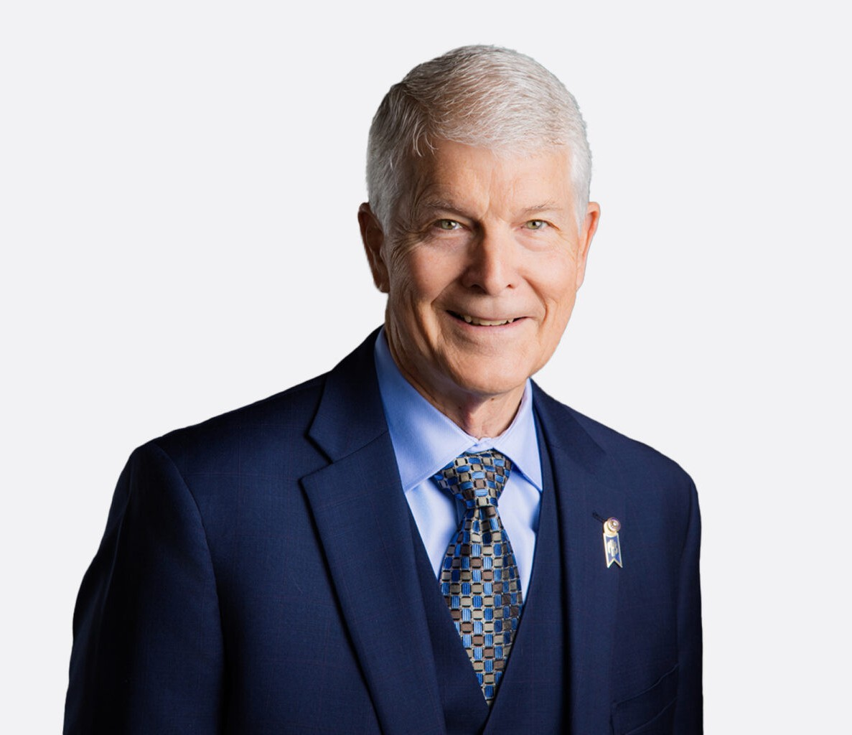
SCOTT REYNOLDS
SCOTT REYNOLDS
Director
Trusts & Estates
Vacaville
P: 707.432.4406
F: 707.207.7955
sreynolds@fennemorelaw.com
Scott Reynolds is a director in Fennemore’s trusts and estates practice, advising individuals, families, and business owners on estate planning, probate, and trust administration matters throughout California. He is a Certified Specialist in Estate Planning, Probate and Trust Law,
designated by the State Bar of California Board of Legal Specialization, a distinction held by a limited number of attorneys in the state.
Scott’s practice focuses on estate planning, trust administration, probate, business formations, business succession planning, and tax-related matters. He works with closely held businesses and high-net-worth individuals to develop strategies that preserve wealth, support long-term goals, and ensure smooth transitions across generations.
Before entering the legal profession, Scott earned his MBA from the University of California, Berkeley and worked in the tax department of a Big Eight accounting firm in San Francisco. He later built a strong legal career across California, including serving as a senior partner at a Redlands-based firm and as a managing shareholder and practice group leader at a North Bay firm.
In 2015, Scott founded Reynolds Law, a firm focused on delivering practical estate and business planning solutions to clients across Solano, Yolo, San Bernardino, and Riverside counties.
Scott has been recognized as a Northern California Super Lawyer for over 17 years. In addition to his legal practice, he taught business law at the University of Redlands for eight years and regularly speaks on trust administration and estate planning topics for organizations, including Continuing Education of the Bar and the Southern California Tax and Estate Planning Forum.

EDUCATION

J.D., McGeorge School of Law, University of the Pacific M.B.A., University of California, Berkeley,
B.A., Stanford University

AREAS OF PRACTICE

Trusts & Estates

Business & Finance

AWARDS AND HONORS

Northern California Super Lawyer, 2005 – 2006, 2008 – 2013, 2019 – 2026
Certified Specialist in Estate Planning, Trust & Probate Law, State Bar of California Board of Legal Specialization
Participant, Thirty-Third Annual National Security Forum

PROFESSIONAL AND COMMUNITY ACTIVITIES

CURRENT

Former Chairman, current member of Board of Directors and Executive Committee, Solano Economic Development Corporation,
Vice Chairman, member, Board of Directors and Executive Committee, NorthBay Healthcare Foundation
Member, American Bar Association
Member, Board of Directors, Vacaville Solano Services Corporation (Opportunity House) Past Chairman, member of Board of Directors, Travis Regional Armed Forces Committee Current member, past President, member of Board of Directors, Vacaville Rotary Club Member, State Bar of California, Estate Planning, Trust and Probate Section
Member, Solano County Bar Association Member, San Bernardino Bar Association

PAST

Former Chairman, member of Board of Directors and Executive Committee, Fairfield-Suisun Chamber of Commerce
Former founder, President and member, Board of Directors, Solano Bicycle Classic Former Director, Solano Workforce Development Board
Former Director, Vacaville Neighborhood Boys & Girls Club
Former Chairman, member of Board of Directors and Executive Committee, Vacaville Chamber of Commerce
Past-President and Member of Board of Directors and Executive Committee, Redlands Chamber of Commerce
Past-President Member, Board of Directors, United Way of Redlands Area Past-President, Member of Board of Directors, Redlands Rotary Club
Past Member, Board of Directors, Redlands Community Hospital Past-President, Board of Directors, Redlands Bicycle Classic, Inc. Past Chairman, Commissioner, Redlands Planning Commission
Co-Founder, past Chairman, member of Redlands Chili Cookoff & Firemen’s Muster

Past Director, Secretary of Redlands 4th of July Committee Former Director, Redlands Economic Development Corp. Past President, Director, United Way of Redlands Area

ADMISSIONS

California
United States Tax Court
U.S. District Court, Northern District of California
U.S. District Court, Central District of California

