
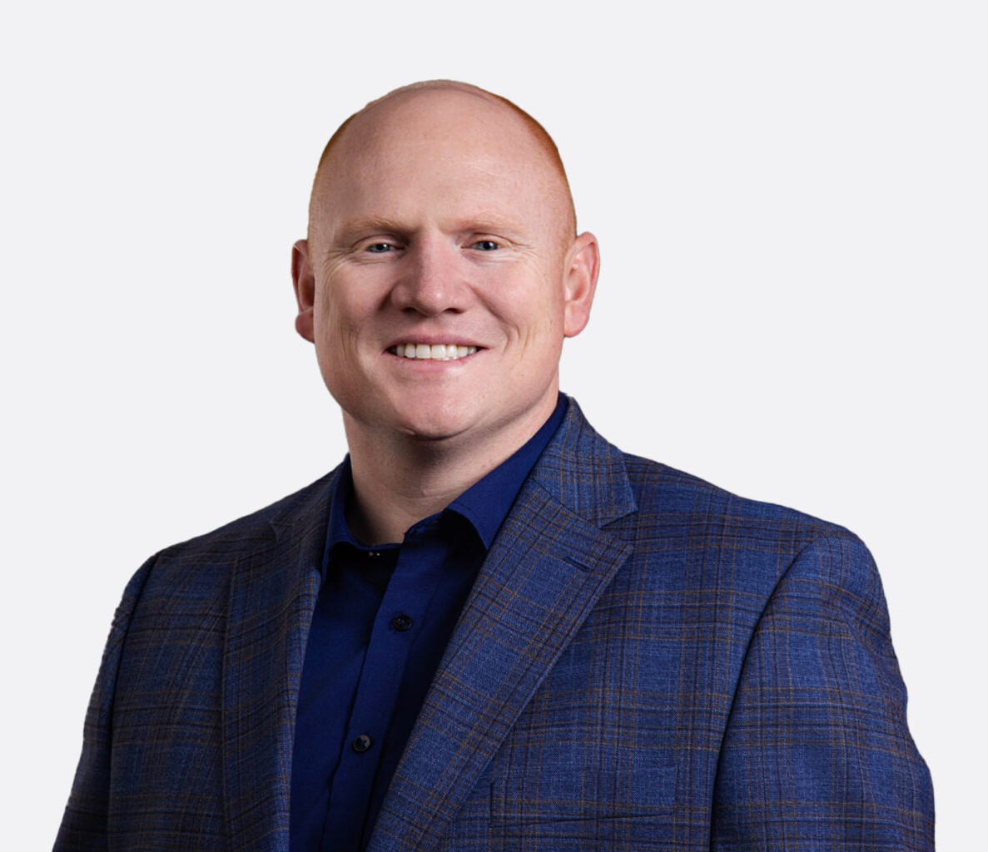
SIMON A. LEBLEU
SIMON A. LEBLEU
Associate
Trusts & Estates
Vacaville
P: 707.399.4297
F: 707.207.7955
slebleu@fennemorelaw.com
Simon A. LeBleu is a trusts & estates attorney at Fennemore who specializes in estate planning, trust administration, probate, and tax planning. He offers guidance to a diverse clientele, including families, individuals, private fiduciaries, institutions, and other non-profit entities.
A native of Solano County, Simon maintains strong ties to the Northern California community he serves. He earned his associate degree from Solano Community College and graduated with honors from California State University, Sacramento with a bachelor’s degree. He went on to receive his Juris Doctor from the University of the Pacific, McGeorge School of Law, along with certificates in Taxation and Business, and later earned a Master of Laws (LL.M.) in Taxation from the University of San Francisco School of Law.
In addition to his legal practice, Simon is an adjunct professor at McGeorge School of Law, where he teaches estate and gift taxation and income taxation of trusts and estates. He is also a regular contributor to California Continuing Education of the Bar and the California Lawyers
Association, providing insight on estate, gift, generation-skipping transfer, and real estate taxation topics.
Simon lives in Solano County with his wife and two sons and remains actively engaged in the local community.

EDUCATION

Certified Specialist in Estate Planning, Trust & Probate Law, State Bar of California Board of Legal Specialization
LL.M., University of San Francisco School of Law
J.D., McGeorge School of Law, University of the Pacific B.S., California State University, Sacramento
A.S., Solano Community College

AREAS OF PRACTICE

Trusts & Estates

Tax Law

AWARDS AND HONORS

Northern California Super Lawyers Rising Star, Estate & Probate, Tax, 2025-2026

ARTICLES AND PRESENTATIONS

Co-Presenter, “From Clifford to Q-Stack: The Post OBBBA Landscape of Planning with Non-Grantor Trusts,” California Lawyers Association Estate and Gift Tax Conference (San Francisco), 2026.
Co-Author, “Valuation Freeze Techniques” (Chapter 25), Continuing Education of the Bar (CEB) Update, January 2026
Co-Author, “Estate and Gift Taxes” (Chapter 10), Continuing Education of the Bar (CEB) Update, January 2026
Co-Presenter, “GST Tax: The Unfriendly Ghost of Estate Planning,” California Lawyers Association Estate and Gift Tax Conference (San Francisco), 2025
Co-Presenter, “Crummey Withdrawal Rights and Notices: Current State and Best Practices,” American Bar Association Midyear Tax Meeting (Los Angeles), 2025
Co-Author, “Navigating the Complexities of Fine Art and Collectibles for Fiduciaries. Vol. 31, Issue 11,” California Trust and Estate Quarterly, 2025.
Co-Author, “Valuation Freeze Techniques” (Chapter 25), Continuing Education of the Bar (CEB) Update, January 2025
Co-Author, “Estate and Gift Taxes” (Chapter 10), Continuing Education of the Bar (CEB) Update, January 2025
Co-Author, “Valuation Freeze Techniques” (Chapter 25), Continuing Education of the Bar (CEB) Update, January 2024
Co-Author, “GST Tax” (Chapter 11), Continuing Education of the Bar (CEB) Update, January 2024
Co-Author, “Estate and Gift Taxes” (Chapter 10), Continuing Education of the Bar (CEB) Update, January 2024
Co-Author, “When Should an IRC Section 645 Election be Made? Almost Always! Vol. 29, Issue 3,” California Trust and Estate Quarterly, 2023
Co-Author, “Estate and Gift Taxes” (Chapter 10), Continuing Education of the Bar (CEB) Update, January 2023
Co-Author, “Real Property Ownership & Taxation” (Chapter 7), Continuing Education of the Bar (CEB) Update, January 2023
Co-Author, “GST Tax” (Chapter 11), Continuing Education of the Bar (CEB) Update, January 2023
Author, “Overview of California Estate Planning Techniques for the Single Client,” Continuing Education of the Bar (CEB, Practitioner)August 2022
Author, “Estate Planning Questionnaire for Single Client,” Continuing Education of the Bar (CEB, Practitioner), August 2022
Co-Author, “Real Property Ownership & Taxation” (Chapter 7), Continuing Education of the Bar (CEB), January 2022

Author, Issue Editor: LPS, General, and Limited Conservatorships: Where We Were, Where We Are and Where We Are Going; Vol. 28. Issue 3, California Trusts and Estates Quarterly, 2022

PROFESSIONAL AND COMMUNITY ACTIVITIES

Adjunct Professor, University of the Pacific, McGeorge School of Law Dixon City Treasurer
Volunteer, California Trust and Estates Section of the Bar, Trust and Estates Subcommittee Member, Taxation Section, State Bar of California
Member, Trust & Estates Section, State Bar of California Member, Business Law Section, State Bar of California
Member, Trust and Estates Law Section, Sacramento County Bar Association Member, Solano County Bar Association

ADMISSIONS

California
U.S. Tax Court

