
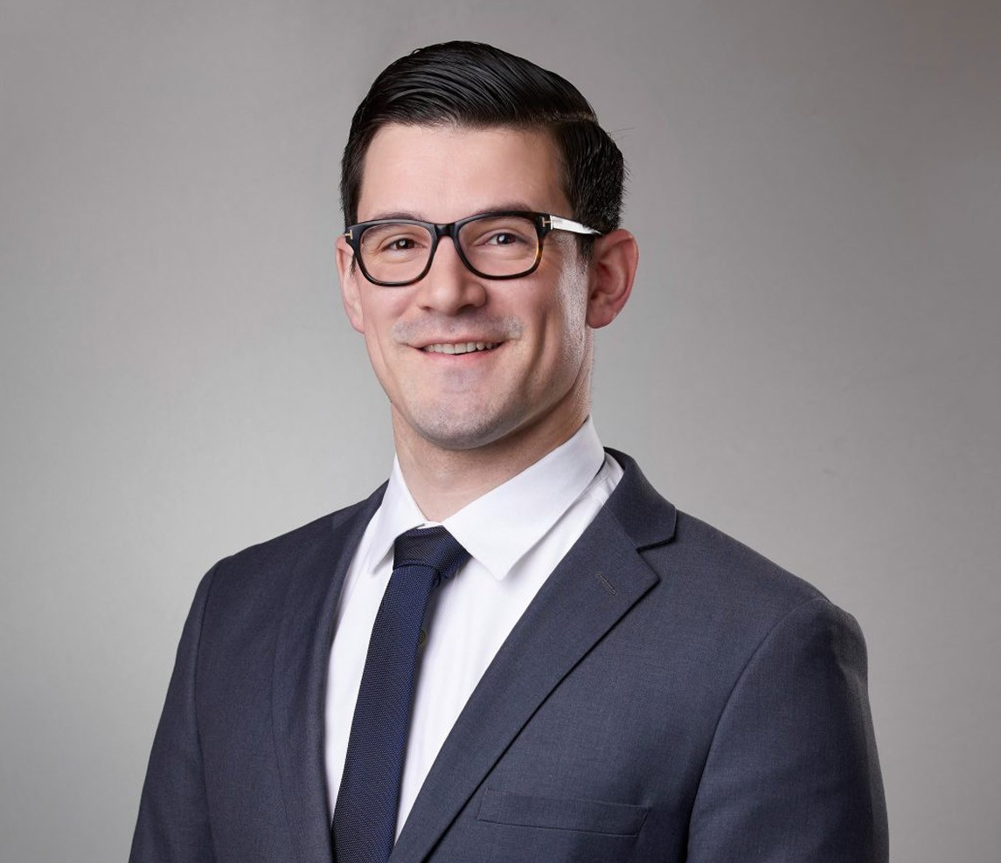
TAIT J. VISKOVICH
TAIT J. VISKOVICH
Associate
Real Estate
Inland Empire
P: 909.890.4499
F: 909.890.9877
tviskovich@fennemorelaw.com
“
Wise men speak because they have something to say; fools because they
have to say something.
- Plato
”
Tait Viskovich is an associate in the Real Estate practice group in the firm’s San Bernardino office. With a reputation as a forward thinking attorney interested in the intersections of law, business, real estate, and technology, his practice involves all aspects of real estate transactions, including the acquisition, development, construction, leasing, ownership, financing,
management and disposition of industrial, commercial, retail and office properties.

Tait assists clients with various land use matters including strategy, approvals, zoning, amendments, and conditional use permits and variances.
Tait was formerly a construction litigator and understands the complex nature of development from the ground up. This enables him to anticipate issues before they arise to better protect our clients throughout the development process.
Real Estate Advanced Energy

EDUCATION

J.D., University of Southern California Gould School of Law, Graduate Certificate in Business Law B.A., Political Science, University of California, Riverside
AREAS OF PRACTICE

OTHER EXPERIENCE
Land Use Real Estate
Advanced Energy

ARTICLES AND PRESENTATION

Author, “Power Plays: Navigating Zoning and Utility Challenges in Solar, Battery Energy Storage, and Data Center Projects,” San Diego Business Journal, May 18, 2025

AWARDS AND HONORS
Best Lawyers in America®, Ones to Watch, Land Use and Zoning Law, Real Estate Law, 2026

PROFESSIONAL AND COMMUNITY ACTIVITIES

Member, State Bar of California

ADMISSIONS

California

