
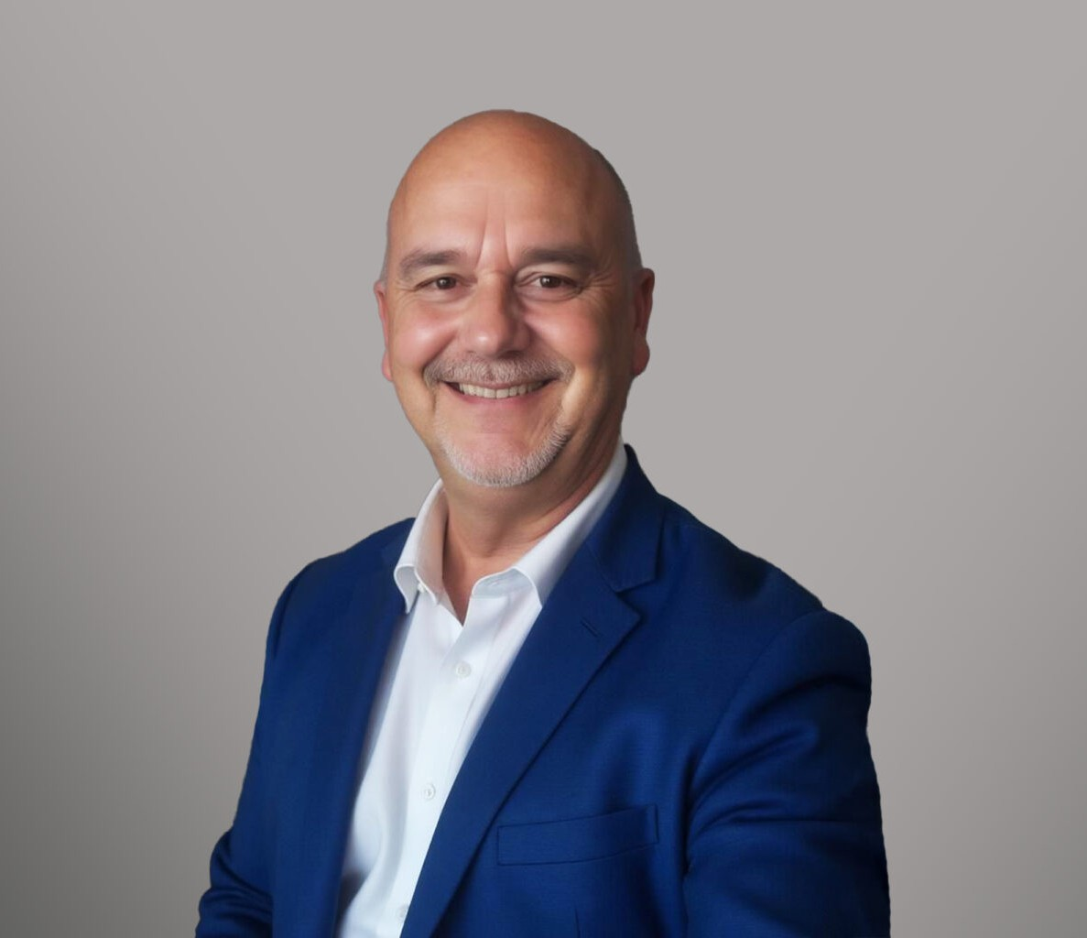
Tim Kneis is a paralegal who works out of our Oakland office where his work focuses on several probate and post-death trust administrations.
TIM KNEIS
Paralegal
Trusts & Estates
Oakland
P: 510.834.6600 F: 510.834.6600
tkneis@fennemorelaw.com
TIM KNEIS“
Keep passing the open windows
”
Tim worked as a Probate Examiner for almost 20 years, providing him with knowledge of the internal workings of the probate court, a history of judicial court rulings, and also how to avoid common pitfalls with probate court filings. Prior to joining Fennemore, Tim was a Trust Officer at a bank. A law firm he worked with closely was looking for a probate paralegal, and he thought it would be a nice and challenging change. In his role at our firm, Tim takes great pride in knowing that the services we provide the clients are tremendously helpful during what can be a difficult time following the death of a loved one.
Outside of work, Tim unwinds by reading and playing golf.

Trusts & Estates

EDUCATION

B.A., San Francisco State University

AREAS OF PRACTICE

Trusts & Estates

PROFESSIONAL AND COMMUNITY AFFILIATIONS

Member, San Francisco Bar Association

ARTICLES AND PRESENTATIONS

Speaker, “The Probate Process from Start to Finish in California,” National Business Institute Speaker, “How to Avoid Being Haunted by Probate Pitfalls,” Daily Journal Corporation
Speaker, “Conservatorship and Guardianship Accountings, Keeping Tabs and How to Read Between the Lines of an Accounting,” California Association of Superior Court Investigators
Speaker, “Recent Developments and Current Topics in the San Francisco Probate Court,” Estate Planning, Trust & Probate Section of the San Francisco Bar Association
Presenter, “And the estate is in a position to be closed – Petitions for Final Distribution in California Probate Estates,” Continuing Education of the Bar

ADMISSIONS

*Not licensed to the practice of law

