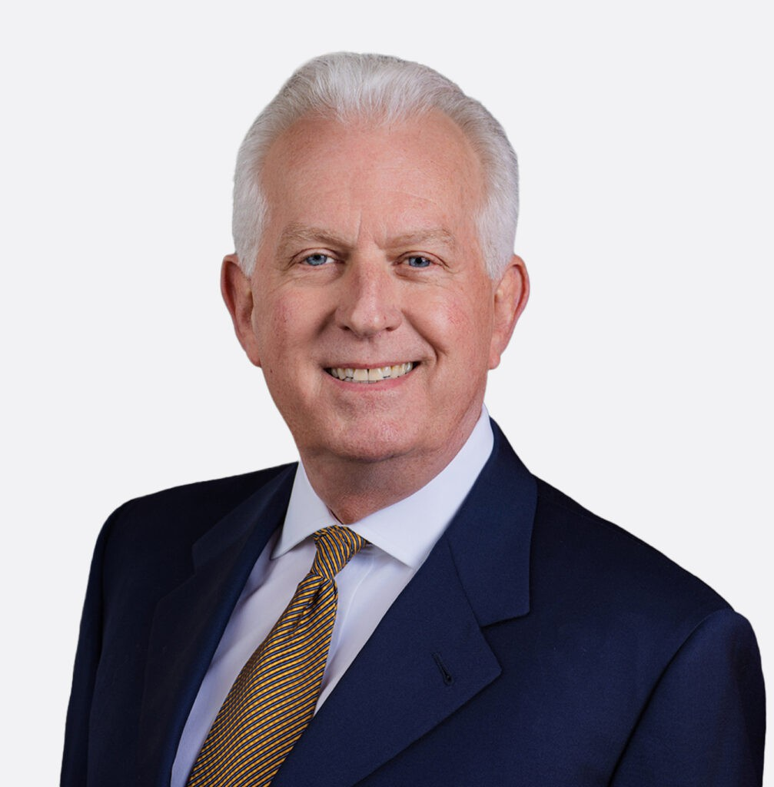

TODD LOWELL
Of Counsel
Real Estate

Sacramento
P: 707.432.4412 F: 707.207.7955

Vacaville
P: 707.432.4412 F: 707.207.7955
tlowell@fennemorelaw.com

TODD LOWELL
Todd Lowell is Of Counsel in the Sacramento Office working in Fennemore’s real estate group. He advises clients on a wide range of real estate, development, finance, construction, and business matters. His practice focuses on helping small businesses, developers, property owners, and businesses navigate complex transactions, regulatory requirements, and project challenges across California.
Todd began his legal career more than 30 years ago in civil litigation before transitioning to real estate and construction law. His experience spans both legal and business perspectives, including managing development projects and working through land use and regulatory
processes. This background allows him to provide practical, solutions-oriented counsel that aligns with his clients’ goals.
Having spent much of his life along the Interstate 80 corridor—from growing up in Nevada City to working in San Francisco—Todd brings a strong understanding of Northern California’s real estate landscape. With early work experience carrying tool bags on construction jobs to driving
tomato trucks through the Central Valley, he developed a deep appreciation for the region and a strong work ethic that continues to shape his approach today.
Todd has been actively involved in his community and values building long-term relationships. He served for 16 years as an elected school board member, including eight years as board
president. He is currently a member of the Roseville Rotary Club and serves on the board of a local historical foundation, reflecting his ongoing commitment to the communities he serves.

EDUCATION

J.D., McGeorge School of Law, University of the Pacific B.A., University of California, Davis

AREAS OF PRACTICE

Real Estate

REPRESENTATIVE MATTERS

Real Estate

Represent Bay Area office developer with a multi-county portfolio regarding leasing matters and asset sales.
Represented a family in the sale of a 2,200 acre ranch which involved water rights allocations and a lease-back to be able to continue the ranch operation.
Represent the family in the sale of property they had owned for nearly 100 years in a seller-financing transaction.
Represent a senior-living developer in the acquisition and financing of multiple development sites across northern California
Represent the seller in a more than $30 million transaction acquire multiple replacement properties through 1031 exchanges.
Represent Solano-Napa Habitat for Humanity in its mission to create owner-occupied housing for families who otherwise would not have the opportunity to own their own home.
Represent a landowner regarding title issues of roads that were created in the 1860s.
Represented a ground lease tenant to obtain a Temporary Restraining Order and Preliminary Injunction when the landlord was interfering with construction

Land Use

Represented multi-family developer to obtain project entitlements under the then newly amended Housing Accountabilty Act when the site’s zoning did not permit multi-family use.
Represent clients before local staff, planning commissions and city councils/county boards of supervisors to process and obtain land use entitlements, including general plan amendment, rezoning, conditional use permits, tentative maps and parcel maps.

Business and Finance

Represent a developer to close out of state financing for the construction of condominiums in South Lake Tahoe.
Represent an LLC consisting of 24 members in a transaction where 20 of the members were selling their respective interests to a single buyer.
Represent buyers and sellers, respectively, in the sales of businesses, such as restaurants, gas stations, a record store and professional service companies.

AWARDS AND HONORS

Outstanding Trustee of the Year, Placer County School Boards Association, 2010 Finalist, Best Oralist, Moot Court Competition
Recipient, Chancellor’s Outstanding Graduating Senior Award

PROFESSIONAL AND COMMUNITY ACTIVITIES

Member, Roseville Rotary Club
Member (Elected), Rocklin Unified School District Board of Trustees, 2002 – 2018. Served as board president for eight years.
Board Member, South Placer Heritage Foundation, 2007–present Board of Directors, Vacaville Chamber of Commerce, 2022 – 2025 Member, Vacaville Rotary Club, 2020 – 2023
Founding Board Member, Rocklin Educational Excellence Foundation, 2008–2022
and Member of the Board of Directors, Chairman of the Board of Directors (2008), Rocklin Area Chamber of Commerce, 2006–2009
Coach, Rocklin Youth Soccer Club, 2001-2006
Whitney High School Bond Measure Committee, 2001-2002
Board of Directors, Sacramento Valley Teen Challenge, 1997 – 2003

ADMISSIONS

California
Federal District Court, Eastern District of California
U.S. Supreme Court

