
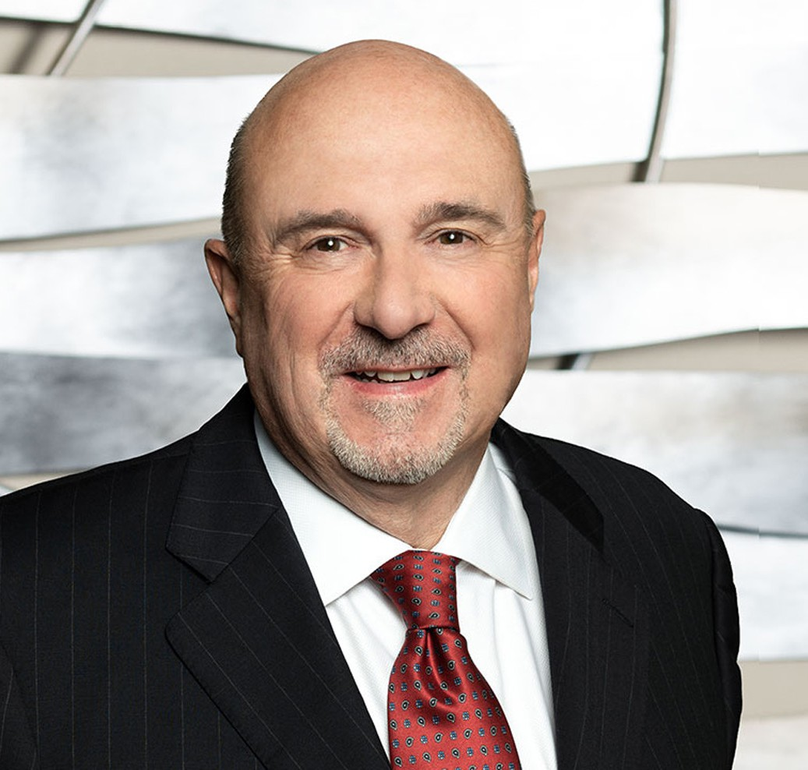
WM. LANIER THOMAS
WM. LANIER THOMAS
Of Counsel
Trusts & Estates
Fresno
P: 559.432.4500
F: 559.432.4590
lthomas@fennemorelaw.com
Lanier Thomas practices in the areas of strategic wealth conservation, business continuity planning, charitable giving, and asset protection. He focuses his practice on integrating sophisticated estate and tax planning with business succession planning. His practice also includes the efficient transfer of family wealth and plan administration.
Lanier decided to become a lawyer at an early age, and his gift has been to guide people through the complex area of family wealth transfer and to help them develop solutions to financial and personal issues. He likes to think creatively, and the estate planning field provides those challenges and opportunities. For over forty years, Lanier has been involved with clients from all walks of life, helping them to bring order to their family, legal and financial affairs. Using living trusts, a wide variety of business entities, and advanced strategies. He has helped clients convert paper profits to increased cash flow, with the ability to maintain control and pass on
their values to the next generation, while minimizing estate, gift and income taxes. He truly enjoys listening to the families he serves and learning their stories and history. Lanier believes that if he can expand his clients’ horizons of what can be achieved through planning, and give them peace of mind, he has truly done his job. He enjoys taking otherwise complicated strategies and making them simple and easy to understand. In addition to practicing law, he is actively involved in educating insurance professionals, lawyers, financial advisors, and CPAs in basic and advanced estate planning concepts.
To relax and recharge, Lanier enjoys the outdoors, fly fishing, hiking, and skiing. He is also an avid reader of biographies and history.

EDUCATION

J.D., SMU Dedman School of Law
B.A., with high honors, English Literature and Political Science, Westmont College

AREAS OF PRACTICE

OTHER EXPERIENCE

Business Succession Charitable Planning
Strategic Wealth Preservation

Trusts & Estates Estate Planning

AWARDS AND HONORS
AV® Preeminent™ Peer Review Rated (the highest rating available), by Martindale-Hubbell

ARTICLES AND PRESENTATIONS

Co-author, “Business Succession Planning,” Treatise California Continuing Education of the Bar

PROFESSIONAL AND COMMUNITY ACTIVITIES

Member, California Bar Association, Trusts and Estates Section
Member, Fresno County Bar Association, Estate Planning and Probate Section
Founding Member, Wealth Counsel, LLC, a national network of estate planning attorneys Member, Fresno Estate Planning Council
Partnership for Philanthropic Planning
Co-Chair of Major Gifts Committee, Fresno Rescue Mission Audit Committee, Valley Public Television, lnc.
Former Member, Board of Directors, Fresno Art Museum

ADMISSIONS

California
U.S. District Court, Eastern District of California

