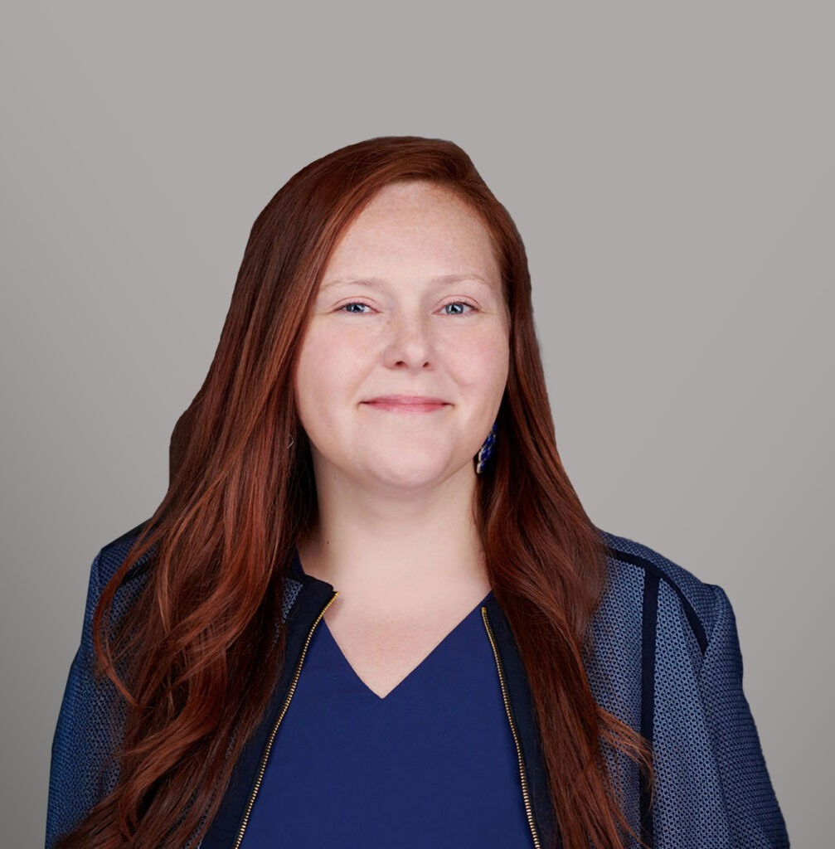

ELISE O’BRIEN
Director
Labor & Employment

Orange County
P: 949.430.3417 F: 949.752.0953

Seattle
P: 949.430.3417 F: 949.752.0953
eobrien@fennemorelaw.com

ELISE O'BRIEN
Elise O’Brien is a director in our Irvine office who works in our Agribusiness and Employment & Labor practice groups. Elise has extensive experience representing employers in federal and state court litigation involving wrongful termination, discrimination, harassment, retaliation, and wage and hour claims. She has successfully represented management in various administrative forums, including the California Division of Labor Standards and Enforcement, the California Civil Rights Department, the California Unemployment Insurance Appeals Board, the Equal
Employment Opportunity Commission and the National Labor Relations Board.

Elise devotes a significant portion of her practice to advising employers on a broad spectrum of employment matters, including employee discipline, terminations, leaves of absence, and wage and hour issues. Elise regularly assists employers in drafting employment policies and handbooks to ensure compliance with California, Washington, and federal law.
In addition to her employment practice, Elise practices agricultural law and has nearly two decades of experience enforcing trust rights of produce sellers under the Perishable Agricultural Commodities Act (PACA) in U.S. District and Bankruptcy Courts throughout the United States, including managing complex, multi-party PACA litigation. She also represents produce companies and individuals in administrative proceedings before the PACA Branch of the U.S.
Department of Agriculture.

Outside of work, Elise enjoys traveling and spending time with her husband and two young children.
Labor & Employment Agribusiness
Food & Beverage

EDUCATION

J.D., Chapman University School of Law, magna cum laude

Notes Editor, Chapman Law Review Dean’s Fellow
B.S., Wright State University, magna cum laude
Beta Gamma Sigma

AREAS OF PRACTICE

Labor & Employment Agribusiness
Food & Beverage

ARTICLES AND PRESENTATIONS

Co-Author, “The ‘no tax’ overtime myth: employer payroll and reporting obligations under the ‘One Big Beautiful Bill’ act explained,” Orange County Register, April 30, 2026
Co-Author, “No tax on overtime and tips is a myth: What employers need to know,” AZ Big Media, March 8, 2026
Co-Author, “One Big Beautiful Bill: What Employers Should Know About Reporting,” Greater Phoenix inBusiness Magazine, February 24, 2026
Co-Author, “The ‘No Tax’ Overtime Myth: Employer Payroll and Reporting Obligations Under the One Big Beautiful Bill Act Explained,” Fennemore Blog, February 16, 2026
Co-Author, “New Year, New Rules: Key California Employment Law Updates For 2026,” Fennemore Blog, December 31, 2025
Co-Author, ““Stay-or-Pay” No More: California’s New Limits on Training and Retention Agreement Payback,” Fennemore Blog, December 10, 2025
Co-Author, “A Canadian Produce Trust Law, Eh?” Fennemore Client Alert, January 17, 2025.
Co-Author, “Unionization in the Fast Lane: NLRB’s New Rule Accelerates Union Formation,” California Lawyers Association, Business Law News, Spring 2024
Co-Author, “Two New California Non-Compete Laws Take Aim at Employers in the Golden State and Beyond,” California Lawyers Association, Business Law News, Spring 2024
Speaker, “To Arbitrate or Not to Arbitrate? That is the Question,” Western Growers Association Webinar, May 15, 2024
Co-Author, “SCOTUS Subtly Redefines the Landscape of Workplace Religious Accommodations,”
HR Daily Advisor, August 23, 2023
Featuring, “Pay Transparency Backlash: the Harm of Reluctant Compliance,” BioSpace, February 27, 2023
Featuring, “How Small Firms Can Trim The Burden Of Administrative Work,” Law360, November 23, 2022
Interview, “Don’t Be Afraid To Say ‘YES’ To Opportunities That Are Outside Of Your Comfort Zone,” Fennemore Blog, October 21, 2022

PROFESSIONAL AND COMMUNITY ACTIVITIES

Member, State Bar of California Member, State Bar of Washington
Past Chair of the Agribusiness Committee, Business Law Section, California Lawyers Association
Past Vice-Chair of Programs of the Agribusiness Committee, Business Law Section, California Lawyers Association

ADMISSIONS

California Washington
U.S. District Court, Northern District of California
U.S. District Court, Eastern District of California
U.S. District Court, Central District of California
U.S. District Court, Southern District of California
U.S. District Court, Western District of Washington
U.S. District Court, Eastern District of Washington

