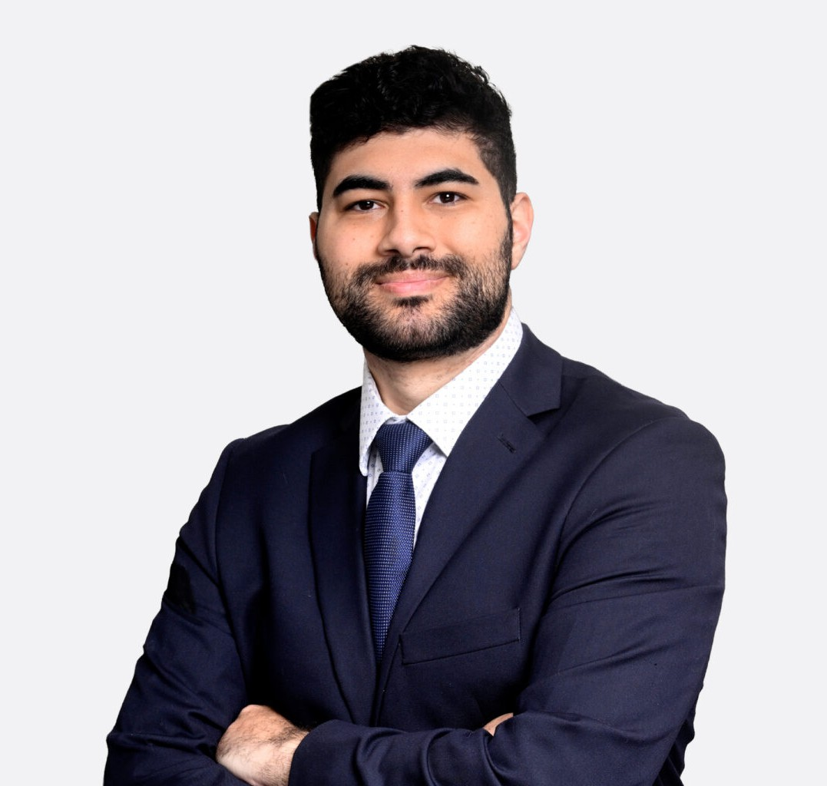

JAKE N. MOAWAD
Associate
Business Litigation

Oakland
P: 510.622.7507 F: 510.834.1928
jmoawad@fennemorelaw.com

JAKE N. MOAWAD
Jake Moawad is a business litigation associate representing both individuals and companies in commercial disputes in state and federal courts. He works with businesses ranging from emerging startups to Fortune 500 organizations, helping clients resolve contract disputes, business torts, franchise litigation, and other high-stakes commercial conflicts through strategic advocacy and practical legal counsel.
Jake manages every stage of litigation, from early case assessment and legal strategy through discovery, motion practice, depositions, and trial preparation. He has extensive experience prosecuting and defending breach of contract claims, franchisor-franchisee disputes, and transactional litigation.
Jake combines his engineering degree and STEM background with his experience in intellectual property litigation, including patent litigation, trademark, copyright, and trade secret matters.
This combination gives him a deep understanding of the technical and legal issues involved in protecting innovation and intellectual property. Clients value his thoughtful, detail-oriented approach to developing litigation strategies that align with their business objectives while positioning matters for efficient and favorable resolution.
Prior to joining Fennemore, Jake served as a judicial extern to Chief Judge Algenon L. Marbley of the U.S. District Court for the Southern District of Ohio. During his externship, he assisted with preparing judicial orders involving a variety of legal issues, including patent and trademark
litigation, giving him valuable insight into judicial decision-making and effective advocacy.

EDUCATION

J.D., Santa Clara University School of Law High Tech Law Certificate
Associate Development Editor, High Technology Law Journal
AIPLA Giles Sutherland Rich Memorial Patent Moot Court Competition INTA Saul Lefkowitz Trademark Moot Court Competition
B.S., The Ohio State University

Double Majored in Chemical Engineering and Economics

REPRESENTATIVE MATTERS

Secured early dismissals of multimillion-dollar commercial fraud lawsuits against a Fortune 500 company arising from the manufacture, marketing, and sale of products; eliminating the client’s exposure to financial and litigation risk.
Successfully defeated a motion for summary judgment in a defamation lawsuit involving allegations of investment fraud, insider trading, and financial misconduct, positioning the case for a favorable resolution on behalf of the client.

AREAS OF PRACTICE

Business Litigation Intellectual Property Business & Finance
Government Relations & Regulatory

AWARDS AND HONORS

Recipient of the Santa Clara School of Law Dean’s Fellowship Witkin Award for Academic Excellence – Constitutional Law I

ARTICLES AND PRESENTATIONS

Author, “Auris Health, Inc. V. Intuitive Surgical Operations: A New “Rigid Rule” for Patent Obviousness,” Santa Clara High Technology Law Journal, August 8, 2022

ADMISSIONS

California
United States District Court for the Central District of California United States District Court for the Southern District of California United States District Court for the Eastern District of California

