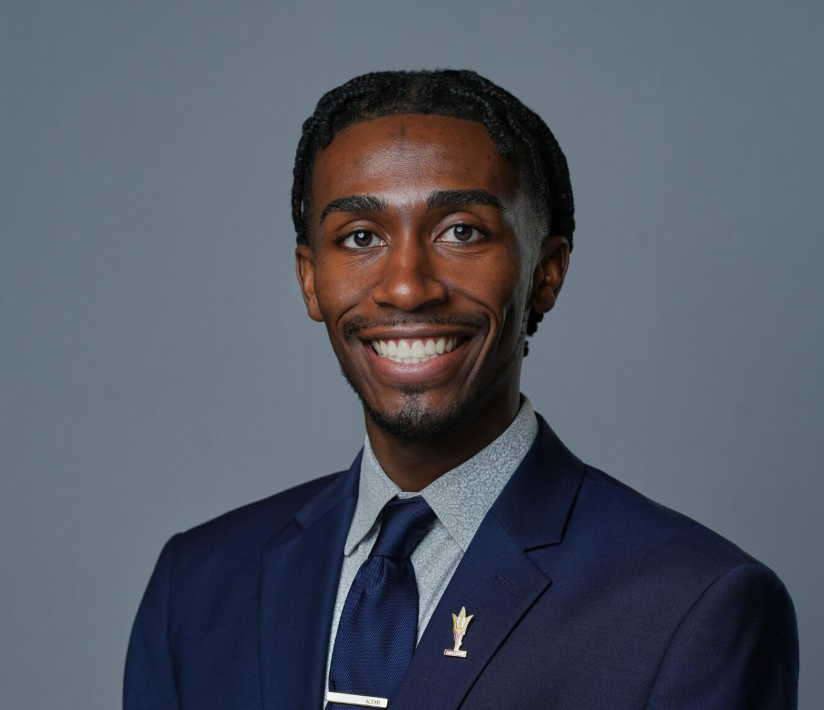

K.J. RUSSELL
Associate
Business & Finance

Phoenix
P: 602.916.5326 F: 602.916.5999
krussell@fennemorelaw.com

K.J. RUSSELL
K.J. Russell is an associate attorney in Fennemore’s Business & Finance practice group. He advises startups, emerging growth companies, entrepreneurs, investors, and established businesses on corporate law, business transactions, and commercial matters. His practice includes business formation, entity selection and governance, commercial contracts, mergers and acquisitions, strategic transactions, corporate compliance, and intellectual property-related business matters. K.J. works with clients across a variety of industries, including technology,
fashion, entertainment, and sports, helping them navigate legal issues that support growth and long-term business success. He also assists individuals and business owners with select estate planning matters.
K.J. also has a particular focus on the rapidly evolving area of collegiate athletics name, image, and likeness (NIL). He counsels NIL collectives, college athletes, sports agencies, universities, and other industry participants on NCAA and conference compliance considerations, deal
structuring, risk management, and the negotiation of NIL agreements, endorsement agreements, sponsorship agreements, licensing agreements, marketing agreements, branding partnerships, and athlete services contracts. As a certified Athlete Agent, K.J. provides practical guidance to clients navigating the legal and business challenges of the modern sports marketplace.
Prior to joining Fennemore, K.J. served as a legal extern with Klutch Sports Group, where he assisted with drafting and negotiating athlete representation agreements, endorsement
contracts, sponsorship agreements, and other sports-related commercial transactions. He also conducted legal research involving sports contracts, name, image, and likeness (NIL)
regulations, athlete eligibility, and compliance issues. During law school, K.J. completed legal externships with Granderson Des Rochers, the Arizona Coyotes, and the Arizona Department of Gaming, further expanding his experience in sports, gaming, entertainment, and business law.
Before pursuing a legal career, K.J. worked in sales and marketing with Paragon Marketing
Group, the Atlanta Hawks, the Milwaukee Bucks, Fiserv Forum, Ohio University Ticket Operations, and the Southern Ohio Copperheads Baseball Team. His firsthand experience in professional sports and sports marketing gives him valuable insight into the business objectives of athletes, sports organizations, brands, and corporate partners.
Outside the office, K.J. enjoys playing basketball and tennis, traveling, and discovering local donut shops and ice cream parlors wherever he goes. He is also an avid sports video game

enthusiast, with favorites including NBA 2K, Madden, and EA Sports FC.

EDUCATION

J.D., Arizona State University, Sandra Day O’Connor College of Law Arizona State University College of Law, Outstanding Graduate Award Arizona State University College of Law, Dean’s Award Sports and Entertainment Law Journal Zealous Leader Award
MSLB, Master of Sports Law and Business, Arizona State University, Sandra Day O’Conner College of Law
Arizona State University College of Law, Outstanding Graduate B.S.M, Ohio University, College of Business
Excellence in Leadership and Scholarship Award
B.A., Ohio University, College of Business Outstanding Senior Leader Award

AREAS OF PRACTICE

Business & Finance Intellectual Property Apparel & Fashion Automotive Dealership

AWARDS AND HONORS

Fiesta Bowl McLendon Award
Fennemore Craig, ASU Law Diversity Scholarship/Fellowship

PROFESSIONAL AND COMMUNITY AFFILIATIONS

Community Relations Chair, Black Sports Professionals Member, Forbes BLK
Member, Black Entertainment and Sports Lawyer Association Member, Maricopa County Bar Association
Member, Arizona Black Bar Association Member, Sports Lawyer Association

ARTICLES AND PRESENTATIONS

Co-Author, “Nebraska NIL ruling offers roadmap for structuring safer NIL deals,” Fennemore Blog, June 30, 2026

Co-Author, “March Madness, NIL and ambush marketing: What brands should include in their deals with collegiate basketball stars,” Sports Business Journal, March 16, 2026
Co-Author, “Influencer-Athletes at the Olympics and on Campus: The Contract Pitfalls Are the Same,” Fennemore Blog, February 13, 2026
Co-Author, “NCAA settlement, Arizona’s SB 1615 reshaping student-athlete compensation — here’s how,” Wrangler News Independent, July 3, 2025
Co-Author, “A new chapter in college athletics,” Arizona Capitol Times, July 2, 2025
Co-Author, “Finally, Arizona schools will pay student athletes. But it could cost you | Opinion,” AZ Central, July 2, 2025
Co-Author, “NIL Agents: The Good, the Bad, and the Unregulated,” Fennemore Blog, March 4, 2025
Co-Author, “A patchwork of name, image and likeness agent regulations leaves student-athletes largely unprotected,” Phoenix Business Journal, March 1, 2025
Featured, “Meet recent grads beginning their careers right after commencement,” ASU News, May 8, 2024
Author, “The Ten-Cent Infrastructure of a Billion-Dollar Industry,” Arizona State Sports and Entertainment Law Journal
Author, “Adverse Advertisement Galore,” Arizona State Sports and Entertainment Law Journal

ADMISSIONS

Arizona

