
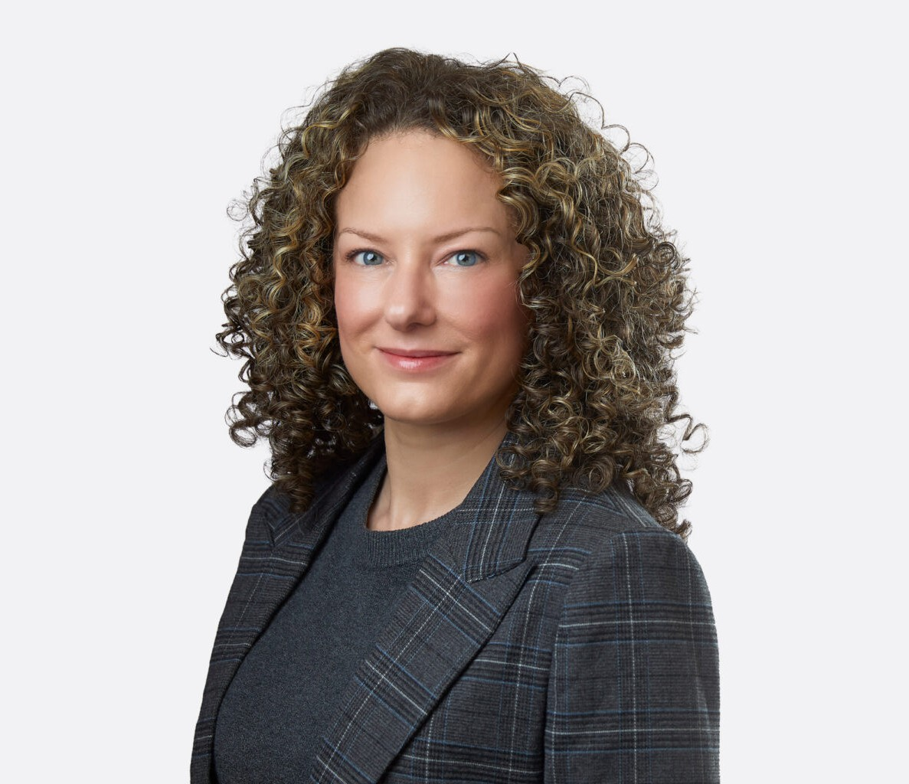
Chelsie is a trial attorney and Director in Fennemore’s business litigation practice group and serves as Managing Partner of the firm’s Las Vegas office. She represents businesses, entrepreneurs, and individuals in complex commercial and construction litigation in Nevada
CHELSIE ADAMS
Director
Business Litigation
Las Vegas
P: 702.791.8237
F: 702.791.8238
cadams@fennemorelaw.com
“
Well done is better than well said.
-Benjamin Franklin
CHELSIE ADAMS
”
state and federal courts, arbitration, and other dispute-resolution forums. She works closely with in-house counsel and business owners to develop practical solutions that resolve disputes while protecting broader business objectives.
Chelsie handles commercial contract disputes, breach-of-contract claims, business torts, and shareholder and partnership disputes, helping clients enforce their rights, defend claims, address payment issues, and protect their businesses. Her clients operate in commercial real estate,
construction, professional services, manufacturing and supply, lending, and health care.

Chelsie also represents owners, developers, general contractors, subcontractors, and other project participants in construction litigation involving contract performance, delays and
disruptions, differing site conditions, construction defects, change orders, payment disputes, mechanic’s liens, surety and bond claims, insurance coverage, and indemnity.
A fourth-generation Nevadan who grew up in a family-run small business, Chelsie understands the risks, margins, and real-world consequences litigation can have on businesses and
livelihoods. She brings that perspective to her representation, providing thoughtful, candid advice about strategy, timing, risk, and cost so clients can make informed decisions and plan with confidence.
Outside the office, Chelsie enjoys discovering the food, culture, and landscapes that shape people and places. She stays active through weight training and Pilates and enjoys evening strolls – or passeggiate – with her husband. She is a proud alumna of Leadership Henderson Class of 2021.

EDUCATION

J.D., Willamette University College of Law B.A., Nevada State College
AREAS OF PRACTICE

OTHER EXPERIENCE

Litigation

Business Litigation

ARTICLES AND PRESENTATIONS

Featured, “Evolving with Nevada Business: Las Vegas’ Chelsie Adams on Litigation, Leadership, and the Bigger Picture,” Fennemore blog, March 13, 2026
Author, “Balancing Leadership and Lawyering: Managing a Local Office Within a Regional Firm,” Clark County Bar Association, February 27, 2026
Interview, “A conversation on lessons learned & life in the law with attorney Chelsie Adams,” Fennemore Blog, March 16, 2023

AWARDS AND HONORS
Best Lawyers in America®, Commercial Litigation, Construction Law, 2027
Best Lawyers in America®, Ones to Watch, Commercial Litigation, Litigation – Construction, 2023-2026, Litigation – Real Estate, 2025-2026
“Legal Elite,” Nevada Business Magazine, 2018-2020

PROFESSIONAL AND COMMUNITY ACTIVITIES

Member, State Bar of Nevada
Volunteer, Legal Aid Center of Southern Nevada, Children’s Attorney Project

ADMISSIONS

Nevada

