
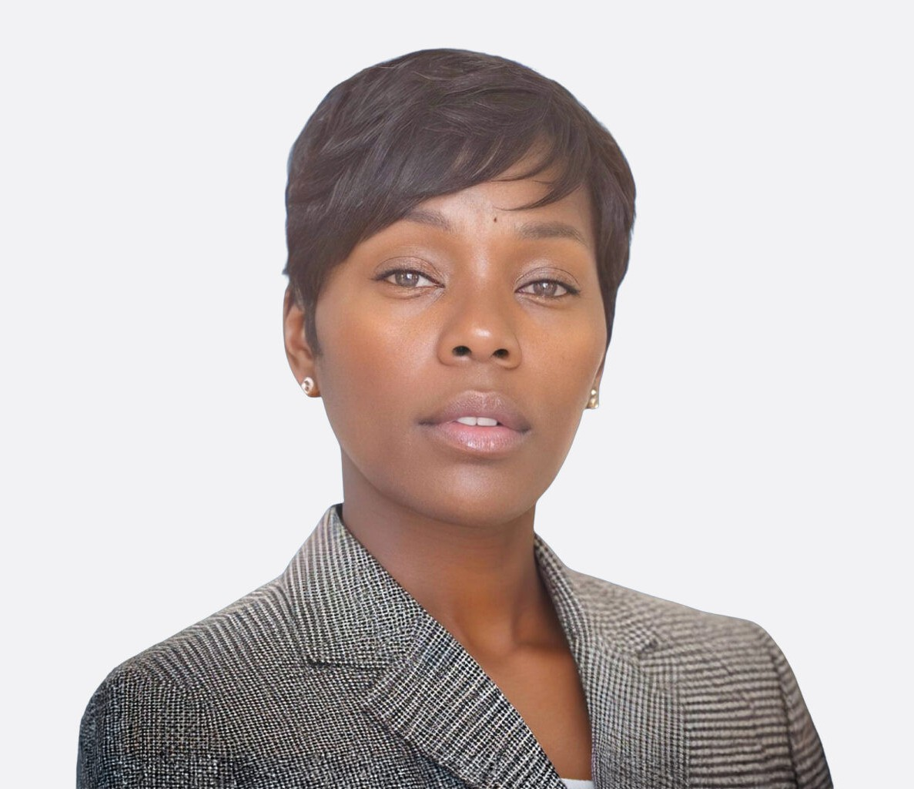
E. SHAN DAVIS
Paralegal
Business Litigation

E. SHAN D“AVIS

Comfort kills ambition over time.
San Diego
P: 619.595.3275
sdavis@fennemorelaw.com

”

E. Shan Davis is a business litigation paralegal in Fennemore’s San Diego office.

With over 19 years of experience in Nevada state and federal courts, she has supervised support staff, drafted subpoenas, deposition notices, and written discovery. She has handled ERISA
litigation, prepared pleadings and discovery, managed litigation calendars, and handled subrogation and third-party recovery claims by reviewing medical records and preparing demand letters. Shan has also worked on complex civil cases including personal injury, product liability, medical malpractice, wrongful death, and minor compromise proceedings.
Shan has owned a loan signing company, assisting homeowners during the loan closing process. She holds a Master of Dispute Resolution and a Master of Legal Studies from Pepperdine
University, Caruso School of Law, and is a commissioned Nevada notary. In her spare time, Shan enjoys concerts, dancing, and reading.

EDUCATION

M.L.S./M.D.R., Pepperdine University, Caruso School of Law B.S., Tennessee State University, cum laude

AREAS OF PRACTICE

Business Litigation

PROFESSIONAL AND COMMUNITY ACTIVITIES

Member, Nevada State Bar Paralegal Association

ADMISSIONS

*Not licensed to the practice of law

