
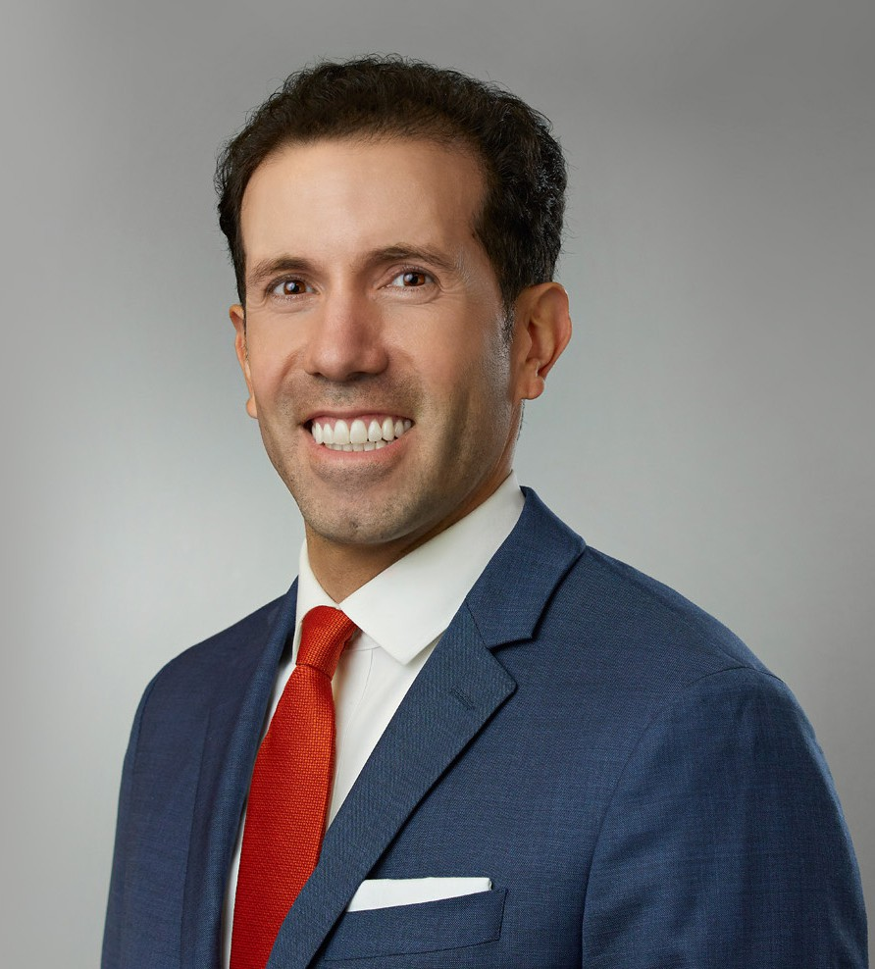
ENRIQUE SCHAERER
ENRIQUE SCHAERER
Of Counsel
Business Litigation
Las Vegas
P: 702.692.8013
F: 702.692.8099
Reno
P: 702.692.8013
F: 702.692.8099
eschaerer@fennemorelaw.com
Enrique Schaerer is an Of Counsel attorney in Fennemore’s Business Litigation and Estate Litigation practice groups. He represents businesses, executives, fiduciaries, and individuals in complex commercial disputes, contract litigation, trust and estate controversies, employment matters, criminal defense, and government investigations. Enrique has represented clients in high-stakes litigation in state and federal courts across Nevada, Arizona, and California.
An experienced trial lawyer and appellate advocate, Enrique approaches every matter with a comprehensive litigation strategy tailored to each client’s objectives. He believes that thoughtful planning at the earliest stages of a dispute can position clients for stronger outcomes, whether through negotiation, motion practice, trial, or appeal.
Before joining private practice, Enrique served as a Deputy District Attorney, where he prosecuted misdemeanor and felony cases, tried dozens of criminal matters before judges and juries, and worked closely with law enforcement on investigations. His courtroom experience in motion practice and trial, combined with his appellate practice, enable him to guide clients through every phase of complex litigation. He has briefed and argued civil and criminal matters
before numerous courts, including the U.S. Supreme Court, the U.S. Court of Appeals for the Ninth Circuit, and the Nevada Supreme Court.
Enrique previously served as a judicial law clerk to the Honorable James V. Selna of the U.S. District Court for the Central District of California and the Honorable Carlos T. Bea of the U.S.
Court of Appeals for the Ninth Circuit. He earned his J.D. from Yale Law School, where he served on the Yale Law Journal and won the Potter Stewart Prize for best written brief and oral argument in the school-wide moot court competition. He graduated as valedictorian from the University of Notre Dame, earning degrees in finance and political science.
In addition to his litigation practice, Enrique has published scholarly articles on constitutional law, statutory interpretation, employment law, and emerging issues at the intersection of law and
technology, reflecting his longstanding interest in legal analysis, advocacy, and forecasting.

EDUCATION

J.D., Yale Law School
Potter Stewart Prize, Moot Court Winner Senior Editor, Yale Law Journal
B.A., University of Notre Dame, summa cum laude
Valedictorian of Class of 2005 Helen Kellogg Prize
Herman Crown Award Phi Beta Kappa

AREAS OF PRACTICE

Business Litigation Cannabis Business

REPRESENTATIVE MATTERS

Advised and counseled on legal protections under Nevada law for spendthrift trusts with assets worth billions of dollars.
Crafted complex legal argument that helped settle multi-million-dollar dispute over holographic will on favorable terms for prestigious out-of-state university.
Exposed fabricated claims by plaintiff that resulted in complete dismissal of federal lawsuit with serious allegations against client under quasi-criminal, sex-trafficking law.
Spearheaded litigation in probate/guardianship cases with 3/4 of a billion dollars in trust at stake. Achieved restatement of trust over allegations of testamentary incapacity/undue influence.
Achieved removal of personal representative of estate and successor trustee of trust. Achieved trial verdict for damages and order for company to recover assets from exmanager. Achieved arbitration award that police department had just cause to fire police officer.
Achieved order issuing pretrial writ of habeas corpus and dismissing felony perjury charge. Achieved favorable settlement in mediation of federal employment discrimination claims. Deposed expert witness and helped settle trust contest of hundreds of millions of dollars.
Deposed party opponent and her accountant in litigation over personal service agreement.
Negotiated favorable settlement of trust contest of millions of dollars for prestigious out-of-state university.
Removed notice of pendency of litigation on real estate and had quiet title action dismissed.
Represented applicants seeking protection orders and defendants charged with nonviolent crimes.

AWARDS AND HONORS

Best Lawyers in America®, Commercial Litigation, 2024-2027

ARTICLES AND PRESENTATIONS

Featuring, “On the Move,” Las Vegas Business Press, November 1, 2022
Proving the Constitution: Burdens of Proof and the Confrontation Clause, 55 University of Richmond Law Review 491, 2021
What the Heller?: An Originalist Critique of Justice Scalia’s Second Amendment Jurisprudence, 82 University of Cincinnati Law Review 795, 2014
A Rose by Any Other Name: Why a Parens Patriae Action Can Be a “Mass Action” under the Class Action Fairness Act of 2005, 6 N.Y.U. Journal of Legislation & Public Policy 39, 2013
Intragroup Discrimination in the Workplace: The Case for “Race Plus,” 45 Harvard Civil Rights–Civil Liberties Law Review 57, 2010
Liability in Robotics: An International Perspective on Robots as Animals, Advanced Robotics, 2010 (co-authored with Richard C. Kelley, Monica Nicolescu, and Micaela Gomez)
Robots as Animals: A Framework for Liability and Responsibility in Human-Robot Interactions, Proceedings of the 18th IEEE Symposium on Robot & Human Interactive Communication, 2009 (co-authored with Richard C. Kelley and Monica Nicolescu)

PROFESSIONAL AND COMMUNITY ACTIVITIES

Part-Time Olin-Searle Fellow, Federalist Society, UCLA Law School, 2016-2019 Member, Executive Committee, Yale Law School Association, 2011-2014
Member, College of Arts and Letters Advisory Council, University of Notre Dame, 2009-2012

ADMISSIONS

All Nevada and California state courts
U.S. Supreme Court
U.S. Court of Appeals for the Ninth Circuit
U.S. District Court for the Central District of California
U.S. District Court for the Southern District of California
U.S. District Court for the District of Nevada

LANGUAGES

Spanish, Fluent
Italian, Conversational

