
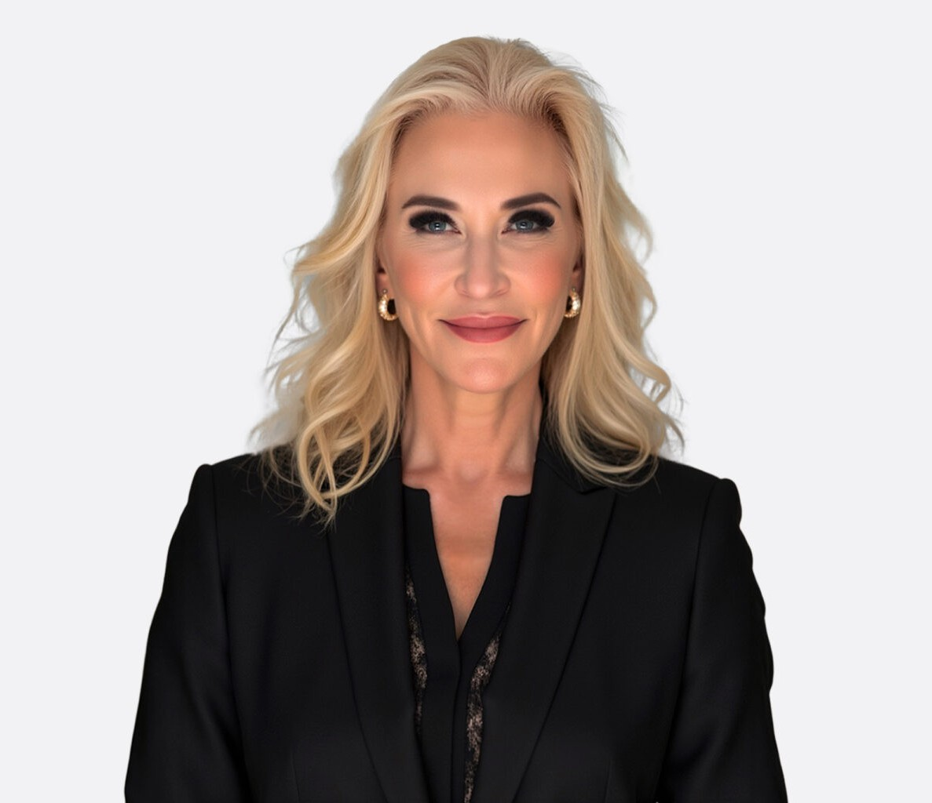
LESLEY B. MILLER
LESLEY B. MILLER
Of Counsel
Business & Finance
Las Vegas
P: 702.692.8014
F: 702.692.8099
lmiller@fennemorelaw.com
Lesley Miller is a Las Vegas administrative and regulatory attorney who helps businesses navigate Nevada licensing requirements, agency proceedings and regulatory compliance. As Of Counsel at Fennemore, she represents clients in matters involving the Nevada Gaming Control Board,
Nevada Transportation Authority and Nevada State Contractors Board, as well as other regulated industries.
Lesley advises businesses on administrative law, gaming law, licensing, regulatory compliance and government agency matters. She also handles civil litigation, including disputes that
intersect with agency enforcement, licensing issues or administrative proceedings. Her approach is practical and strategic, helping clients understand regulatory requirements, evaluate available options and pursue efficient solutions to complex legal and business challenges.
Before joining Fennemore, Lesley spent more than 15 years in private practice representing businesses in administrative, regulatory, and litigation matters. Her professional experience also includes civil litigation and insurance defense. She brings valuable public-sector experience to her regulatory practice as a former commissioner and administrative law judge with the Nevada Transportation Authority after being appointed by the governor. In that role, she adjudicated contested cases involving certificates of public convenience and necessity, licensing and permitting disputes, tariffs and rates, and safety enforcement actions involving regulated transportation providers. She also completed administrative law adjudication training through the National Judicial College and has served as an American Arbitration Association® Panelist.

EDUCATION

J.D., Loyola Law School
B.A., University of Michigan
Certification of Completion, Administrative Law Adjudication Skills, University of Nevada, Reno, The National Judicial College
American Arbitration Association® Arbitrator Panelist Training

AREAS OF PRACTICE

OTHER EXPERIENCE

Transportation

Business & Finance Gaming & Hospitality Construction Law

REPRESENTATIVE MATTERS

Represented gaming operators and restricted-license holders in licensing and compliance matters
Represented hospitality and entertainment operators in combined liquor and gaming licensing proceedings
Counseled regulated businesses on compliance before the Nevada Gaming Control Board, Nevada Transportation Authority and Nevada State Contractor’s Board
Represented client leading to a precedent-setting decision expanding first-party bad faith rights under Nevada insurance law

AWARDS AND HONORS
Best Lawyers in America®, Gaming Law, 2025-2027
Super Lawyers® Mountain States, Business Litigation, 2025-2026
Super Lawyers® Mountain States, Rising Stars, Business Litigation, 2012-2016 “Women in Law 2017 Award” in Gaming Law, Lawyer Monthly, 2017
“Legal Elite: Top Attorneys in Nevada,” Administrative, Regulatory & Gaming Law, Litigation and Real Estate & Construction, Nevada Business Magazine, 2013, 2014
Top “20 under 40” Professionals Award, Reno-Gazette Journal, 2011

ARTICLES AND PRESENTATIONS

Presenter, “Emerging Fraud Risks in the Cannabis Industry: Cannabis Industry Fraud Trends,
Insights, and Emerging Risks to Fraud Investigation Professionals,” Association of Certified Fraud Examiners (ACFE)

PROFESSIONAL AND COMMUNITY ACTIVITIES

Member, Administrative Law Section, American Bar Association Member, State Bar of Nevada, Gaming Law Section, Litigation Section

ADMISSIONS

Nevada

LANGUAGES
Spanish

