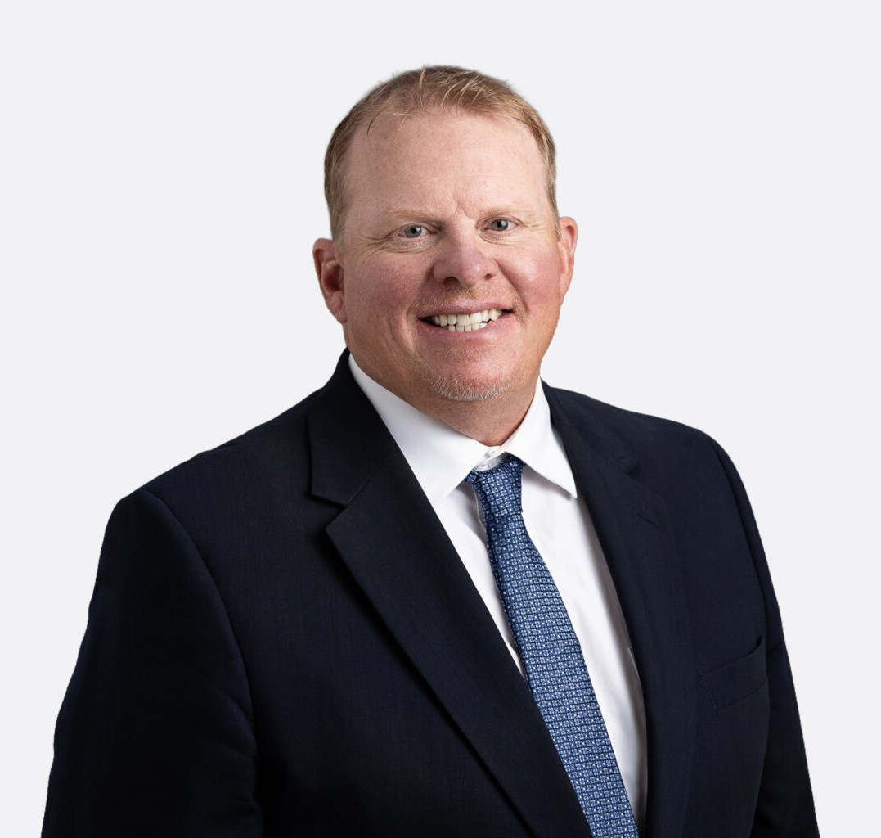

ARNOLD L. WAGNER
Director
Construction Law

Boise
P: 208.738.9471
awagner@fennemorelaw.com

ARNOLD L. WAGNER
Arnold L. Wagner (“Arnie”) is a trial attorney at Fennemore who represents contractors,
subcontractors, sureties, project owners, suppliers, and businesses in complex construction, commercial, and employment disputes. With nearly 30 years of experience, Arnie helps clients manage legal risk, resolve high-value disputes, negotiate sophisticated contracts, and make informed business decisions that support long-term success.
Arnie’s practice focuses on construction law, commercial litigation, and business counseling. He represents clients in construction litigation, contract disputes, delay and payment claims, defect and warranty litigation, surety matters, and alternative dispute resolution, including mediation and arbitration. He also advises clients on the drafting, negotiation, and administration of construction contracts, helping them identify risks before they become costly disputes. Many of Idaho’s largest contractors rely on Arnie as a trusted legal advisor for day-to-day operational
issues, contract strategy, and project risk management.

Beyond the construction industry, Arnie represents businesses in a wide range of commercial litigation matters, including breach of contract, business/partnership disputes, employment
disputes, breach of warranty, defective product litigation, and complex debt collection matters. He works closely with business owners and executives to develop litigation strategies that align with their operational and financial objectives, whether pursuing an efficient resolution or preparing a case for trial.
Known for his practical, business-minded approach, Arnie is committed to helping clients do more than resolve legal disputes. He partners with businesses to strengthen their operations, reduce future risk, and implement proactive legal strategies that support continued growth. Clients value his responsiveness, strategic thinking, and ability to provide clear, actionable advice in high-stakes situations.
Arnie earned his bachelor’s degree, summa cum laude, from Western Washington University,, and received his Juris Doctor from the University of Washington School of Law.

EDUCATION

J.D., University of Washington School of Law

B.A., Western Washington University

AREAS OF PRACTICE

Construction Law Business Litigation Labor & Employment

AWARDS AND HONORS

Best Lawyers, Construction Law, Litigation – Construction, 2018-2026
Best Lawyers, “Lawyer of the Year.” Construction Law, Litigation – Construction, 2024 Super Lawyers, Construction Litigation, 2020-2026
Lawyers of Distinction, Charter Member, Civil Litigation Forty Accomplished Under 40, Idaho Business Review Martindale-Hubbell “AV” Peer Review Rated Attorney

PROFESSIONAL AND COMMUNITY ACTIVITIES

Member, Idaho State Bar, Sections on Litigation and Employment Law Member, American Bar Association, Trial Lawyers Section
Member, Boise Metro Chamber of Commerce
Board of Directors, Construction Financial Management Association (CFMA) Member, Idaho Associated General Contractors
Member, East Boise Youth Baseball and Softball Executive Board Former Board of Directors for Idaho March of Dimes
Former Board of Directors for Idaho Botanical Gardens Member, Executive Board for Idaho Legion Boise Gems Baseball Leadership Boise Alumni
Member, Hillcrest Country Club

ADMISSIONS

Idaho

