
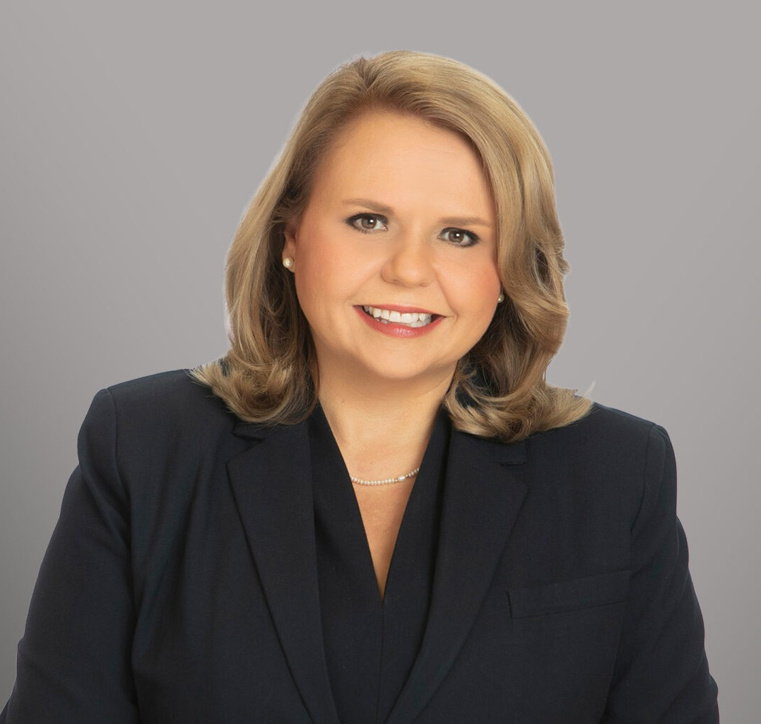
CHRISTINE REINHARD
CHRISTINE REINHARD
Director
Labor & Employment
San Antonio
P: 210.447.8033
F: 210.447.8036
creinhard@fennemorelaw.com
Christine E. Reinhard is a Director in Fennemore’s Employment & Labor practice group based in San Antonio, Texas.
Christine is Board Certified in Labor and Employment Law by the Texas Board of Legal
Specialization. Her practice encompasses all aspects of labor and employment law. An active trial lawyer, she has defended employers in jury and bench trials and frequently litigates in court and in private arbitrations. She additionally assists employers with various preventative and non-litigation strategies and activities, such as:
Counseling employers on strategic and complex employment policy and contractual issues
Advising employers through governmental investigations and audits, including by such agencies as the Texas Workforce Commission, EEOC, DOL, and OFCCP
Reviewing and preparing employment contracts and non-compete agreements Conducting in-house training on a variety of labor and employment-related topics
Besides representing employers in National Labor Relations Board proceedings, Christine also has guided employers through union negotiations and corporate campaigns. Christine’s representation in the traditional labor context has included both public and private entities.
Before joining Fennemore, Christine was a founding partner of Schmoyer Reinhard, LLP. Earlier in her career, she was a counsel in the labor and employment section of Akin Gump Strauss Hauer & Feld LLP.

EDUCATION

Board Certified in Labor and Employment Law by the Texas Board of Legal Specialization J.D., St. Mary’s University School of Law, summa cum laude
B.A., Texas A&M University, magna cum laude

AREAS OF PRACTICE

Labor & Employment Business Litigation

AWARDS AND HONORS

2024 Lee Cusenbary Ethical Life & Leadership Award, Association of Corporate Counsel – San Antonio Chapter
Chambers USA, Labor & Employment: Texas, 2018 – 2026
San Antonio’s Outstanding Women Lawyers, Scene in S.A., 2026
Best Lawyers in America®, San Antonio Lawyer of the Year, Labor Law – Management (2022), Employment Law – Management (2019, 2027), and Litigation – Labor and Employment (2012)
The Best Lawyers in America®, 2011 – 2027 Thomson Reuters Texas Super Lawyer, 2013 – 2025
Top Labor and Employment Attorney, San Antonio Magazine, 2025

ARTICLES AND PRESENTATIONS

Panelist, “Crisis Management and the Role of Social Media,” 48th Annual Corporate Counsel Institute, University of Texas Law CLE, April 23-24, 2026
Co-Author, “The Future of Remote Work,” The State Bar Litigation Section Report – The Advocate in the Volume 110, Spring 2025 edition
Presenter, “Practical Litigation,” 32nd Annual Advanced Employment Law Conference, January 11, 2024
Presenter, “Workplace Accommodations Under State and Federal Law, Including the New
Pregnant Workers Fairness Act,” State Bar of Texas Labor & Employment Law Section 33rd Annual Labor and Employment Law Institute, August 26, 2023
Co-Author, “COVID-19’s Impact on the Practice of Employment Law,” Texas Bar Journal, May 2022
Presenter, “Not My Employee: The Legal Realities of a Contingent Workforce,” State Bar of Texas, 30th Annual Advanced Employment Law Course, April 22, 2022

PROFESSIONAL AND COMMUNITY ACTIVITIES

Life Fellow, Texas Bar Foundation
Life Fellow, San Antonio Bar Foundation
Member, State Bar of Texas Labor and Employment Law Section Council (2022 – 2024) Member, Texas Board of Legal Specialization – Labor & Employment Law Exam Commission
Scholarship Task Force Member (2022) and Scholarship Committee Member, San Antonio Bar Foundation (2023)
Symposium and Seminars Co-Chair, LEAD Academy Steering Committee (2016 – 2022) Board Member, San Antonio Bar Association (2014 – 2018)

Past President (2010) and Member, Bexar County Women’s Bar Association & Foundation

ADMISSIONS

Texas
U.S. District Court, Eastern District of Texas
U.S. District Court, Northern District of Texas
U.S. District Court, Southern District of Texas
U.S. District Court, Western District of Texas
U.S. District Court, District of Colorado
U.S. Court of Appeals, 5th Circuit
U.S. Court of Appeals, 10th Circuit

