
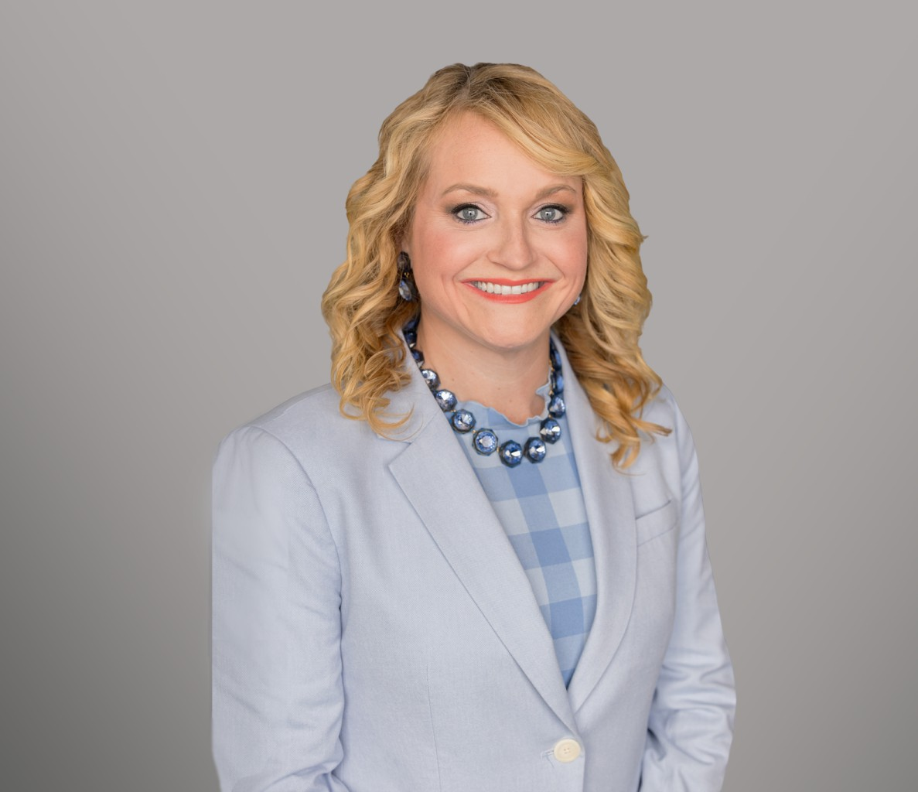
JENNI HARMON
JENNI HARMON
Of Counsel
Trusts & Estates
Sacramento
P: 916.920.5286
F: 916.920.8608
jharmon@fennemorelaw.com
Jenni Harmon practices trust and estate litigation, probate and trust administration, estate planning, taxation, and business transactions. Her comprehensive estate planning services
include skillfully crafting tailored plans that include drafting complex estate planning documents, including wills, trusts, special needs trusts, and other key documents to meet the unique needs and goals of her clients.
Jenni navigates the complexities of probating estates, administering trusts, and advising personal representatives, trustees, and beneficiaries to ensure a smooth and compliant process for her
clients. Jenni’s probate litigation practice involves representing fiduciaries and beneficiaries in all types of trust and estate matters, as well as conservatorships and guardianships. Her skill in this area, combined with her knowledge in taxation and business transactions, makes her a valuable asset to clients looking for well-rounded legal guidance in trusts and estates matters.

EDUCATION

E-LL.M., Taxation, New York University School of Law
J.D., with Distinction, Concentration in Tax Law, McGeorge School of Law, University of the Pacific
B.S., Political Science with Pre-Law Emphasis and an Italian Minor, Santa Clara University

AREAS OF PRACTICE

Trusts & Estates Estate Litigation Tax Law
Estate Planning

AWARDS AND HONORS
Best Lawyers in America®, Trusts and Estates , 2026-2027
Witkin Award for highest grade in Fundamental Rights in Europe and the United States

Witkin award for highest grade in Bankruptcy Law
Witkin Award for highest grade in Taxation (U.S.) of International Transactions Sacramento Magazine List of 2017 Top Lawyers in Sacramento (Tax)
Sacramento Magazine List of 2018 Top Lawyers in Sacramento (Tax)
Sacramento Magazine List of 2019 Top Lawyers in Sacramento (Estate Planning and Probate) Sacramento Magazine List of 2023 Top Lawyers in Sacramento (Estate Planning and Probate) Sacramento Business Journal Best of the Bar – 2017

ARTICLES AND PRESENTATION

Presenter, “Third Time’s a Charm? Key v. Tyler and No Contest Clauses,” 2025 Estate and Gift Tax Conference, March 6-7, 2025
Presenter, “The Tip of the Iceberg: How Not to Muck Up An Estate Plan,” 2024 Estate and Gift Tax Conference, California Lawyers Association, March 21, 2024
Co-Author, “Clarifying Standards for Trade or Business Real Estate Debt,” Viewpoint Tax Notes, September 11, 2015

PROFESSIONAL AND COMMUNITY ACTIVITIES

Member, Executive Committee, Taxation Section, State Bar of California Member, State Bar of California
Trusts and Estates Section
Taxation Section
Member, Sacramento County Bar Association Probate and Estate Planning Section
Tax Section Business Section
Sacramento Estate Planning Council, Education Chair, 2021-2022
Director, 2021-2022
Program Co-Chair, 2022-2023
Social Co-Chair, 2023-2024
Board Member at Large, Barristers Club of Sacramento Member, Women Lawyers of Sacramento
Anthony M. Kennedy Inns of Court
Co-Chair for the 54th Annual CalCPA Golf Tournament

ADMISSIONS

California

U.S. District Court, Eastern District of California
U.S. District Court, Northern District of California
U.S. Tax Court

