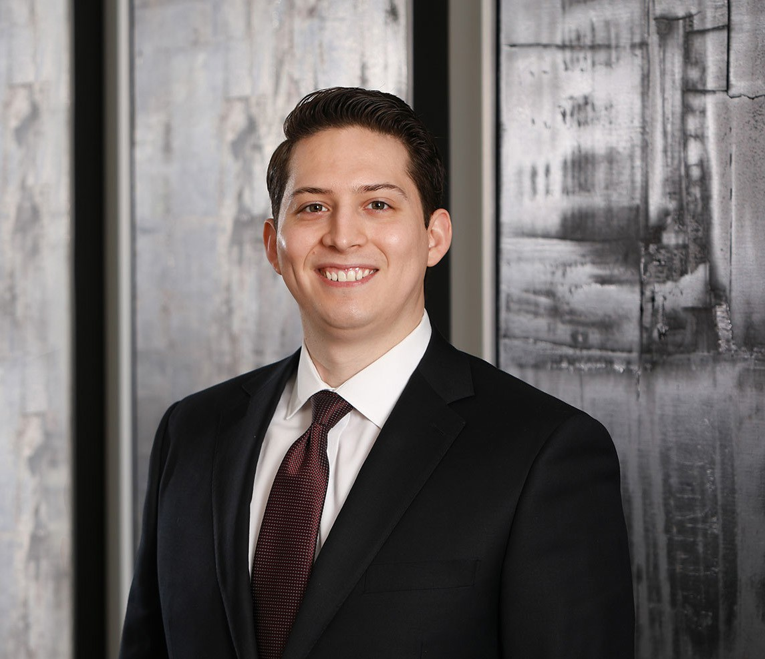

JUSTIN A. ROBLES
Associate
Business Litigation

Phoenix
P: 602.916.5415 F: 602.916.5615
jrobles@fennemorelaw.com

JUSTIN A. ROBLES
Justin A. Robles works out of our Phoenix office in our business litigation practice group focusing primarily on commercial litigation, including a broad array of construction matters between
owners, general contractors, and subcontractors.

A Phoenix native and fluent in Spanish, Justin is a graduate from the new downtown campus of the Sandra Day O’Connor College of Law at Arizona State University. During law school, Justin externed at the United States District Court for the District of Arizona and interned in the election law department at the Arizona Secretary of State’s Office. As a business litigation attorney, he enjoys the intellectual challenge of interpreting complex contracts and laws on behalf of his business clients to ensure their success.
Justin is married to his high school sweetheart, Katrina. Outside of his work as a business litigation attorney, Justin is a former wrestler and baseball player and enjoys following both sports. He enjoys traveling and spending time with his family.

EDUCATION

J.D., cum laude, Arizona State University, Sandra Day O’Connor College of Law
B.S. University of Arizona
Research Editor, Arizona State Law Journal, 2018-2019 CALI Award for highest grade in International Contracts Pedrick Scholar, 2016-2018

AREAS OF PRACTICE

Business Litigation Construction Law

AWARDS AND HONORS
Best Lawyers in America®, Ones to Watch, Construction Law, Litigation – Construction, 2022, 2027

Top Lawyer – Construction, Phoenix Magazine, 2026
Southwest Super Lawyers Rising Stars®, Business Litigation, 2026 Top Lawyers, Phoenix Magazine, 2025

ADMISSIONS

Arizona Nevada

LANGUAGES

Spanish, Fluent

