
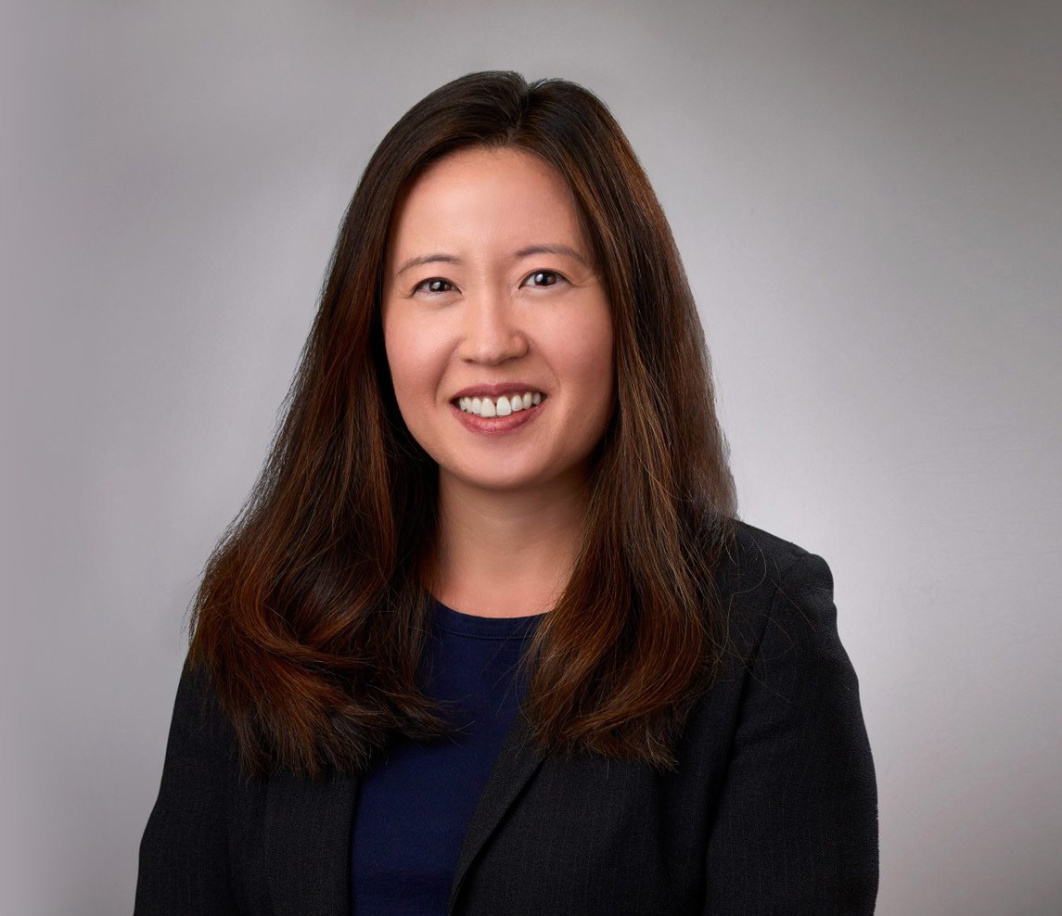
KATE PARK HONG
Of Counsel
Business & Finance

KATE PAR“K HONG
San Diego
P: 619.344.2989 F: 619.231.4372
khong@fennemorelaw.com

It’s a good day if you helped someone. ”

Kate Hong is an Of Counsel attorney in our San Diego office who assists clients in raising capital and obtaining financing through private and public debt offerings, secured and unsecured
loans, private equity offerings and asset purchase and sale transactions. She has extensive experience in entity formation, corporate compliance, SEC filings, and advising clients with respect to entity selection, structure, and operation.
Kate is also experienced in real estate matters including leases, easements, and purchase and sale transactions. Her practice covers financing transactions, and negotiates commercial real estate finance loan documents, mezzanine/bridge loan documents and other debt transaction documents for clients.
She is also well-versed in corporate provisions relating to syndicated transactions, and she has broad experience closing purchases and sales of syndicated properties across the country. Kate advises a number of nonprofit and educational organizations about tax exempt status, disclosure requirements, and corporate and tax compliance under California and federal law.
In the past, Kate served as in-house counsel for a real estate company in San Diego. She started her career at a New York firm as an associate in the securitization and secured transactions
group. During law school at Columbia University, Kate was a managing editor of the Columbia Human Rights Law Review, and a recipient of the Human Rights Internship Program fellowship and the Public Interest Law Initiative fellowship.

EDUCATION

J.D., Columbia Law School B.A., Brown University

AWARDS AND HONORS

Best Lawyers: Ones to Watch® in America, Real Estate Law, 2027

AREAS OF PRACTICE

Business & Finance Real Estate

ADMISSIONS

California New York

