
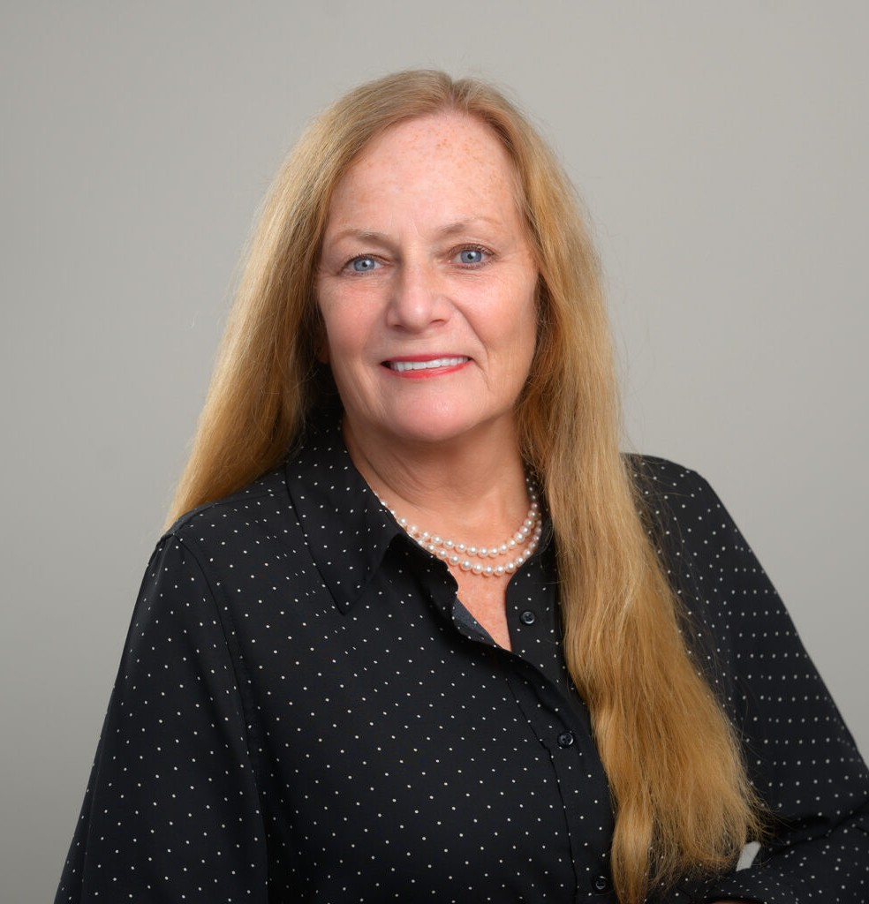
KATHLEEN A. CASHMAN-KRAMER
KATHLEEN A. CASHMAN-KRAMER
Director
Bankruptcy, Creditors’ Rights & Insolvency
San Diego
P: 619.595.3267
F: 619.231.4372
kcashman-kramer@fennemorelaw.com
Kathleen A. Cashman-Kramer brings her knowledge in navigating financial turbulence and offering personalized debt relief strategies to her practice in bankruptcy, insolvency matters, commercial, and real estate litigation. Representing trustees, creditors, and debtors in commercial bankruptcies, she guides clients through the complexities of financial distress, ensuring informed and strategic decisions.
Kathleen has successfully tried cases in federal and state courts and engaged in ADR proceedings with the American Arbitration Association (AAA) and other panels. Her comprehensive approach in Bankruptcy Court extends to representing an array of clients, including bankruptcy trustees, secured, priority, and unsecured creditors, lessors, and commercial bankruptcy debtors in Chapter 11 and Chapter 7 proceedings. This includes her experience as the staff attorney for a standing Chapter 13 Trustee in the U.S. Bankruptcy Court for the Southern District of California.
Her legal practice also covers representing title insurance companies and both individual and corporate clients in business and real estate litigation, showcasing her versatility and
commitment to delivering client-focused solutions in challenging financial and legal situations.

EDUCATION

J.D., New England School of Law
B.A., Stonehill College American University

AREAS OF PRACTICE

Bankruptcy, Creditors’ Rights & Insolvency Business & Finance

AWARDS AND HONORS

Top San Diego Lawyer, San Diego Magazine, 2025
Mediator of the Year by the Judges of the U.S. Bankruptcy Court (2020-21)
Best Lawyers in America®, Bankruptcy, Creditor Debtor Rights/Insolvency and Reorganization Law, 2023-2027

ARTICLES AND PRESENTATION

Co-Author, “ILC Judicial Profile – Meet New Bankruptcy Judge J. Barrett Marum, U.S. Bankruptcy Judge, Southern District of California,” California Lawyers Association, July 2025
Co-Author, “Reminder Lessons: The Interaction between the California Uniform Voidable
Fraudulent Transactions Act and Family Law,” California Lawyers Association, March 2025
Author, “In re Evans,” Insolvency Law Committee eBulletin, California Lawyers Association, September 4, 2023
Author, “In re Mack,” Insolvency Law Committee eBulletin, California Lawyers Association, June 26, 2023
Author, “Young vs. Midland – Debt collector may be held liable under the Rosenthal Act for falsely stating that substitute service had been achieved on the debtor, even if the debt collector did not know the statement was false;” Insolvency Law Committee eBulletin by the California Lawyers Association, February 23, 2023
Author, “Barclay vs. Boskoski,” Insolvency Law Committee eBulletin, California Lawyers Association, December 7, 2022
Author, “In re Open Medicine Institute, LLC,” Insolvency Law Committee eBulletin, California Lawyers Association, November 30, 2022
Author, “In re Powell – Ineligibility to be a Chapter 13 Debtor Does Not Deprive The Debtor of the “Near Absolute Right” to Dismiss His Chapter 13 Case,” Insolvency Law Committee eBulletin, California Lawyers Association, November 14, 2022
Author, “In re Portland Injury Institute – When Can An Avoidance Action Be Sold to a Creditor?” Insolvency Law Committee eBulletin, California Lawyers Association, August 16, 2022
Author, “In re Szanto,” Insolvency Law Committee eBulletin, California Lawyers Association, July 7, 2022
Author, “Jakubaitis v. Golden – Terminating Sanctions Used Against Debtor In Adversary Proceeding Resulting In Revocation of His Discharge,” Insolvency Law Committee eBulletin, California Lawyers Association, May 4, 2022
Author, “In re Crescent Associates, LLC – When Can a Bankruptcy Court Award Attorney’s Fees under California Civil Code Section 1717?” – Insolvency Law Committee eBulletin, California Lawyers Association, April 15, 2022
Author, “In re Koshkalda,” Insolvency Law Committee eBulletin, California Lawyers Association, May 19, 2021
Author, “In re Sarria,” Insolvency Law Committee eBulletin, California Lawyers Association, May 12, 2021

Author, “In re Evans,” Insolvency Law Committee eBulletin, California Lawyers Association, February 18, 2021
Author, “City of Chicago, Illinois, vs. Fulton (U.S. Sup. Ct.),” Insolvency Law Committee eBulletin, California Lawyers Association, January 18, 2021
Author, “Brown v Barclay (In re Brown) (9th Cir.),” Insolvency Law Committee eBulletin, California Lawyers Association, December 9, 2020
Author, “Berkley v. Burchard (In re Berkley) (9th Cir. BAP),” Insolvency Law Committee eBulletin, California Lawyers Association, December 7, 2020
Author, “Elliott vs. Pacific Western Bank – Debtor Cannot Avoid Completed Pre-Petition Judgment Levy on IRA Account,” Insolvency Law Committee eBulletin, California Lawyers Association, November 3, 2020
Author, “In re Bartenwerfer – Debtors Beware: Creditor’s Attorneys’ [sic] Fees for Prosecuting Section 523 Action May Also Be Non-Dischargeable, Regardless of the Amount,” Insolvency Law Committee eBulletin, California Lawyers Association, October 21, 2020
Author, “In re Burton – BAP rules “mere presence” of marijuana near bankruptcy case not
sufficient for dismissal,” Insolvency Law Committee eBulletin, California Lawyers Association, June 9, 2020
Co-Author, “Chapter 12 Bankruptcy and the Family Farmer Relief Act,” Firm Newsletter, July 2020
Co-Author, “Transfers on Death Deeds: The Good, the Bad, and the Ugly,” California Real Property Journal, Vol. 34, No. 3, 2016
“Settlement in “Robo-Signing” Class Action Cases Set Aside,” United Trustees Association Quarterly, Spring 2014 Issue
“Alakozai: The Case of Multiple Filers and The Effect of In-Rem Relief From The Automatic Stay Orders,” United Trustees Association Quarterly, Spring 2014 Issue
“Good News for Short Sellers: Coker vs. Chase,” United Trustees Association Quarterly, Winter 2013 Issue
“Another Borrower Attack on Lender’s Assignment of Home Loan Defeated: Nordeen vs. BOA,”
United Trustees Association Quarterly, Winter 2013 Issue
“Revisions to California Mechanics Lien Law and Developments in the Treatment of Mechanic’s Liens in Bankruptcy: An Update,” California Real Property Journal, Vol. 29, No. 4

PROFESSIONAL AND COMMUNITY ACTIVITIES

Bankruptcy Mediation Panel for the U.S. Bankruptcy Court, Southern District of California Presenter, San Diego Credit Abuse Resistance Education
Board of Directors, Credit Abuse Resistance Education Board of Directors, San Diego Bankruptcy Forum
Chair, San Diego County Bar Association’s Bankruptcy Law Section
Co-Vice Chair, Insolvency Law Committee and Business Litigation Committee of the California Lawyers Association
Member, San Diego Bankruptcy Forum Member, California Bankruptcy Forum

Member, American Bar Association Member, California Bar Association Member, American Bankruptcy Institute Member, Massachusetts Bar Association
Member, District of Columbia Bar Association
Board of Directors, Annual Bankruptcy Tee Golf Tournament Past Board of Directors, Rancho Peñasquitos Pop Warner
Past Religious Education Instructor, Our Lady of Mount Carmel Catholic Church

ADMISSIONS

California
Commonwealth of Massachusetts District of Columbia
U.S. Supreme Court
U.S. Court of Appeals for the Ninth Circuit
U.S. District and Bankruptcy Courts for the Southern Districts of California

