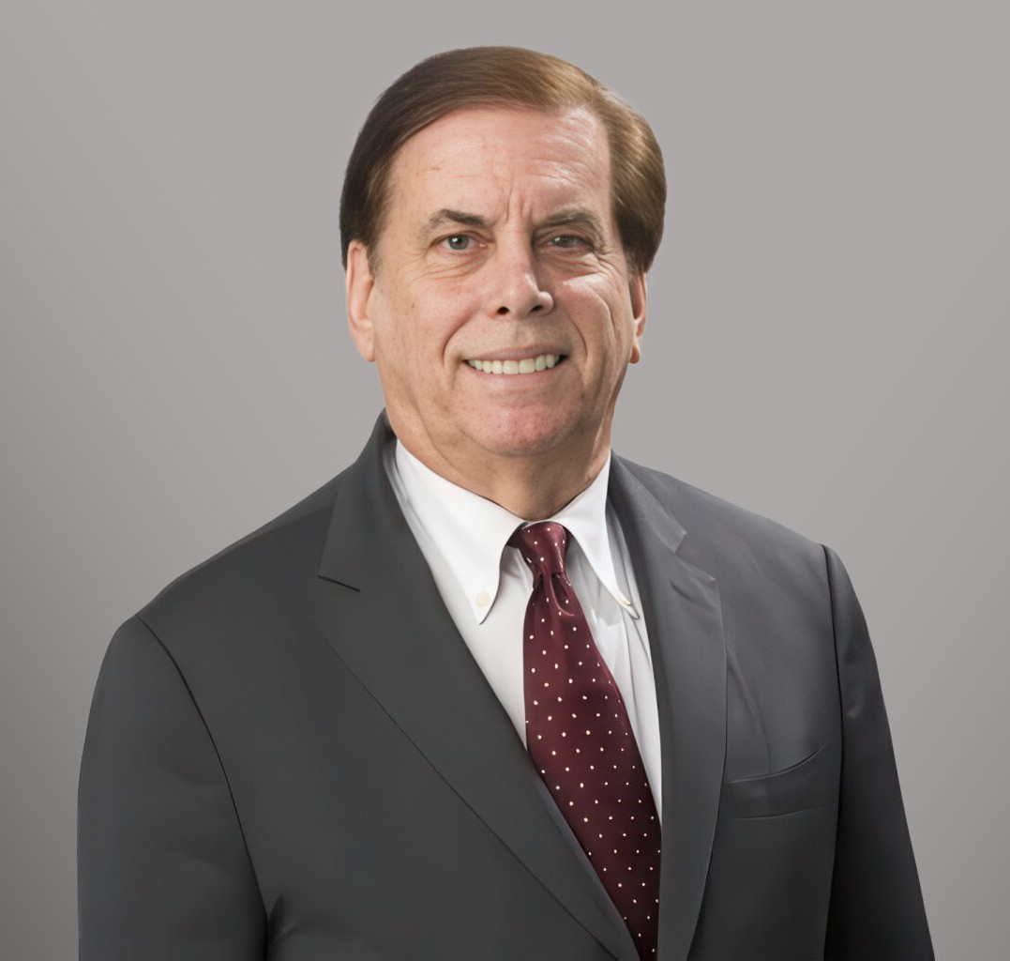

LESLIE ALAN GLICK
Director
International Trade

Fennemore Forward
P: 202.220.1468 P: Cell: 240.447.7796
lglick@fennemorelaw.com

LESLIE ALAN GLICK
Leslie Alan Glick (Les) is a Director in Fennemore’s Business & Finance practice group, based in Washington, D.C., and focusing on international trade and customs law, representing clients before the U.S. International Trade Commission, Department of Commerce, Office of the U.S. Trade Representative, and the Court of International Trade. He has extensive experience with antidumping and countervailing duty cases, as well as investigations under Sections 232 and 337 of U.S. trade law. He has handled complex tariff matters for many exporters, importers, and retailers for many years, including the first Trump administration, where he obtained exclusions from section 232 and 301 tariffs for many companies. During the current administration, he has been widely consulted for his ability to develop “tariff mitigation” strategies and has been a
frequent speaker before various trade associations. Les also conducts trade and tariff-related “due diligence” in mergers and acquisitions.
Les is a particularly a specialist in manufacturing in Mexico and so-called “maquiladora” plants where U.S. companies send raw materials to Mexico for assembly and manufacturing, taking advantage of special tariff provisions in US and Mexican laws. Les is the author of books on the North American Free Trade Agreement (NAFTA) and its successor, the U.S.-Mexico-Canada Agreement (USMCA).
Les previously served as counsel to a subcommittee in the House of Representatives and has an active lobbying practice in Washington, D.C., where he is based and has been a registered
lobbyist for many years.

In addition to trade matters, Les advises both domestic and international clients on compliance with regulatory requirements enforced by agencies such as the Food and Drug Administration
(FDA), the U.S. Department of Agriculture (USDA), and Federal Trade Commission (FTC) particularly in matters involving food products, meat and poultry, plants, medical devices,
cosmetics, and the importation of pharmaceutical and biological materials. His practice also includes regulatory guidance concerning consumer product safety and automotive product compliance and recalls under the National Highway Traffic Safety Administration (NHTSA) and the Federal Motor Vehicle Safety Standards (FMVSS). Les has also had experience in the regulation of alcoholic beverages, including import matters before the U.S. Treasury Department Alcohol and Tobacco Tax and Trade Bureau, involving beer and wine imports from Italy and sake from Japan. He has represented one of the largest dietary supplement importers in the United

States, securing the reclassification of a product as a vitamin, resulting in multimillion-dollar savings in customs duties. His work also includes advising a major U.S. dietary supplement importer on FDA labeling requirements.
Les is a former member of the Food and Drug Law Institute, where he served on the Dietary Supplements Committee and contributed several articles to the institute’s publication, UPDATE, on topics including the Bioterrorism Preparedness and Response Act of 2002. His USDA-related experience includes resolving issues involving meat product regulation and assisting a restaurant chain and retailer in avoiding a significant product recall.

EDUCATION

J.D., Cornell Law School
Editor, Cornell International Law Journal Board Member, Moot Court
Legal Aid Society
B.A., Cornell University

AREAS OF PRACTICE

OTHER EXPERIENCE

Food and Drug
Consumer Product Safety Commission

International Trade Business & Finance Intellectual Property Agribusiness
Food & Beverage Apparel & Fashion
Government Relations & Regulatory

ARTICLES AND PRESENTATIONS

Co-Presenter, “What Malaysian Agribusinesses Need to Know About Doing Business in the United States,” Malaysia Agriculture, Horticulture & Agrotourism Show, September 2, 2026
Author, “New U.S. Tariffs Replace Expiring Section 122 Tariffs,” Fennemore Blog, July 24, 2026
Co-Author, “Fennemore’s Industry Analysis of the Rescheduling of Medical Marijuana,” Fennemore Blog, May 21, 2026
Panelist, “International Ag Trade Update: Tariffs, IEEPA, Refunds, & Related Issues,” National Agricultural Law Center Webinar, April 15, 2026
Interview, “Takeaways on the U.S. Supreme Court Ruling on Tariffs,” Aftermarket News, March 2, 2026

PROFESSIONAL AND COMMUNITY AFFILIATIONS

Co-Chair, American Bar Association International Law Section Chair, American Bar Association International Law Committee Chair, American Bar Association, Mexico Committee
Chair, American Bar Association, Customs Committee Chair, Federal Bar Association, International Law Section

ADMISSIONS

New York Maryland
District of Columbia

LANGUAGES

Conversational Spanish

