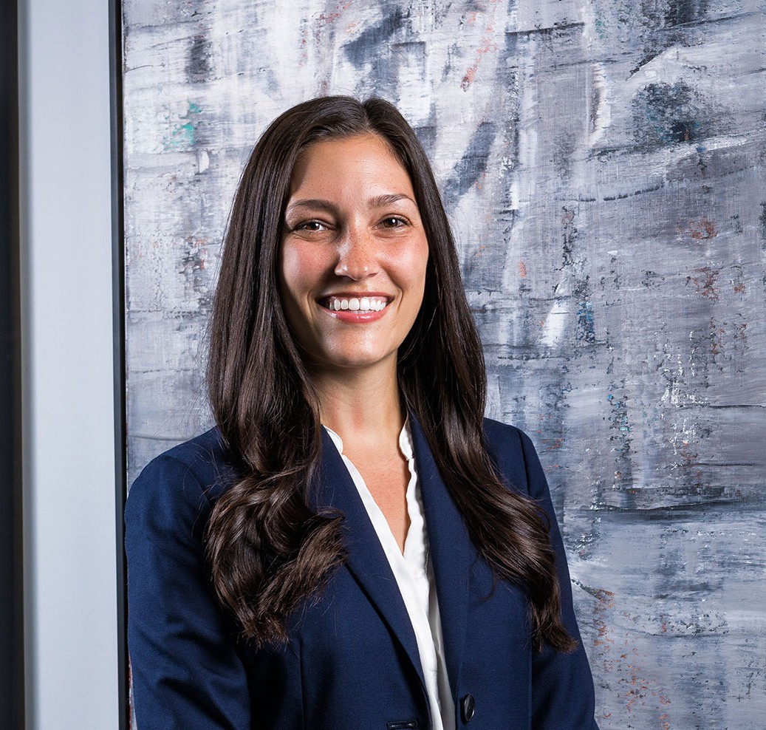

LYNDSEY MAASCH
Associate
Business Litigation

Phoenix
P: 602.916.5401 F: 602.916.5601
lmaasch@fennemorelaw.com
LYNDSEY MAASCH
Lyndsey Maasch is an Associate in Fennemore’s Business Litigation practice group in Phoenix. She represents businesses, business owners, and professionals in complex commercial disputes.
Her practice includes contract disputes, restrictive covenant matters, insurance coverage
disputes, and appeals. She represents clients on both sides and through all stages of a dispute, from early strategy and pre-suit resolution through dispositive motions, evidentiary hearings, trial, and appeal.
Lyndsey particularly enjoys matters that require digging into a complicated factual record, understanding how a client’s business actually works, and finding the clearest path through a difficult problem. She takes pride in mastering the details without losing sight of the client’s broader business objectives.’
Outside the office, Lyndsey is a dedicated member of the Auxiliary Board of Fresh Start Women’s Foundation, where she supports the organization’s mission of empowering women to succeed. When she’s not working, you can find Lyndsey at a local coffee shop with her husband, Jeff, or chasing her daughters, Tatum and Baker, around the zoo or the aquarium.

EDUCATION

J.D., magna cum laude, Arizona State University, Sandra Day O’Connor College of Law B.A., Political Science and Legal Studies, University of Wisconsin-Madison

AREAS OF PRACTICE

Business Litigation Health Care Automotive Dealership

ARTICLES AND PRESENTATIONS

Co-Author, “Seven Significant Differences Between Arizona and Federal Civil Procedure in 2024,” Fennemore Blog, June 20, 2024
Co-author, “OSHA Issues Emergency Temporary Standard for Health Care Employers,” Fennemore Client Alert, July 8, 2021

AWARDS AND HONORS
Best Lawyers in America®, Ones to Watch, Health Care Law, 2026-2027

PROFESSIONAL AND COMMUNITY AFFILIATIONS

Member, Auxiliary Board, Fresh Start Women’s Foundation

ADMISSIONS

Arizona
U.S. District Court, District of Arizona
U.S. Court of Appeals, Federal Circuit

